Unit 4 Lesson 5: How Many Groups? (Part 2)

1 Reasoning with Fraction Strips (Warm up)

Student Task Statement
Write a fraction or whole number as an answer for each question. If you get stuck, use the fraction strips. Be prepared to share your reasoning.
- How many $\frac{1}{2}$s are in 2?
- How many $\frac{1}{5}$s are in 3?
- How many $\frac{1}{8}$s are in $1\frac{1}{4}$?
- $1÷\frac{2}{6}=?$
- $2÷\frac{2}{9}=?$
- $4÷\frac{2}{10}=?$
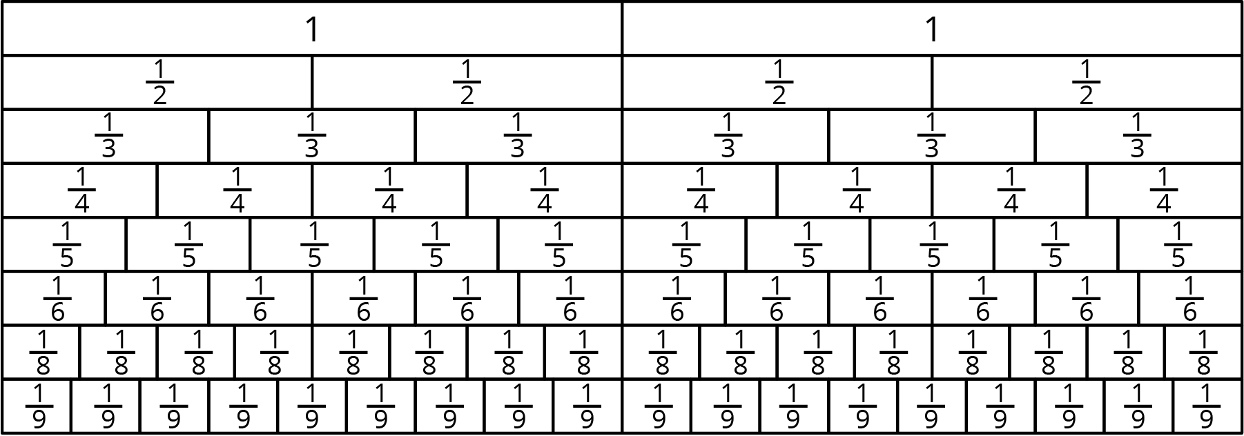

2 More Reasoning with Pattern Blocks

Student Task Statement
Your teacher will give you pattern blocks. Use them to answer the questions.
- If the trapezoid represents 1 whole, what do each of the other shapes represent? Be prepared to show or explain your reasoning.
- 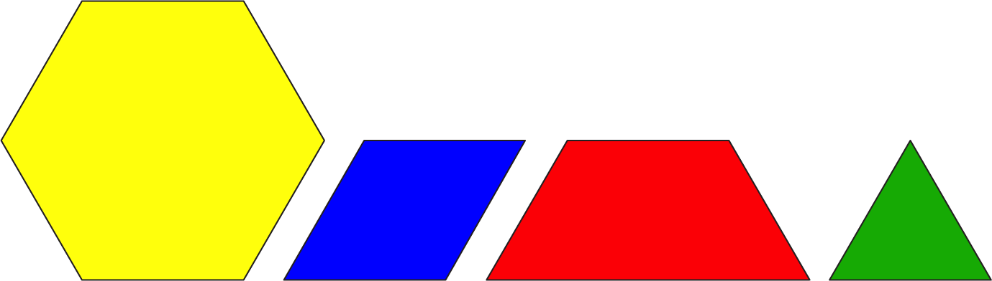
- Use pattern blocks to represent each multiplication equation. Use the trapezoid to represent 1 whole.
  - $3⋅\frac{1}{3}=1$
  - $3⋅\frac{2}{3}=2$
- Diego and Jada were asked “How many rhombuses are in a trapezoid?”
  - Diego says, “$1\frac{1}{3}$. If I put 1 rhombus on a trapezoid, the leftover shape is a triangle, which is $\frac{1}{3}$ of the trapezoid.”
  - Jada says, “I think it’s $1\frac{1}{2}$. Since we want to find out ‘how many rhombuses,’ we should compare the leftover triangle to a rhombus. A triangle is $\frac{1}{2}$ of a rhombus.”
- Do you agree with either of them? Explain or show your reasoning.
- Select all the equations that can be used to answer the question: “How many rhombuses are in a trapezoid?”
  - $\frac{2}{3}÷?=1$
  - $?⋅\frac{2}{3}=1$
  - $1÷\frac{2}{3}=?$
  - $1⋅\frac{2}{3}=?$
  - $?÷\frac{2}{3}=1$

Activity Synthesis
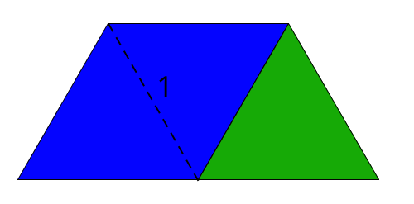

3 Drawing Diagrams to Show Equal-sized Groups (Optional)

Student Task Statement
For each situation, draw a diagram for the relationship of the quantities to help you answer the question. Then write a multiplication equation or a division equation for the relationship. Be prepared to share your reasoning.
- The distance around a park is $\frac{3}{2}$ miles. Noah rode his bicycle around the park for a total of 3 miles. How many times around the park did he ride?
- You need $\frac{3}{4}$ yard of ribbon for one gift box. You have 3 yards of ribbon. How many gift boxes do you have ribbon for?
- The water hose fills a bucket at $\frac{1}{3}$ gallon per minute. How many minutes does it take to fill a 2-gallon bucket?
© CC BY Open Up Resources. Adaptations CC BY IM.

