Lesson 13: Use Bar Graphs to Compare
- Let’s use bar graphs to solve Compare problems.

Warm-up: True or False: Make Ten with 9
Decide if each statement is true or false. Be prepared to explain your reasoning.
- $9+4=9+1+3$
- $9+4=10+3$
- $9+5=10+6$

13.1: What’s the Difference?
A group of third grade students were asked, "What pets do you have?" Their responses are shown in the bar graph.
What do you notice? What do you wonder?
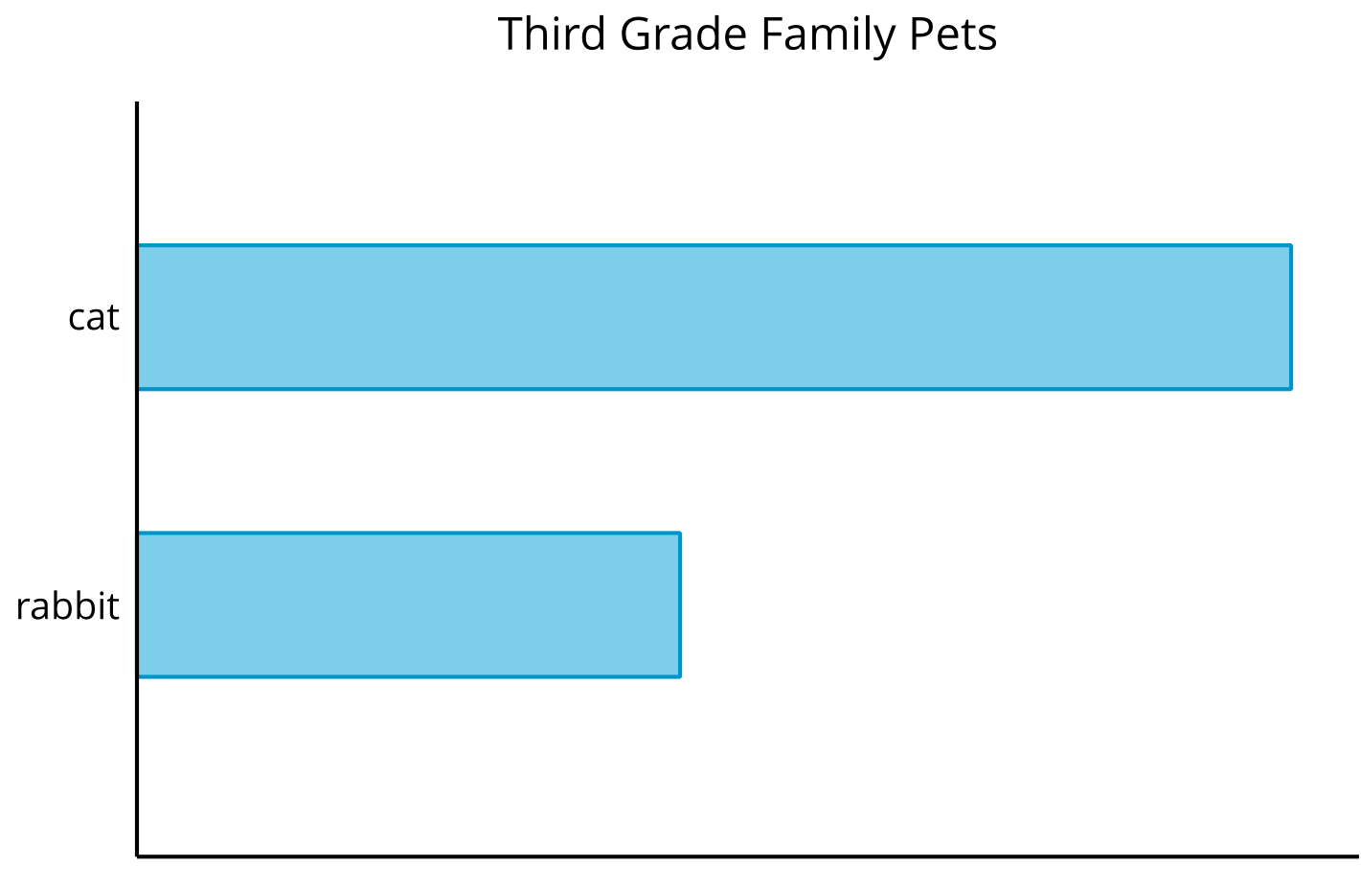
Their responses are also shown in this bar graph.
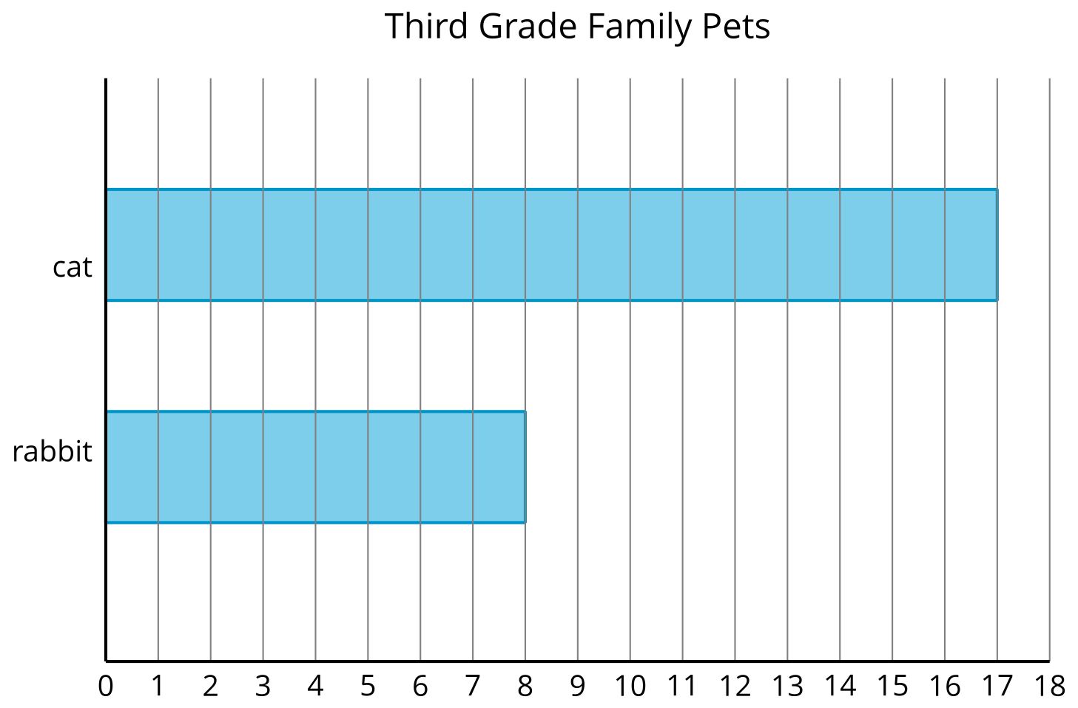
How many more students have cats than have rabbits? Show two ways to find the difference.

13.2: Dogs in the Park
Kiran and Lin counted the types of dogs they saw in a park. Their data is shown in the bar graph.
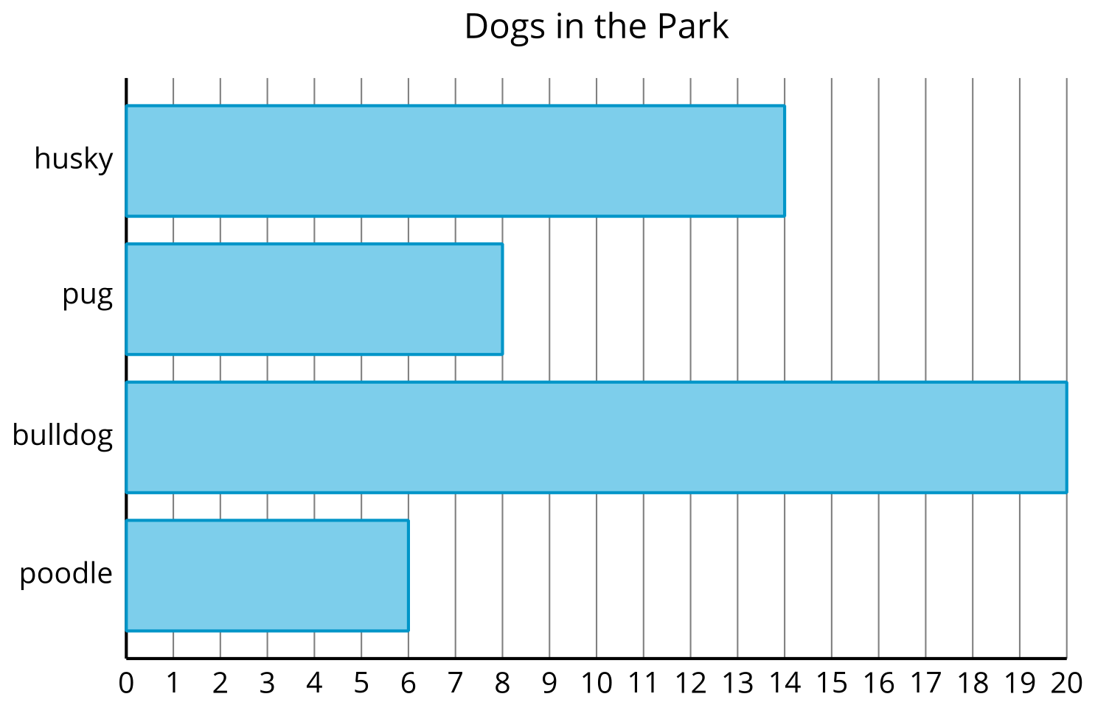
- Make this statement true: There are more
- __________________________ than ___________________________.
- Write an addition and a subtraction equation to show how many more.
- Make this statement true: There are fewer
- ___________________________ than ____________________________.
- Write an addition and subtraction equation to show how many fewer.
© CC BY 2021 Illustrative Mathematics®

