Unit 1 Lesson 20: The Commutative Property

WU Number Talk: Subtraction (Warm up)

Student Task Statement
Find the value of each expression mentally.
- $70−10$
- $68−10$
- $70−12$
- $68−12$

1 Learn More About Multiplication

Student Task Statement
What do you notice? What do you wonder?
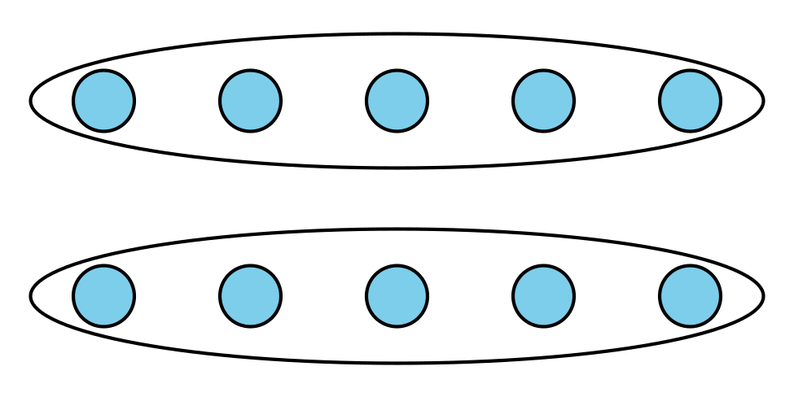
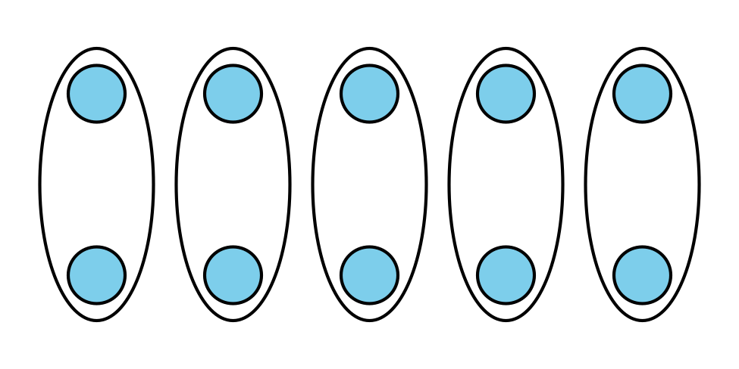
Image A
Image B

  - Write an array situation for each array.
  - Image A
  - Image B
  - How are the situations the same? How are the situations different?

  - Write an equation for each situation.
  - Image A
  - Image B
  - How does your equation connect to the situation and array?
  - Image A
  - Image B

2 Revisit Arrays

Student Task Statement
- Write 2 multiplication equations that represent the array.
- 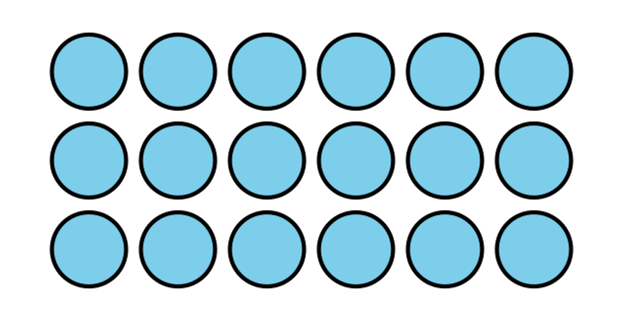
- Explain why both equations can represent the array.
© CC BY 2021 Illustrative Mathematics®

