Lesson 16: Compare and Order Fractions
- Let’s put some fractions in order.

Warm-up: Number Talk: Multiples of 6 and 12
Find the value of each expression mentally.
- $5×6$
- $5×12$
- $6×12$
- $11×12$

16.1: Compare Fractions Game
Play Compare Fractions with 2 players:
- Split the deck between the players.
- Each player turns over a card.
- Compare the fractions. The player with the greater fraction keeps both cards.
- If the fractions are equivalent, each player turns over one more card. The player with the greater fraction keeps all four cards.
- Play until you run out of cards. The player with the most cards at the end of the game wins.
fraction cards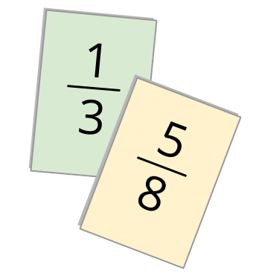
Play Compare Fractions with 3 or 4 players:
- The player with the greatest fraction wins the round.
- If 2 or more players have the greatest fraction, those players turn one more card over. The player with the greatest fraction keeps all the cards.
Record any sets of fractions that are challenging to compare here.
_________ and _________
_________ and _________
_________ and _________
_________ and _________

16.2: Fractions in Order
Put each set of fractions in order, from least to greatest. Be prepared to explain your reasoning.
- $\frac{3}{12} \frac{2}{4} \frac{2}{3} \frac{1}{8}$
- $\frac{8}{5} \frac{5}{6} \frac{11}{12} \frac{11}{10}$
- $\frac{21}{20} \frac{9}{10} \frac{6}{5} \frac{101}{100}$
- $\frac{5}{8} \frac{2}{5} \frac{3}{7} \frac{3}{6}$

Section Summary
Section Summary
In this section, we compared fractions using what we know about the size of fractions, benchmarks such as $\frac{1}{2}$ and 1, and equivalent fractions. For example, to compare $\frac{3}{8}$ and $\frac{6}{10}$, we can reason that:
- $\frac{4}{8}$ is equivalent to $\frac{1}{2}$, so $\frac{3}{8}$ is less than $\frac{1}{2}$.
- $\frac{5}{10}$ is equivalent to $\frac{1}{2}$, so $\frac{6}{10}$ is more than $\frac{1}{2}$.
This means that $\frac{6}{10}$ is greater than $\frac{3}{8}$ (or $\frac{3}{8}$ is less than $\frac{6}{10}$).
We can also compare by writing equivalent fractions with the same denominator. For example, to compare $\frac{3}{4}$ and $\frac{4}{6}$, we can use 12 as the denominator:
$\frac{3}{4}=\frac{9}{12} \frac{4}{6}=\frac{8}{12}$
Because $\frac{9}{12}$ is greater than $\frac{8}{12}$, we know that $\frac{3}{4}$ is greater than $\frac{4}{6}$.
© CC BY 2021 Illustrative Mathematics®

