Unit 2 Lesson 2 Cumulative Practice Problems
- Here are Circles $c$ and $d$. Point $O$ is the center of dilation, and the dilation takes Circle $c$ to Circle $d$.
- 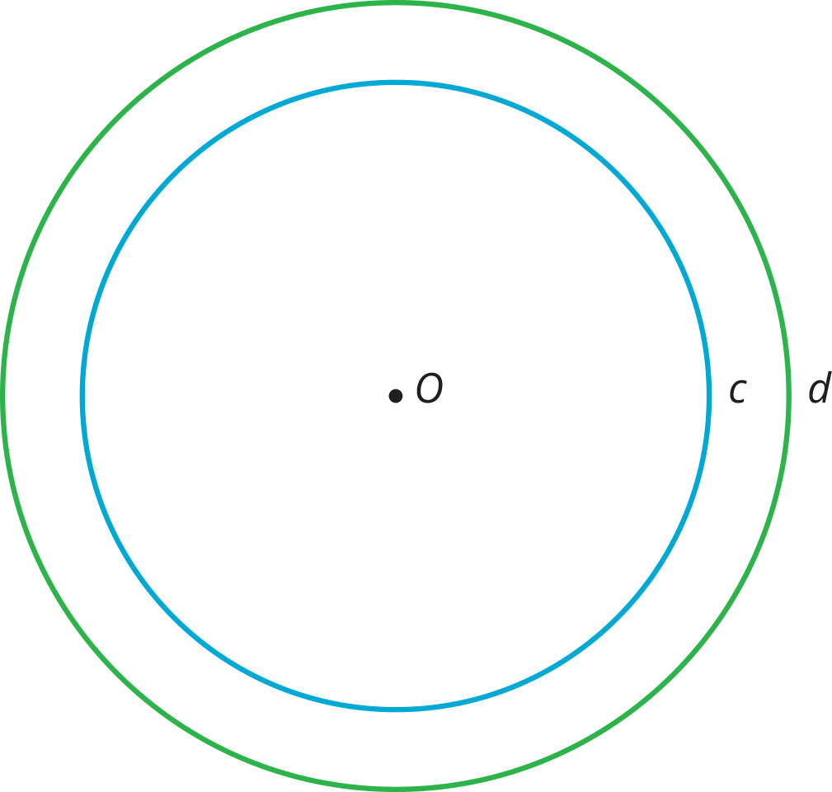

  - Plot a point on Circle $c$. Label the point $P$. Plot where $P$ goes when the dilation is applied.
  - Plot a point on Circle $d$. Label the point $Q$. Plot a point that the dilation takes to $Q$.
- Here is triangle $ABC$.
- 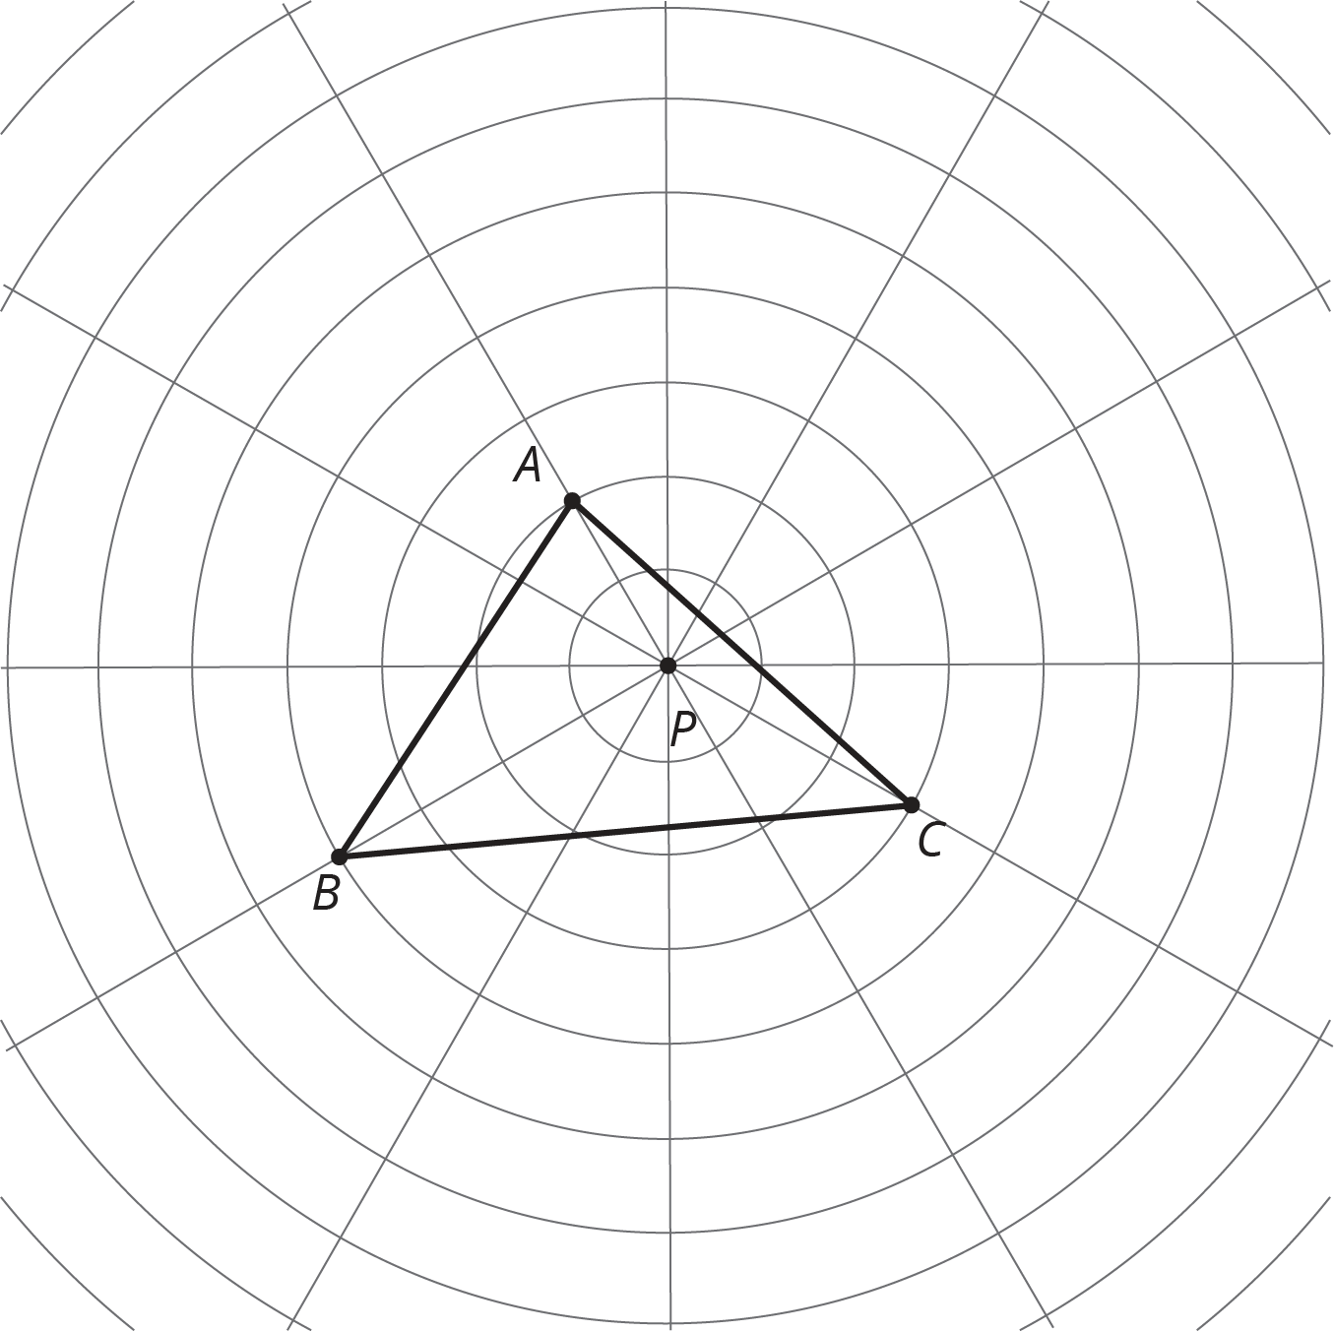
  - Dilate each vertex of triangle $ABC$ using $P$ as the center of dilation and a scale factor of 2. Draw the triangle connecting the three new points.
  - Dilate each vertex of triangle $ABC$ using $P$ as the center of dilation and a scale factor of $\frac{1}{2}$. Draw the triangle connecting the three new points.
  - Measure the longest side of each of the three triangles. What do you notice?
  - Measure the angles of each triangle. What do you notice?
- Describe a rigid transformation that you could use to show the polygons are congruent.
- 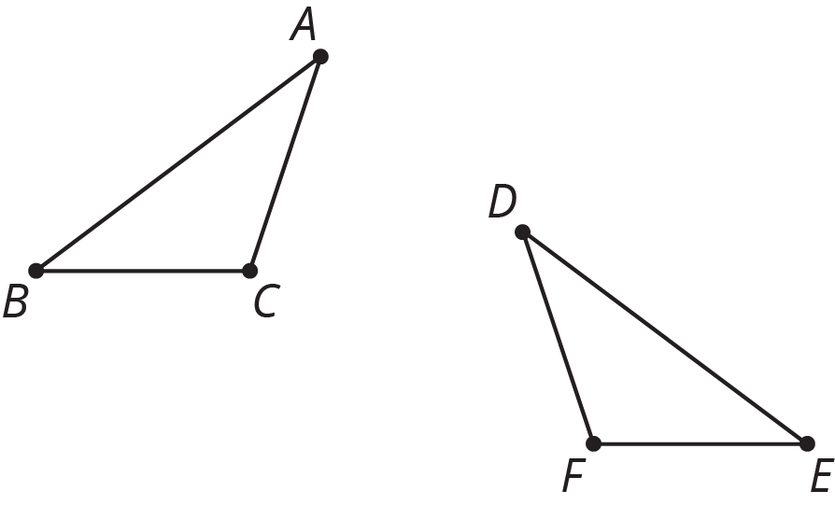

- (From Unit 1, Lesson 12.)
- The line has been partitioned into three angles.
- 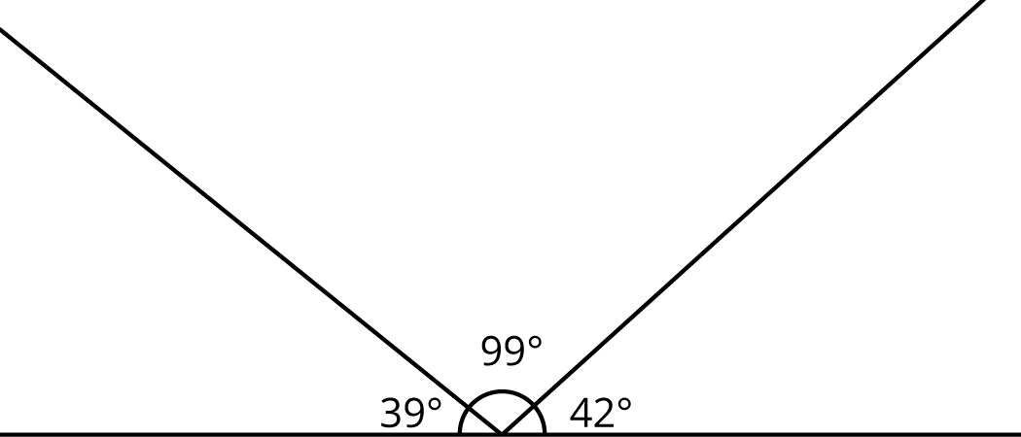
- Is there a triangle with these three angle measures? Explain.
- (From Unit 1, Lesson 15.)
© CC BY Open Up Resources. Adaptations CC BY IM.

