Lesson 16: Solve All Kinds of Compare Problems
- Let’s solve Compare problems.

Warm-up: True or False: Multiples of 10
Decide if each statement is true or false. Be prepared to explain your reasoning.
- $18+5=18+2+3$
- $28+5=30+3$
- $38+4=40+3$

16.1: A Trip to the Library
- Priya and Andre returned books to the library. Priya returned 29 books. Andre returned 8 more books than Priya.
  - Who returned more books?
  - Use the story problem to complete the diagram.
  - 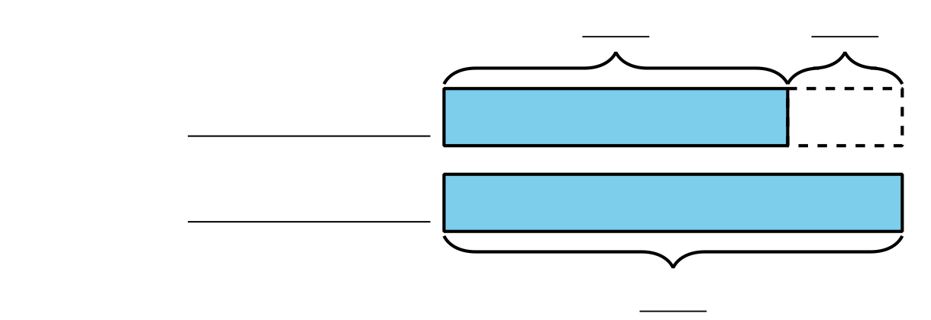
  - How many books did Andre return?
- Andre read 45 pages of his book last night. Priya read 20 fewer pages of her book than Andre.
  - Who read more pages?
  - Use the story problem to complete the diagram.
  - 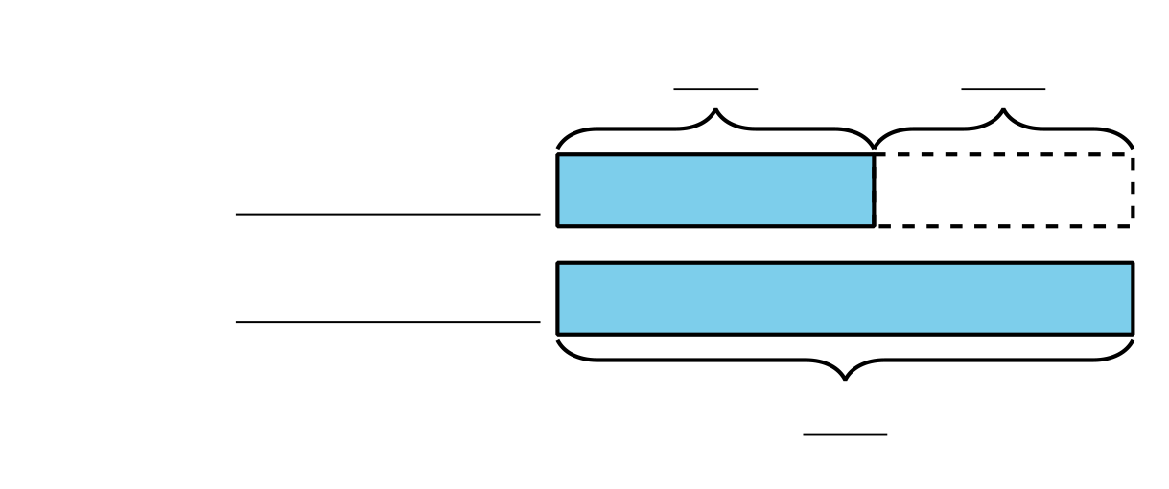
  - How many pages did Priya read?

16.2: Solve Compare Problems
- Jada read 10 fewer pages than Noah. Noah read 27 pages. How many pages did Jada read?
- Noah spent 25 minutes reading. Jada spent 30 more minutes reading than Noah. How many minutes did Jada spend reading?
- Jada read 47 pages of the book. Noah read 20 pages of the book. How many fewer pages did Noah read?
- Noah stacked 14 more books than Jada. Jada stacked 28 books. How many books did Noah stack?

Section Summary
Section Summary
In this section of Unit 1, we learned how to represent and solve Compare problems. First, we used bar graphs to find the difference between two categories.
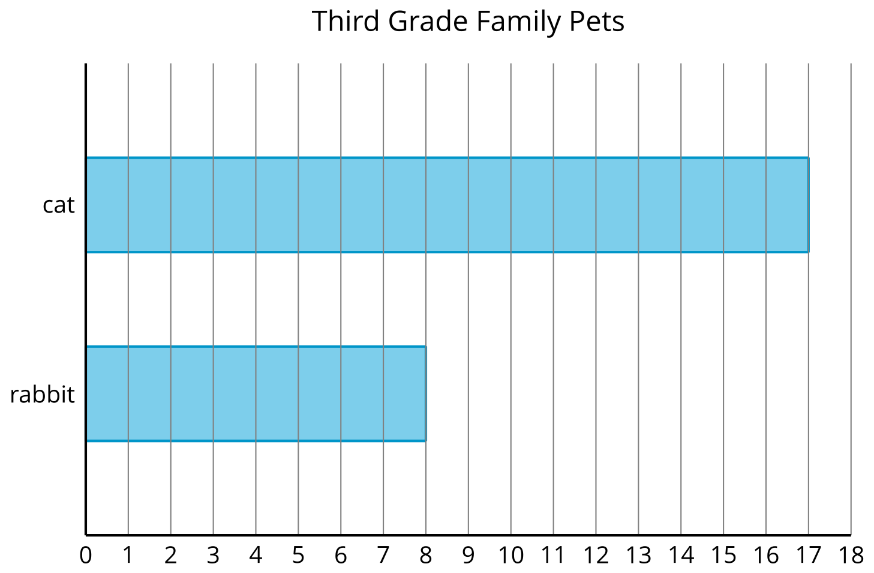
How many more students have cats than have rabbits? Show two ways to find the difference.
We learned about a new representation called a diagram. It helps us make sense of story problems. We can use diagrams to show which part of a comparison we need to find.
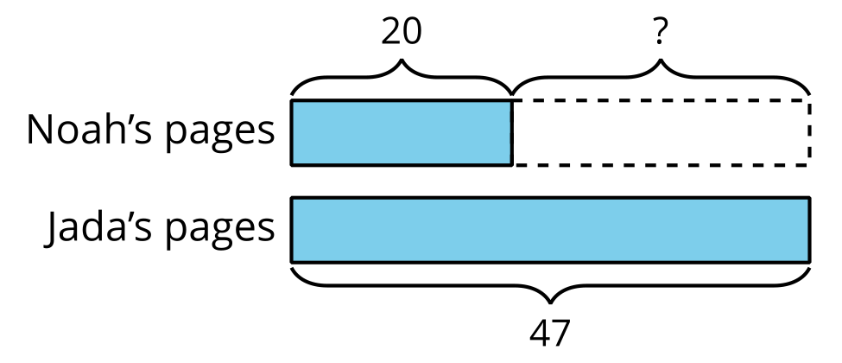
Jada read 47 pages of the book. Noah read 20 pages of the book. How many fewer pages did Noah read?
In this problem, we are finding the difference. We know how many pages Noah and Jada read, so the ? represents the difference.
© CC BY 2021 Illustrative Mathematics®

