Unit 2 Lesson 4 Cumulative Practice Problems
- Here is a diagram showing a mixture of red paint and green paint needed for 1 batch of a particular shade of brown.
- 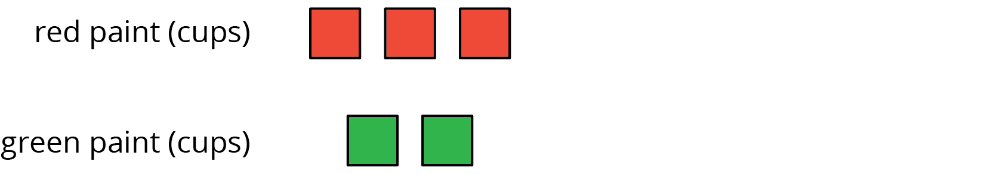
- Add to the diagram so that it shows 3 batches of the same shade of brown paint.
- Diego makes green paint by mixing 10 tablespoons of yellow paint and 2 tablespoons of blue paint. Which of these mixtures produce the same shade of green paint as Diego’s mixture? Select all that apply.
  - For every 5 tablespoons of blue paint, mix in 1 tablespoon of yellow paint.
  - Mix tablespoons of blue paint and yellow paint in the ratio $1:5$.
  - Mix tablespoons of yellow paint and blue paint in the ratio 15 to 3.
  - Mix 11 tablespoons of yellow paint and 3 tablespoons of blue paint.
  - For every tablespoon of blue paint, mix in 5 tablespoons of yellow paint.
- To make 1 batch of sky blue paint, Clare mixes 2 cups of blue paint with 1 gallon of white paint.
  - Explain how Clare can make 2 batches of sky blue paint.
  - Explain how to make a mixture that is a darker shade of blue than the sky blue.
  - Explain how to make a mixture that is a lighter shade of blue than the sky blue.
- A smoothie recipe calls for 3 cups of milk, 2 frozen bananas and 1 tablespoon of chocolate syrup.
  - Create a diagram to represent the quantities of each ingredient in the recipe.
  - Write 3 different sentences that use a ratio to describe the recipe.
- (From Unit 2, Lesson 2.)
- Write the missing number under each tick mark on the number line.
- (From Unit 2, Lesson 1.)
- Find the area of the parallelogram. Show your reasoning.
- 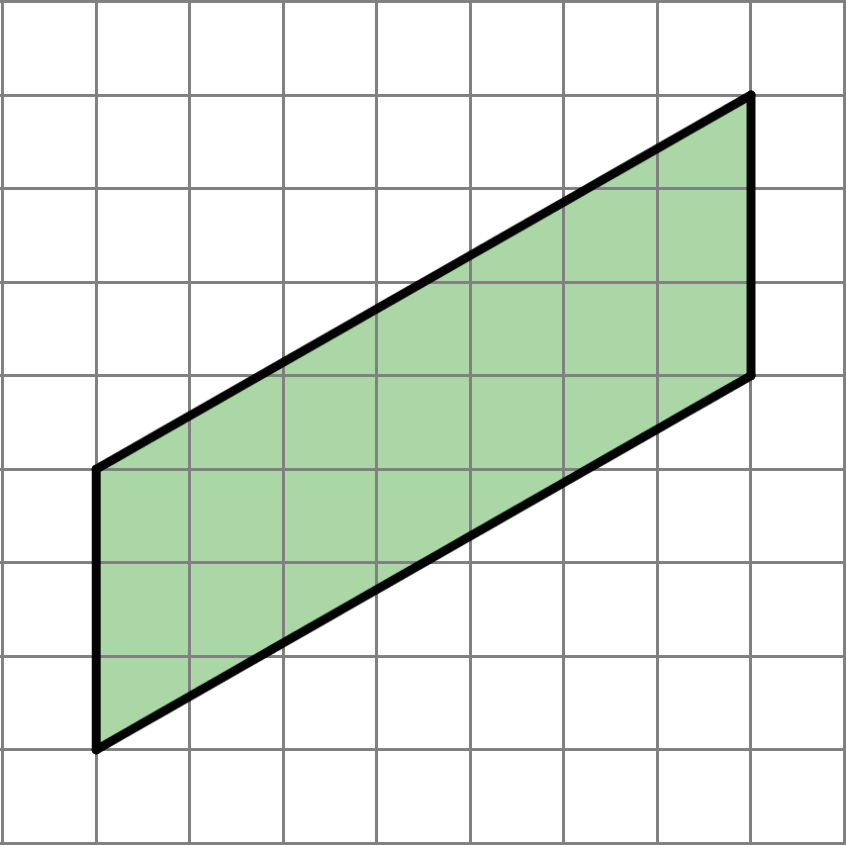
- (From Unit 1, Lesson 4.)
- Complete each equation with a number that makes it true.
  - $11⋅\frac{1}{4}=\text{_______}$
  - $7⋅\frac{1}{4}=\text{_______}$
  - $13⋅\frac{1}{27}=\text{_______}$
  - $13⋅\frac{1}{99}=\text{_______}$
  - $x⋅\frac{1}{y}=\text{_______}$
(As long as $y$ does not equal 0.)
- (From Unit 2, Lesson 1.)
© CC BY Open Up Resources. Adaptations CC BY IM.

