Lesson 13: El perímetro y el área de los rectángulos

Standards Alignments
Addressing | 5.G.A.2, 5.NBT.B.7, 5.OA.B.3
Building Towards | 5.G.A.2

Teacher-facing Learning Goals
- Use the coordinate grid to understand the length and width of rectangles with fixed area.
- Use the coordinate grid to understand the length and width of rectangles with fixed perimeter.

Student-facing Learning Goals
- Exploremos el perímetro y el área de los rectángulos en la cuadrícula de coordenadas.

Lesson Purpose
The purpose of this lesson is for students to examine rectangles with given perimeter or area, plotting their length and width on the coordinate grid.
The purpose of this lesson is to plot the lengths and widths of different rectangles with a given perimeter or with a given area. In a previous course, students found rectangles with the same area and different perimeter and rectangles with the same perimeter and different area. Graphing the possible lengths and widths helps to visualize and quantify these relationships. Specifically, when the perimeter is given, the relationship between the length and width is that each unit taken away from the length is added to the width. When the area is given, the relationship is more complicated and the graphs of the two situations reveal this. As students calculate side lengths they also have opportunities to perform arithmetic with fractions and decimals.
This lesson has a Student Section Summary.

Access for:

Students with Disabilities
- Representation (Activity 1)

English Learners
- MLR8 (Activity 1)

Instructional Routines
Estimation Exploration (Warm-up)

Lesson Timeline
Warm-up | 10 min
Activity 1 | 15 min
Activity 2 | 20 min
Lesson Synthesis | 10 min
Cool-down | 5 min

Teacher Reflection Question
As you finish up this unit, reflect on the norms and routines that have supported each student in learning math. How have you seen each student grow as a young mathematician throughout this work? How have you seen yourself grow as a teacher?

Cool-down
(to be completed at the end of the lesson) 5min
El área y el perímetro de un rectángulo

Standards Alignments
Addressing | 5.OA.B.3

Student-facing Task Statement
El punto que se ve representa el largo y ancho de un rectángulo.
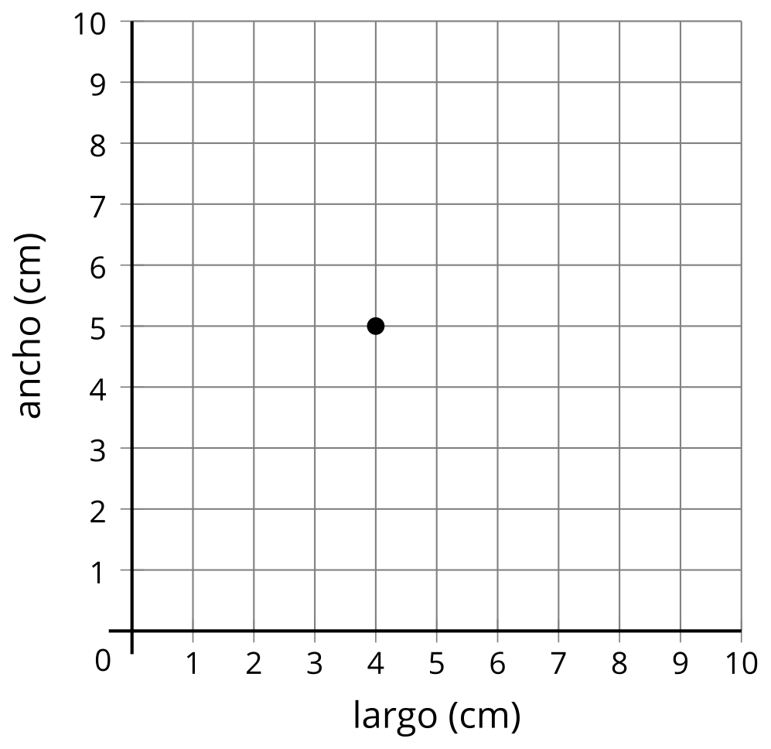
- ¿Cuáles son el área y el perímetro del rectángulo? Explica o muestra cómo razonaste.
- ¿Qué otro punto representa un rectángulo diferente que tenga la misma área? Explica o muestra cómo razonaste.

Student Responses
- Sample response:
- Area: 20 square centimeters since $4×5=20$
- Perimeter: 18 centimeters since $\left(2×4\right)+\left(2×5\right)=18$
- Sample responses: $\left(2,10\right)$, $\left(10,2\right)$, $\left(2.5,8\right)$, $\left(8,2.5\right)$

