Unit 3 Lesson 8: Using the Correlation Coefficient

1 Putting the Numbers in Context (Warm up)

Student Task Statement
Match the variables to the scatter plot you think they best fit. Be prepared to explain your reasoning.
 | $x$ variable | $y$ variable
1. | daily low temperature in Celsius for Denver, CO | boxes of cereal in stock at a grocery in Miami, FL
2. | average number of free throws shot in a season | basketball team score per game
3. | measured student height in feet | measured student height in inches
4. | average number of minutes spent in a waiting room | hospital satisfaction rating

A
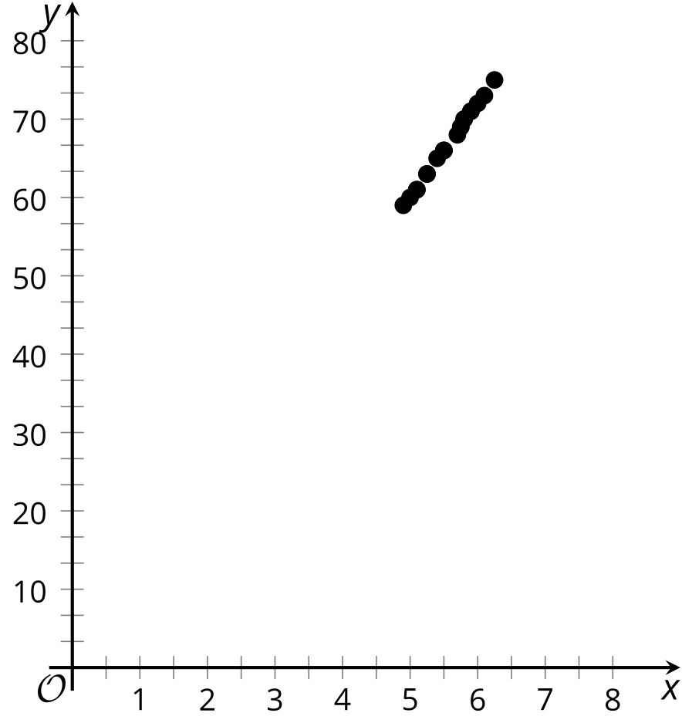

B
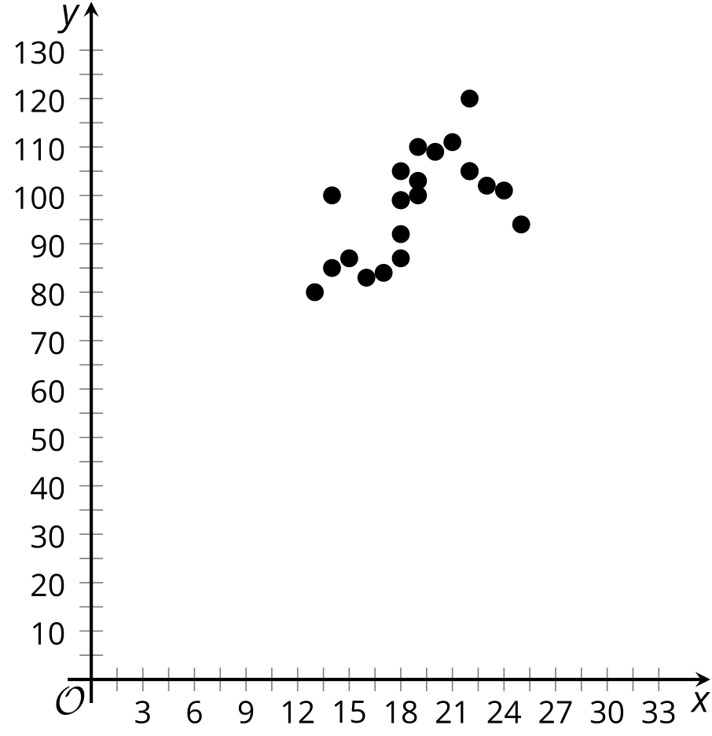

C
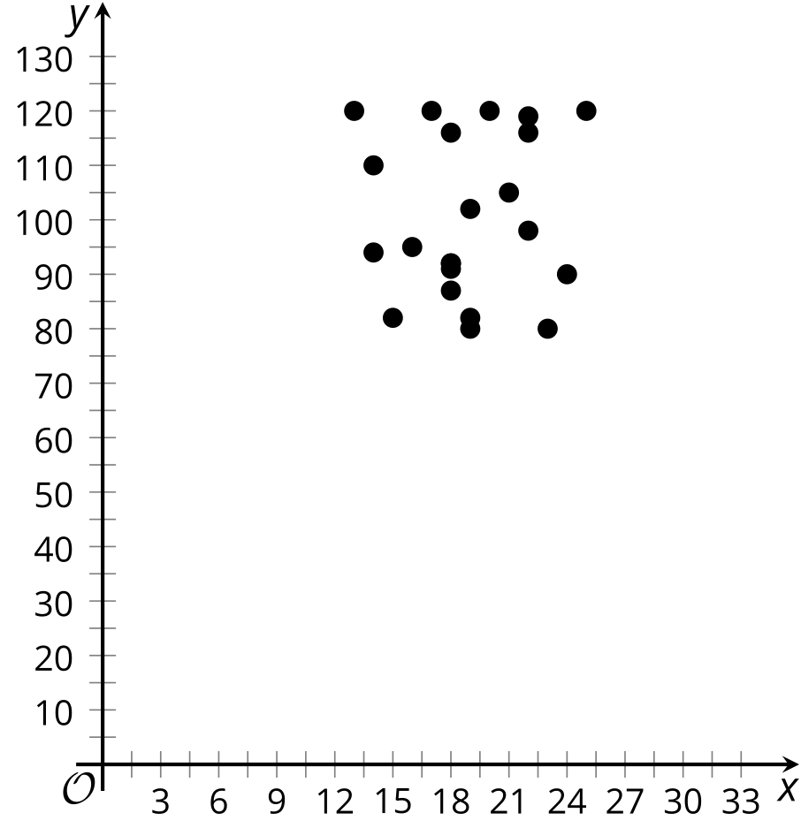

D
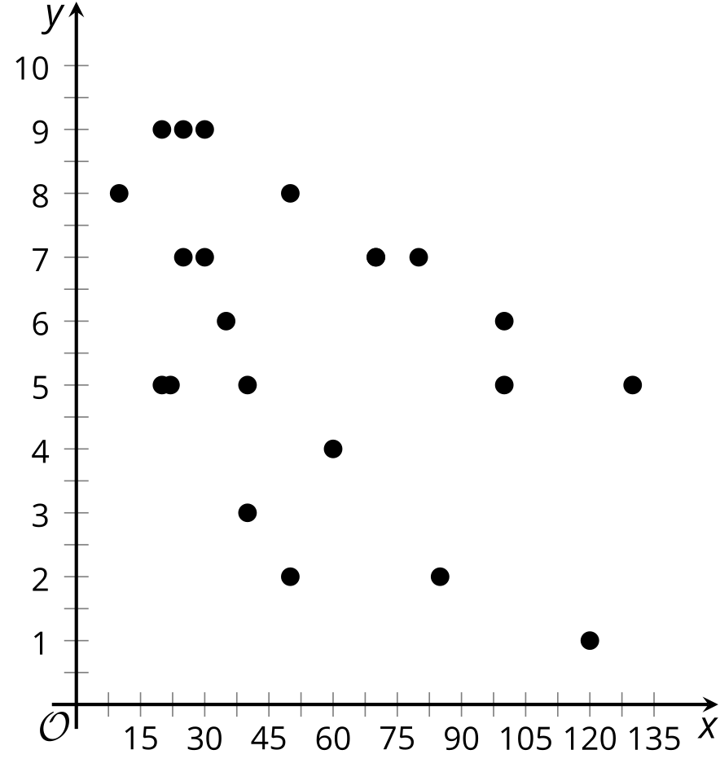

2 Never Know How Far You’ll Go

Student Task Statement
Priya takes note of the distance the car drives and the time it takes to get to the destination for many trips.
distance (mi) ($x$) | travel time (min) ($y$)
2 | 4
5 | 7
10 | 11
10 | 15
12 | 16
15 | 22
20 | 23
25 | 25
26 | 28
30 | 36
32 | 35
40 | 37
50 | 51
65 | 70
78 | 72
- Distance is one factor that influences the travel time of Priya’s car trips. What are some other factors?
- Which of these factors (including distance) most likely has the most consistent influence for all the car trips? Explain your reasoning.
- Use technology to create a scatter plot of the data and add the best fit line to the graph.
- What do the slope and $y$-intercept for the line of best fit mean in this situation?
- Use technology to find the correlation coefficient for this data. Based on the value, how would you describe the strength of the linear relationship?
- How long do you think it would take Priya to make a trip of 90 miles if the linear relationship continues? If she drives 90 miles, do you think the prediction you made will be close to the actual value? Explain your reasoning.

Activity Synthesis

3 Correlation Zoo

Student Task Statement
For each situation, describe the relationship between the variables, based on the correlation coefficient. Make sure to mention whether there is a strong relationship or not as well as whether it is a positive relationship or negative relationship.
- Number of steps taken per day and number of kilometers walked per day. $r=0.92$
- Temperature of a rubber band and distance the rubber band can stretch. $r=0.84$
- Car weight and distance traveled using a full tank of gas. $r=\text{-}0.86$
- Average fat intake per citizen of a country and average cancer rate of a country. $r=0.73$
- Score on science exam and number of words written on the essay question. $r=0.28$
- Average time spent listening to music per day and average time spent watching TV per day. $r=\text{-}0.17$
© CC BY 2019 by Illustrative Mathematics®

