Lesson 14: Use Diagrams to Compare
- Let’s use bar graphs and diagrams to solve Compare problems.

Warm-up: Notice and Wonder: What Kind of Graph Is This?
What do you notice? What do you wonder?
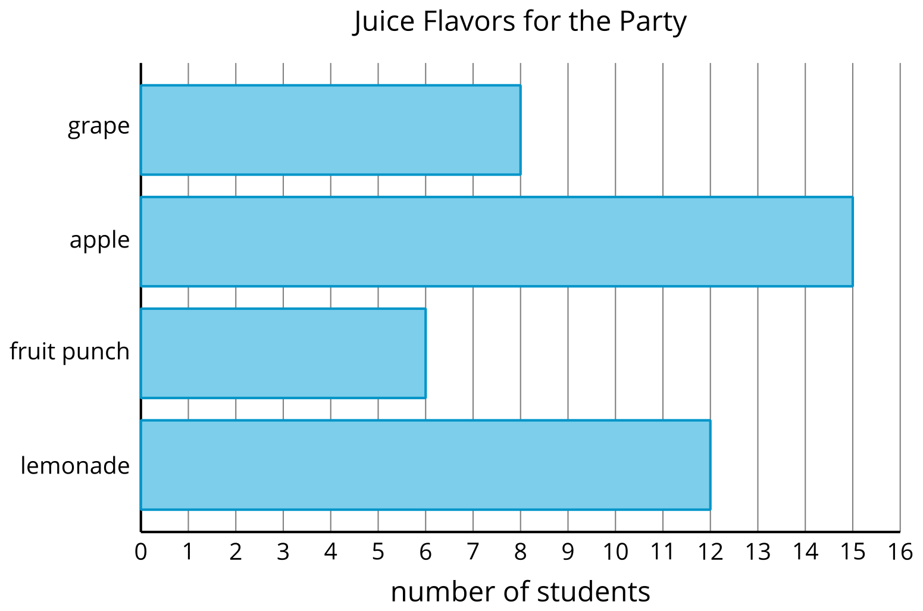
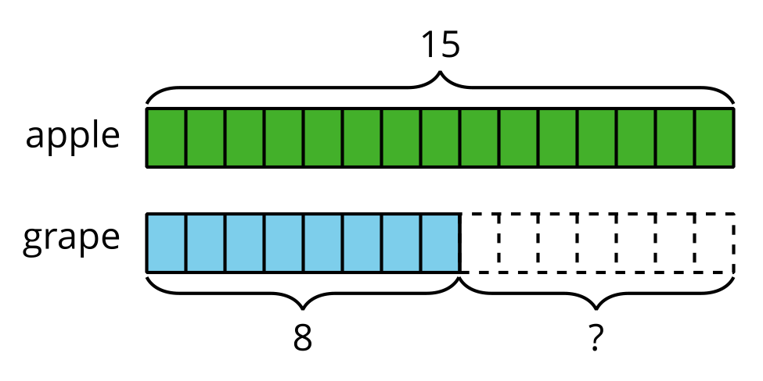
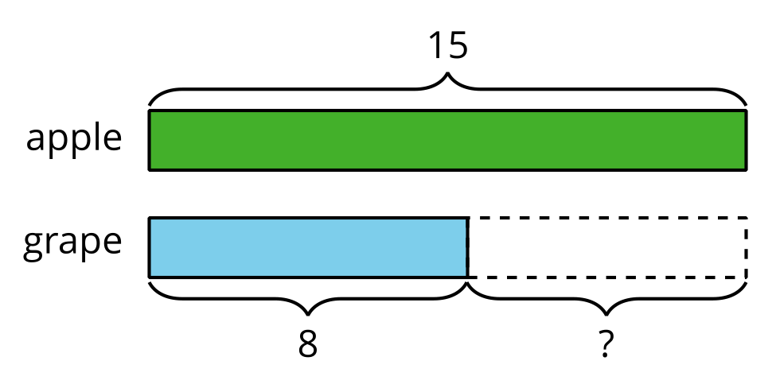

14.1: Party Time (Part 1)
- Glue down the two bars that compare the number of students who picked hot dogs to the number who picked burgers.
- Write two statements that compare the number of students who picked hot dogs to the number who picked burgers.

14.2: Party Time (Part 2)
- Use the data from the bar graph to complete the diagram.
- 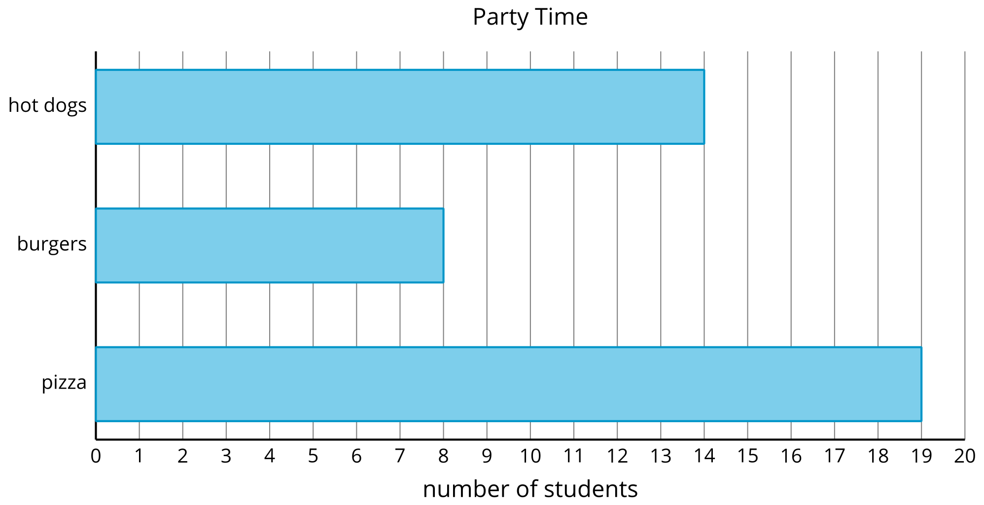
- 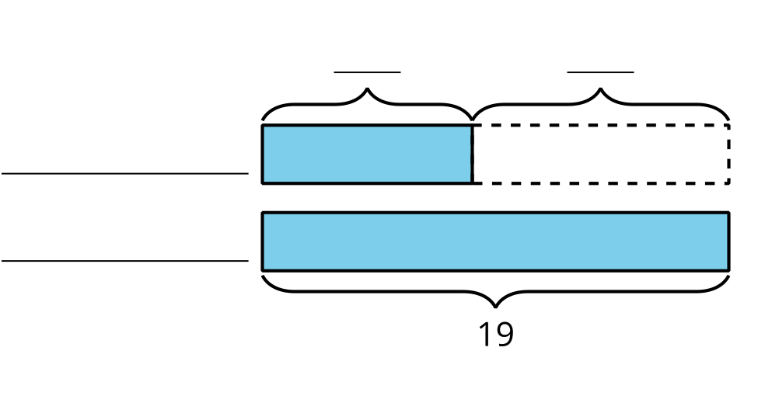
- How many more students chose pizza than chose burgers? Write an equation to show how you found the difference.
- Use the data from the bar graph to complete the diagram.
- 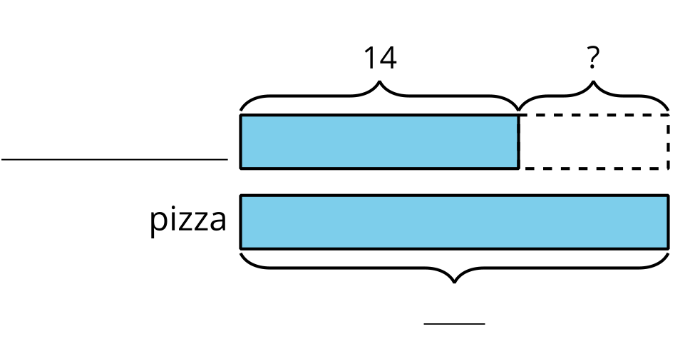
- Write a statement that compares the student votes in the diagram.
© CC BY 2021 Illustrative Mathematics®

