Lesson 5: Building Quadratic Functions to Describe Situations (Part 1)

5.1: Notice and Wonder: An Interesting Numerical Pattern
Study the table. What do you notice? What do you wonder?
$x$ | 0 | 1 | 2 | 3 | 4 | 5
$y$ | 0 | 16 | 64 | 144 | 256 | 400

5.2: Falling from the Sky
A rock is dropped from the top floor of a 500-foot tall building. A camera captures the distance the rock traveled, in feet, after each second.
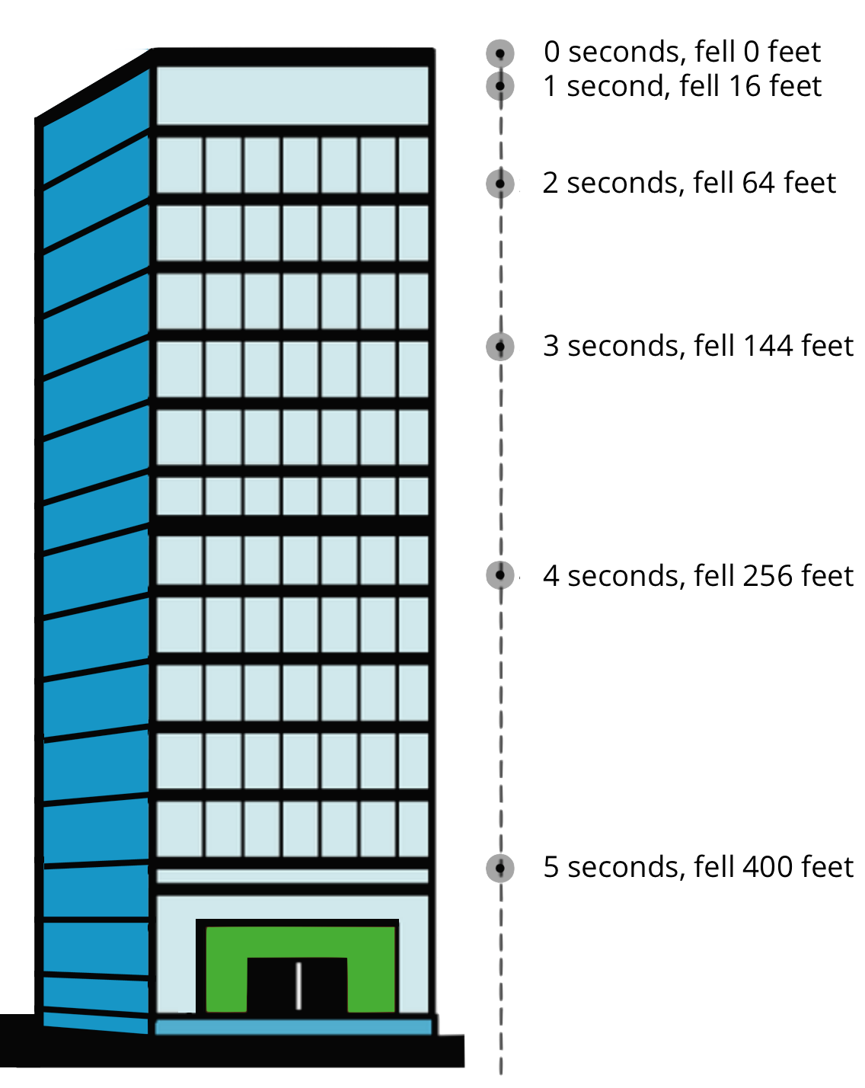
- How far will the rock have fallen after 6 seconds? Show your reasoning.
- Jada noticed that the distances fallen are all multiples of 16.
- She wrote down:
- $\begin{matrix}16 & =16⋅1 \\ 64 & =16⋅4 \\ 144 & =16⋅9 \\ 256 & =16⋅16 \\ 400 & =16⋅25\end{matrix}$
Then, she noticed that 1, 4, 9, 16, and 25 are $1^{2},2^{2},3^{2},4^{2}$ and $5^{2}$.
  - Use Jada’s observations to predict the distance fallen after 7 seconds. (Assume the building is tall enough that an object dropped from the top of it will continue falling for at least 7 seconds.) Show your reasoning.
  - Write an equation for the function, with $d$ representing the distance dropped after $t$ seconds.

5.3: Galileo and Gravity
Galileo Galilei, an Italian scientist, and other medieval scholars studied the motion of free-falling objects. The law they discovered can be expressed by the equation $d=16⋅t^{2}$, which gives the distance fallen in feet, $d$, as a function of time, $t$, in seconds.
An object is dropped from a height of 576 feet.
- How far does it fall in 0.5 seconds?
- To find out where the object is after the first few seconds after it was dropped, Elena and Diego created different tables.
- Elena’s table:
- time (seconds) | - distance fallen  (feet)
- 0 | - 0
- 1 | - 16
- 2 | - 64
- 3
- 4
- $t$
- Diego’s table:
- time (seconds) | - distance from the ground (feet)
- 0 | - 576
- 1 | - 560
- 2 | - 512
- 3
- 4
- $t$
  - How are the two tables are alike? How are they different?
  - Complete Elena’s and Diego’s tables. Be prepared to explain your reasoning.

Are you ready for more?
Galileo correctly observed that gravity causes objects to fall in a way where the distance fallen is a quadratic function of the time elapsed. He got a little carried away, however, and assumed that a hanging rope or chain could also be modeled by a quadratic function.
Here is a graph of such a shape (called a catenary) along with a table of approximate values.
$x$ | -4 | -3 | -2 | -1 | 0 | 1 | 2 | 3 | 4
$y$ | 7.52 | 4.70 | 3.09 | 2.26 | 2 | 2.26 | 3.09 | 4.70 | 7.52
Show that an equation of the form $y=ax^{2}+b$ cannot model this data well.
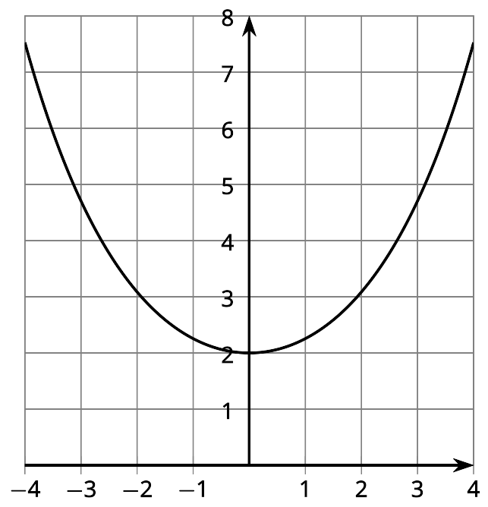

Lesson 5 Summary
The distance traveled by a falling object in a given amount of time is an example of a quadratic function. Galileo is said to have dropped balls of different mass from the Leaning Tower of Pisa, which is about 190 feet tall, to show that they travel the same distance in the same time. In fact the equation $d=16t^{2}$ models the distance $d$, in feet, that the cannonball falls after $t$ seconds, no matter what its mass.
Because $16⋅4^{2}=256$, and the tower is only 190 feet tall, the cannonball hits the ground before 4 seconds.
Here is a table showing how far the cannonball has fallen over the first few seconds.
time (seconds) | distance fallen (feet)
0 | 0
1 | 16
2 | 64
3 | 144
Here are the time and distance pairs plotted on a coordinate plane:
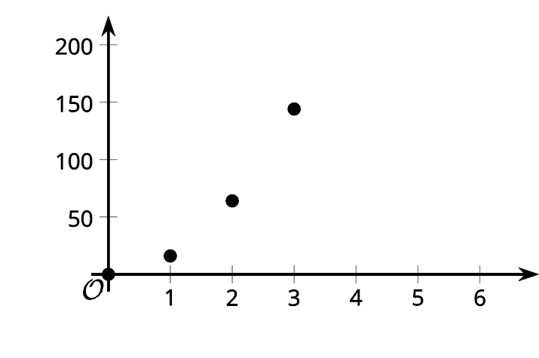
Notice that the distance fallen is increasing each second. The average rate of change is increasing each second, which means that the cannonball is speeding up over time. This comes from the influence of gravity, which is represented by the quadratic expression $16t^{2}$. It is the exponent 2 in that expression that makes it increase by larger and larger amounts.
Another way to study the change in the position of the cannonball is to look at its distance from the ground as a function of time.
Here is a table showing the distance from the ground in feet at 0, 1, 2, and 3 seconds.
time (seconds) | distance from the ground (feet)
0 | 190
1 | 174
2 | 126
3 | 46
Here are the time and distance pairs plotted on a graph:
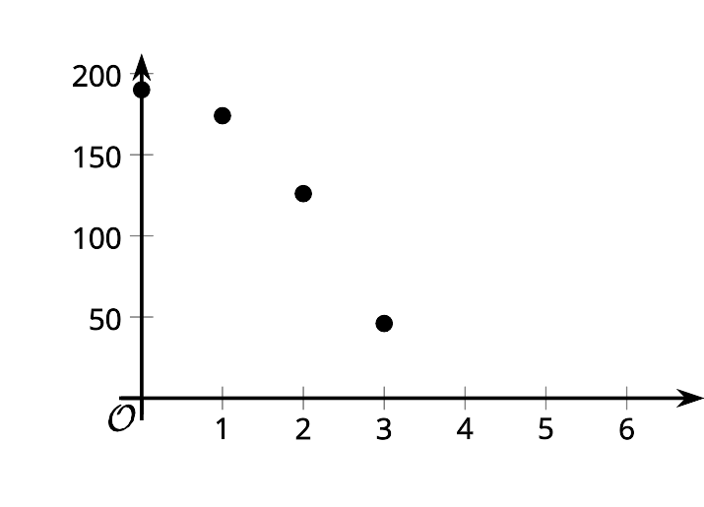
The expression that defines the distance from the ground as a function of time is $190−16t^{2}$. It tells us that the cannonball's distance from the ground is 190 feet before it is dropped and has decreased by $16t^{2}$ when $t$ seconds have passed.
© CC BY 2019 by Illustrative Mathematics®

