Lesson 13: Center Day 2
- Let’s add and subtract and work with tens and ones.

Warm-up: Number Talk: Within 20
Find the value of each expression mentally.
- $10+4$
- $9+4$
- $9+6$
- $15–6$

13.1: Centers: Choice Time
Choose a center.
Grab and Count
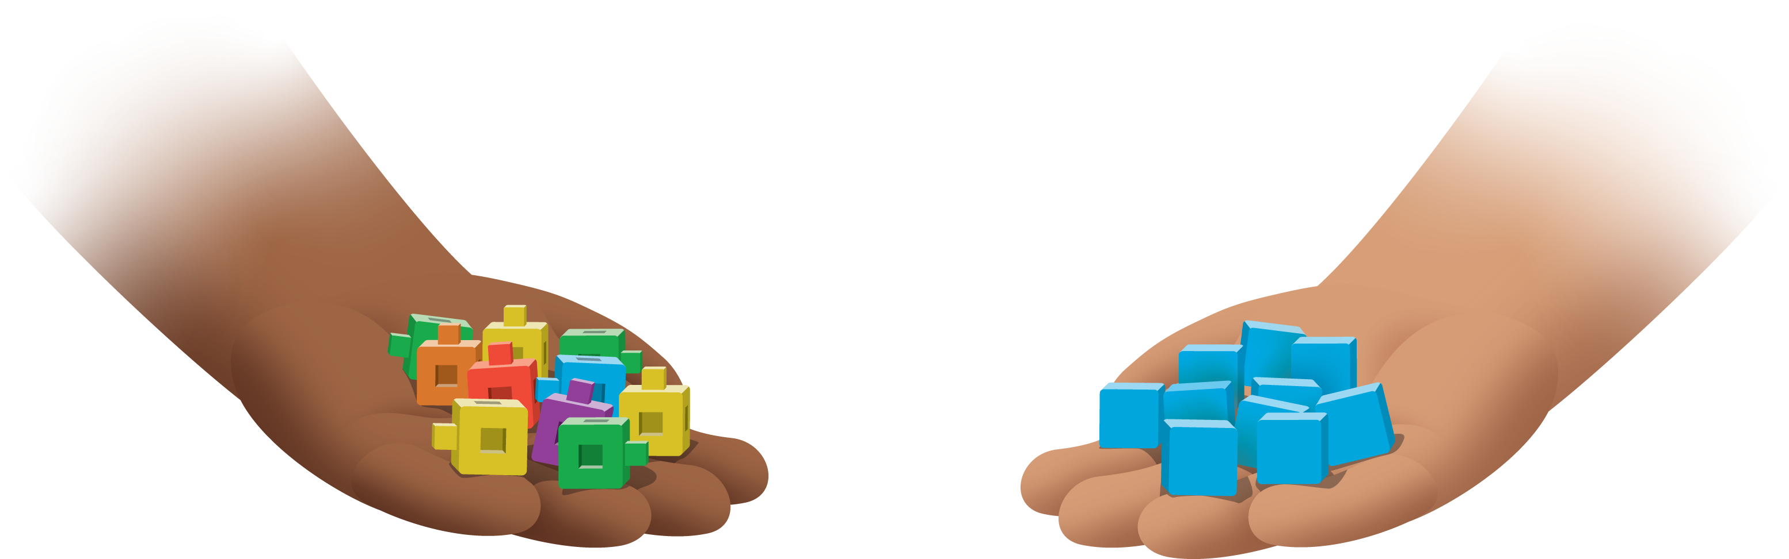
Five in a Row
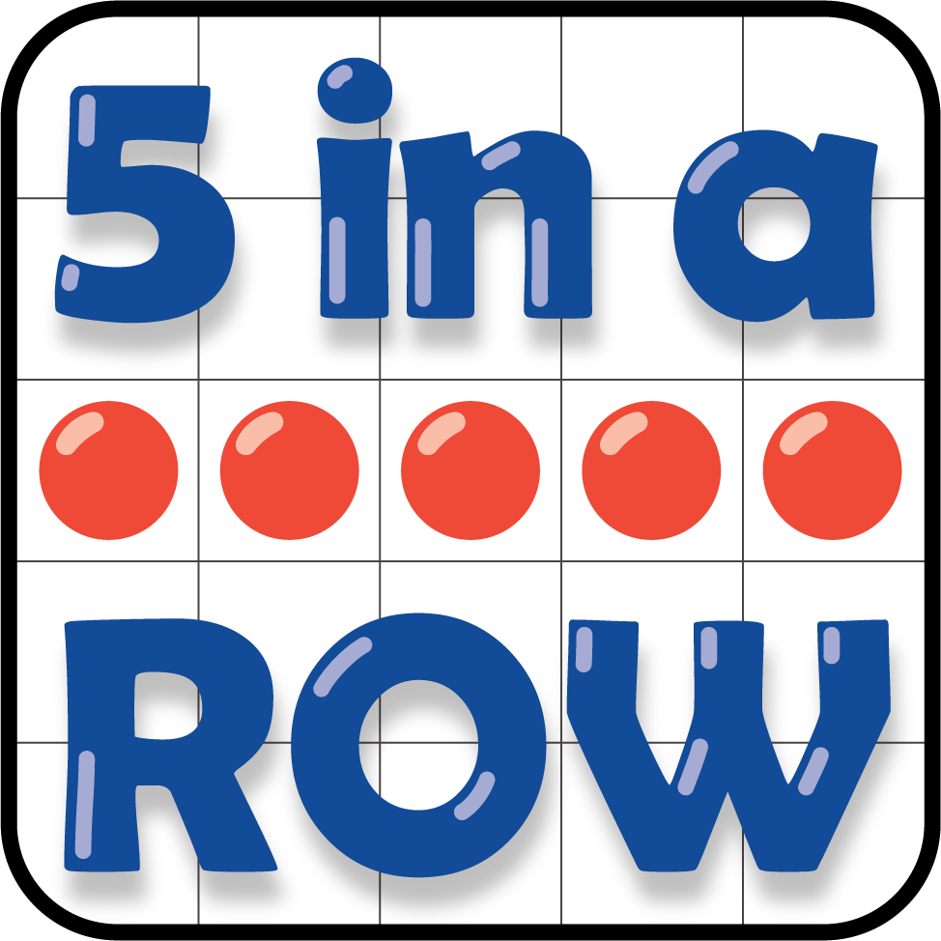
Check It Off

13.2: Centers Choice Time
Choose a center.
How Close?
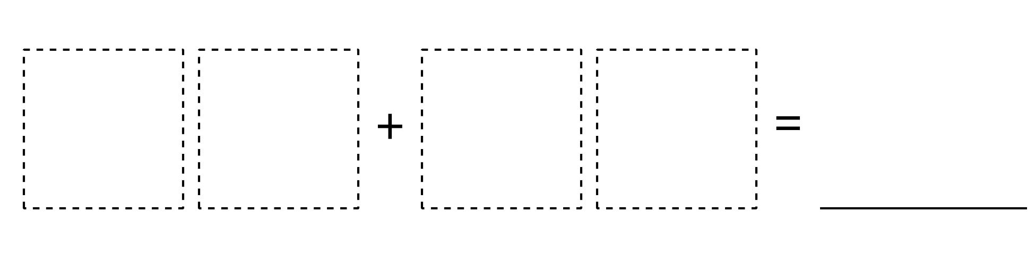
Number Puzzles
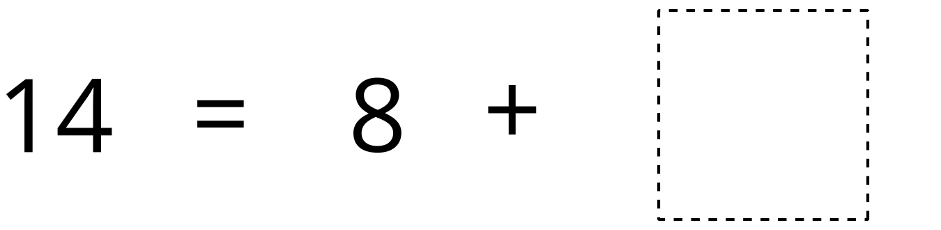
Shake and Spill
© CC BY 2021 Illustrative Mathematics®

