Unit 1 Lesson 21: Game Night Seating Plan

WU Notice and Wonder: Squares and Circles (Warm up)

Student Task Statement
What do you notice? What do you wonder?
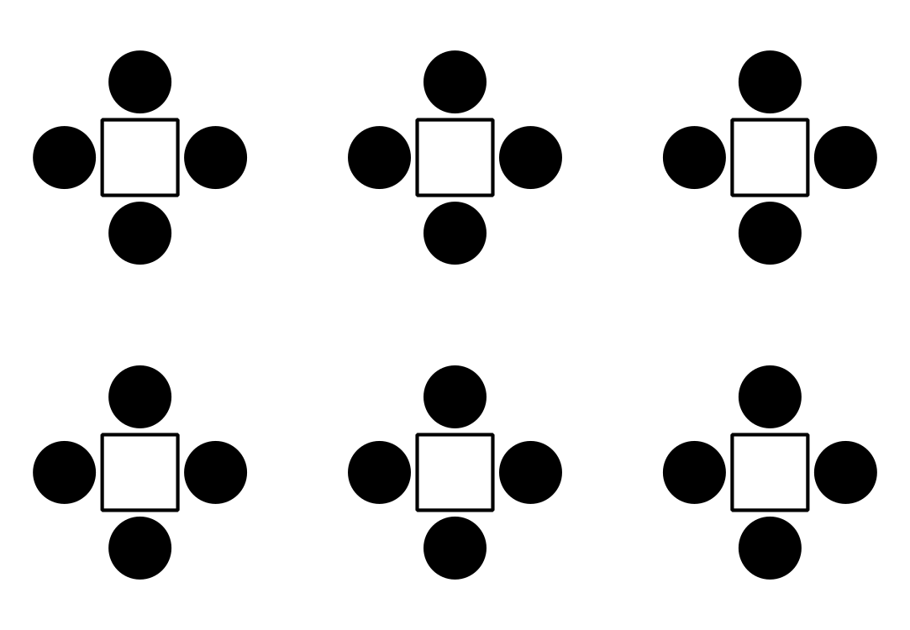

1 Game Night

Student Task Statement
Your club is planning a game night.
Guests can play one of four different games that require a different number of players:
- Game A - 2 players
- Game B - 4 players
- Game C - 5 players
- Game D - 10 players
The game room has 16 identical square tables, where one person can sit on each side.
- Make a seating plan that shows the table arrangement so that each guest can play one of the games.
- Make a poster that includes:
  - a seating chart
  - an explanation about how you decided on your seating plan
  - how many people can play games in the room with your seating plan

2 Game Night on a Graph

Student Task Statement
Make a scaled bar graph that shows the number of guests that can play each of the games A, B, C, and D.
Be sure to include:
- a title and other labels
- a scale that counts by a number other than 1
© CC BY 2021 Illustrative Mathematics®

