Unit 4 Lesson 15: Equal Groups, Larger Numbers

Which One Doesn’t Belong: Rectangles (Warm up)

Student Task Statement
Which one doesn’t belong?
A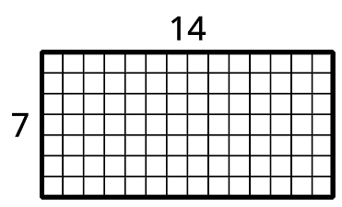
B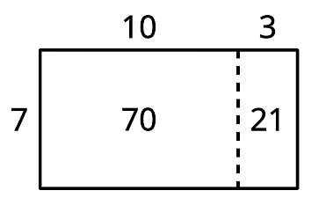
C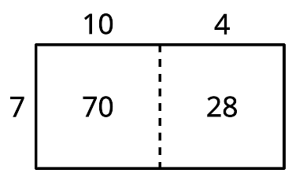
D

1 Equal Groups, Larger Numbers

Student Task Statement
Solve each problem. Explain or show your reasoning.
- Noah sees a large painted mural that has side lengths of 15 feet and 4 feet. What is the area of the mural?
- Noah’s family buys a mosaic that has 12 rows and 8 columns of 1 inch tiles. What is the area of the mosaic?
- At the art festival, Noah uses sidewalk chalk to help decorate a rectangular piece of sidewalk that is 6 feet by 14 feet. What is the area of the piece of sidewalk that Noah helped decorate?
- At the art festival, Noah buys a pack of stickers. There are 5 sheets and each sheet has 16 stickers. How many stickers are in the pack?

2 Gallery Walk: Equal Groups, Larger Numbers

Student Task Statement
As you visit the posters with your partner, discuss what is the same and what is different about the thinking shown on each poster.

Activity Synthesis
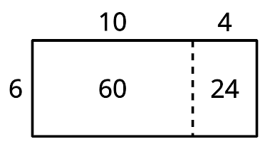
© CC BY 2021 Illustrative Mathematics®

