Lesson 6: Squares and Square Roots
- Let’s compare equations with squares and square roots.

6.1: Math Talk: Four Squares
Find the solutions of each equation mentally.
$x^{2}=4$
$x^{2}=2$
$x^{2}=0$
$x^{2}=\text{-}1$
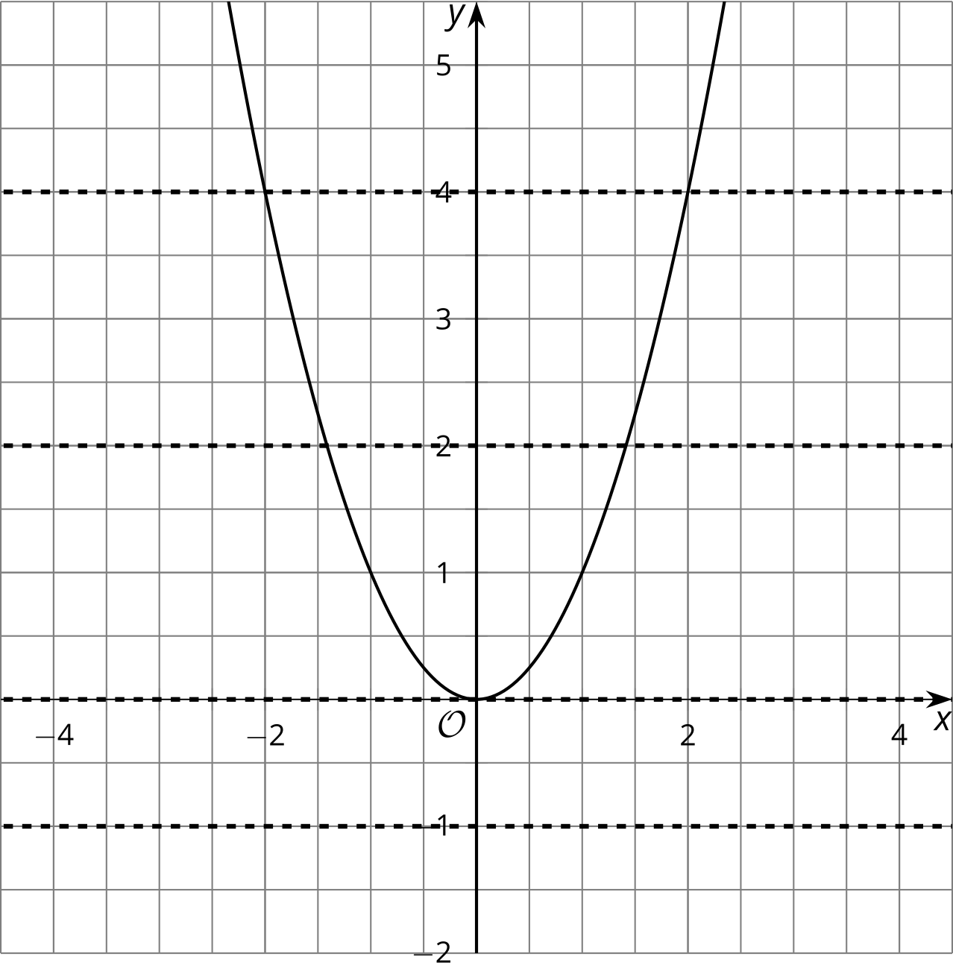

6.2: Finding Square Roots
Clare was adding $\sqrt{4}$ and $\sqrt{9}$, and at first she wrote $\sqrt{4}+\sqrt{9}=2+3$. But then she remembered that 2 and -2 both square to make 4, and that 3 and -3 both square to make 9. She wrote down all the possible combinations:
2 + 3 = 5
2 + (-3) = -1
(-2) + 3 = 1
(-2) + (-3) = -5
Then she wondered, “Which of these are the same as $\sqrt{4}+\sqrt{9}$? All of them? Or only some? Or just one?”
How would you answer Clare’s question? Give reasons that support your answer.

Are you ready for more?
- How many solutions are there to each equation?
  - $x^{3}=8$
  - $y^{3}=\text{-}1$
  - $z^{4}=16$
  - $w^{4}=\text{-}81$
- Write a rule to determine how many solutions there are to the equation $x^{n}=m$ where $n$ and $m$ are non-zero integers.

6.3: One Solution or Two?
- The graph of $b=\sqrt{a}$ is shown.
- 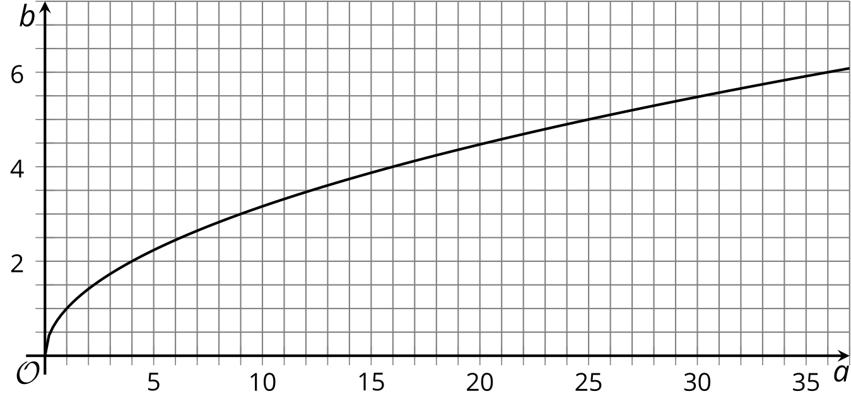
  - Complete the table with the exact values and label the corresponding points on the graph with the exact values.
- $a$ | - 1 | - 4 | - 9 | - 12 | - 16 | - 20
  - $\sqrt{a}$
  - Label the point on the graph that shows the solution to $\sqrt{a}=4$.
  - Label the point on the graph that shows the solution to $\sqrt{a}=5$.
  - Label the point on the graph that shows the solution to $\sqrt{a}=\sqrt{5}$.
- The graph of $t=s^{2}$ is shown.
  - Label the point(s) on the graph that show(s) the solution(s) to $s^{2}=25$.
  - Label the point(s) on the graph that show(s) the solution(s) to $\sqrt{t}=5$.
  - Label the point(s) on the graph that show(s) the solution(s) to $s^{2}=5$.

- 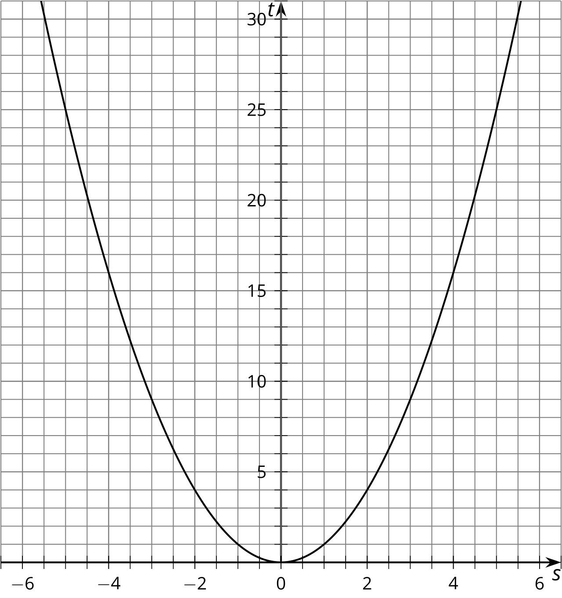

Lesson 6 Summary
The symbol $\sqrt{11}$ represents the positive square root of 11. If we want to represent the negative square root, we write $\text{-}\sqrt{11}$.
The equation $x^{2}=11$ has two solutions, because ${\sqrt{11}}^{2}=11$, and also${\left(\text{-}\sqrt{11}\right)}^{2}=11$.
The equation $\sqrt{x}=11$ only has one solution, namely 121.
The equation $\sqrt{x}=\sqrt{11}$ only has one solution, namely 11.
The equation $\sqrt{x}=\text{-}11$ doesn’t have any solutions, because the left side is positive and the right side is negative, which is impossible, because a positive number cannot equal a negative number.
© CC BY 2019 by Illustrative Mathematics®

