Unit 3 Lesson 1: Standard Units of Measure

WU What Do You Know About Measuring? (Warm up)

Student Task Statement
What do you know about measuring?

1 Priya’s Pet

Student Task Statement
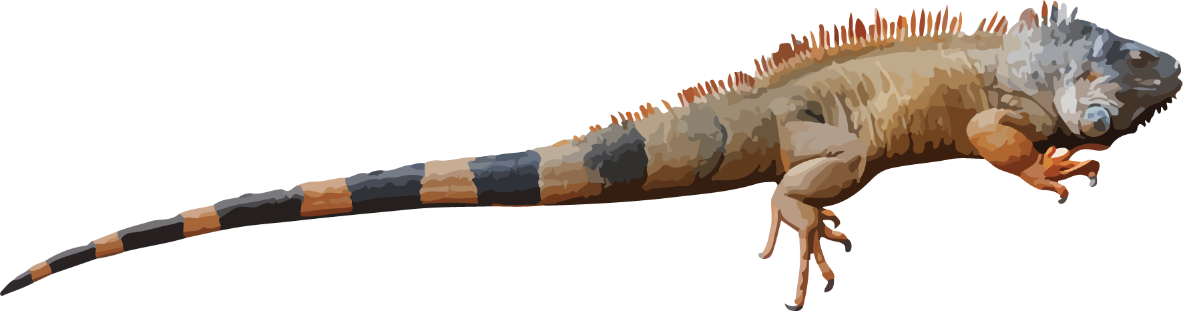
Use straws to measure the string that shows how long Priya's iguana is.
Priya’s iguana is ____________ straws long.

2 Use a Standard Unit

Student Task Statement
Use the cubes to measure Priya’s string.
- Priya’s iguana is ______ cubes long.
- Compare your measurement with another group.
© CC BY 2021 Illustrative Mathematics®

