Unit 6 Lesson 14: Interpreting Representations

1 Notice and Wonder: The Arrow (Warm up)

Student Task Statement
An archer shoots an arrow. The arrow’s height above level ground, in feet, is modeled by the equation $h(t)=(1+2t)(18−8t)$, and also represented by this graph and table. The time $t$ is measured in seconds.
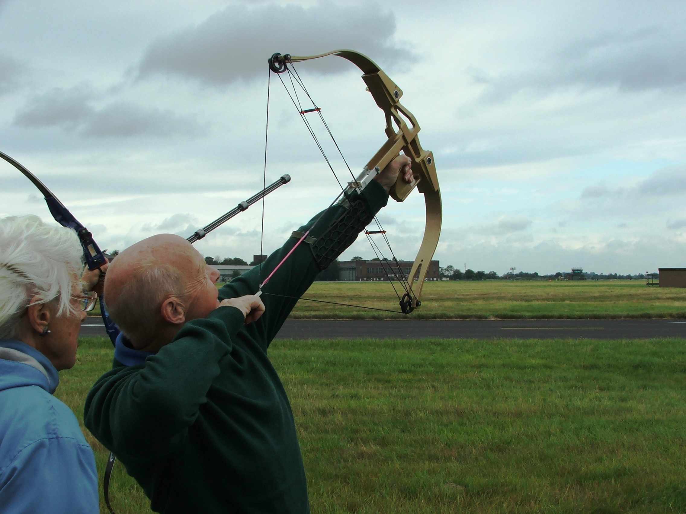
$t$ | 0 | 0.5 | 2 | 2.25
$h(t)$ | 18 | 28 | 10 | 0
What do you notice? What do you wonder?

2 Three Objects

Student Task Statement
Some different objects are launched into the air. The height of each object is modeled as a function of time in seconds.
- The height, in feet, of the first object is modeled by the function $d$ and represented by the graph.
- The height, in feet, of the second object is modeled by the function $f$ and represented by the table.
- $t$ | - 0 | - 0.25 | - 1 | - 1.75
- $f(t)$ | - 14 | - 18 | - 18 | - 0
- The height, in feet, of the third object is given by the equation $g(t)=(16t+4)(2.5−t)$.
- For each object, from what height was it launched?
- For each object, how long was it in flight before it hit the ground?
- For each object, what was its maximum height and when did it reach its maximum height? If needed, give your best estimate.

3 Comparing Two Situations with Different Representations

Student Task Statement
Two objects are thrown into the air. The height of object M in meters is modeled by the function $m(x)=(5+10x)(1.5−x)$. The height of object P in meters is modeled by the function $p$, represented by the graph.
- For each object, determine:
  - the time at which the object hit the ground
  - the height from which the object was thrown
  - the maximum height of the object
  - the time at which the object reached its maximum height
- Which object was launched from a greater height? Explain your reasoning.
- Which object hit the ground first? Explain your reasoning.
- Which object reached a greater maximum height? Explain your reasoning.
© CC BY 2019 by Illustrative Mathematics®

