Unit 2 Lesson 6 Cumulative Practice Problems
- A particular shade of orange paint has 2 cups of yellow paint for every 3 cups of red paint. On the double number line, circle the numbers of cups of yellow and red paint needed for 3 batches of orange paint.
- 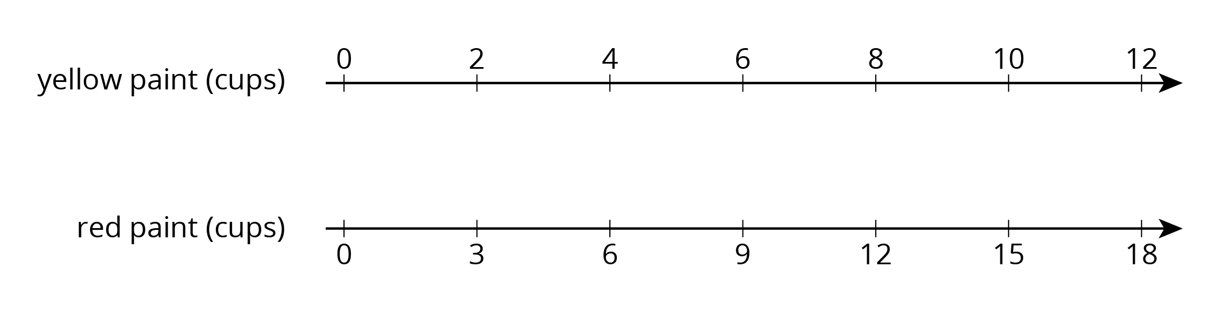
- This double number line diagram shows the amount of flour and eggs needed for 1 batch of cookies.
  - Complete the diagram to show the amount of flour and eggs needed for 2, 3, and 4 batches of cookies.
  - What is the ratio of cups of flour to eggs?
  - How much flour and how many eggs are used in 4 batches of cookies?
  - How much flour is used with 6 eggs?
  - How many eggs are used with 15 cups of flour?
- Here is a representation showing the amount of red and blue paint that make 2 batches of purple paint.
  - On the double number line, label the tick marks to represent amounts of red and blue paint used to make batches of this shade of purple paint.
- 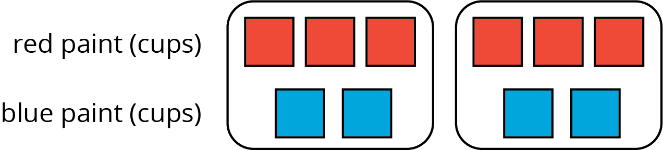
  - How many batches are made with 12 cups of red paint?
  - How many batches are made with 6 cups of blue paint?
- 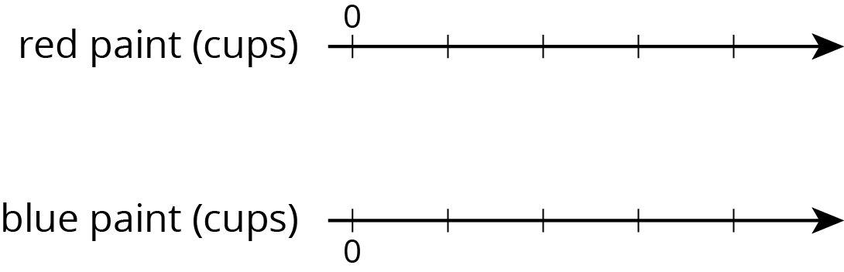
- Diego estimates that there will need to be 3 pizzas for every 7 kids at his party. Select all the statements that express this ratio.
  - The ratio of kids to pizzas is $7:3$.
  - The ratio of pizzas to kids is 3 to 7.
  - The ratio of kids to pizzas is $3:7$.
  - The ratio of pizzas to kids is 7 to 3.
  - For every 7 kids there need to be 3 pizzas.
- (From Unit 2, Lesson 1.)
  - Draw a parallelogram that is not a rectangle that has an area of 24 square units. Explain or show how you know the area is 24 square units.
  - Draw a triangle that has an area of 24 square units. Explain or show how you know the area is 24 square units.
- (From Unit 1, Lesson 6.)
© CC BY Open Up Resources. Adaptations CC BY IM.

