Lesson 20: ¿Cuánto hay en el grupo? (Optional)

Standards Alignments
Addressing | 5.NF.B.7.b

Teacher-facing Learning Goals
- Represent and solve problems involving division of a whole number by a unit fraction.

Student-facing Learning Goals
- Resolvamos más problemas en los que se multiplica y se divide con fracciones.

Lesson Purpose
The purpose of this lesson is for students to solve fraction division problems that ask: “How many in one group?”
In this optional lesson, students solve problems where a whole number quantity is a unit fraction of an unknown whole number. In these situations students may rely on their understanding of the relationship between multiplication and division. For example, if 8 ounces is $\frac{1}{4}$ of the amount of water in a bottle, students might represent this with a tape diagram:
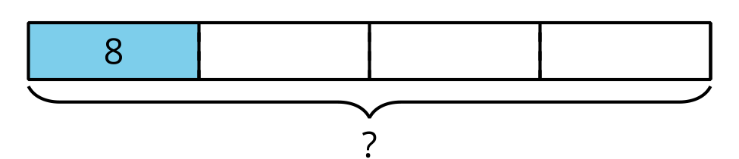
The tape diagram suggests the equation $8=\frac{1}{4}×?$ which students will likely solve by seeing that $?=4×8$. The equation $8=\frac{1}{4}×?$ can also be written using division with the equation $?÷4=8$.

Access for:

Students with Disabilities
- Engagement (Activity 2)

English Learners
- MLR8 (Activity 1)

Instructional Routines
Estimation Exploration (Warm-up)

Lesson Timeline
Warm-up | 10 min
Activity 1 | 20 min
Activity 2 | 10 min
Activity 3 | 10 min
Lesson Synthesis | 10 min
Cool-down | 5 min

Teacher Reflection Question
What do you love most about math? How are you sharing that joy with your students and encouraging them to think about what they love about math?

Cool-down
(to be completed at the end of the lesson) 5min
Camino a la escuela

Standards Alignments
Addressing | 5.NF.B.7.b

Student-facing Task Statement

  - Si 2 millas son $\frac{1}{3}$ del camino a la escuela de Han, ¿qué tan largo es el camino completo a la escuela? Dibuja un diagrama y explica cómo razonaste.
  - Escribe una ecuación de división que represente esta situación.

Student Responses

  - The drive is 6 miles. The diagram shows each $\frac{1}{3}$ of the drive is 2 miles, and that makes the whole drive 6 miles long since it's 3 groups of 2.
  - 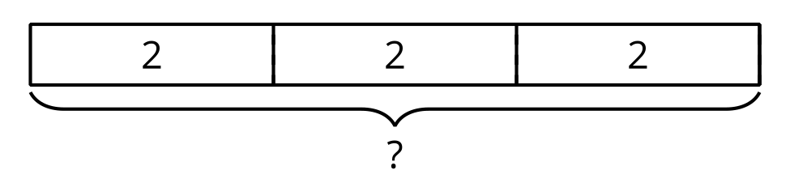
  - $2÷\frac{1}{3}=6$

