Unit 8 Lesson 7 Cumulative Practice Problems
- These two histograms show the number of text messages sent in one week by two groups of 100 students. The first histogram summarizes data from sixth-grade students. The second histogram summarizes data from seventh-grade students.
- 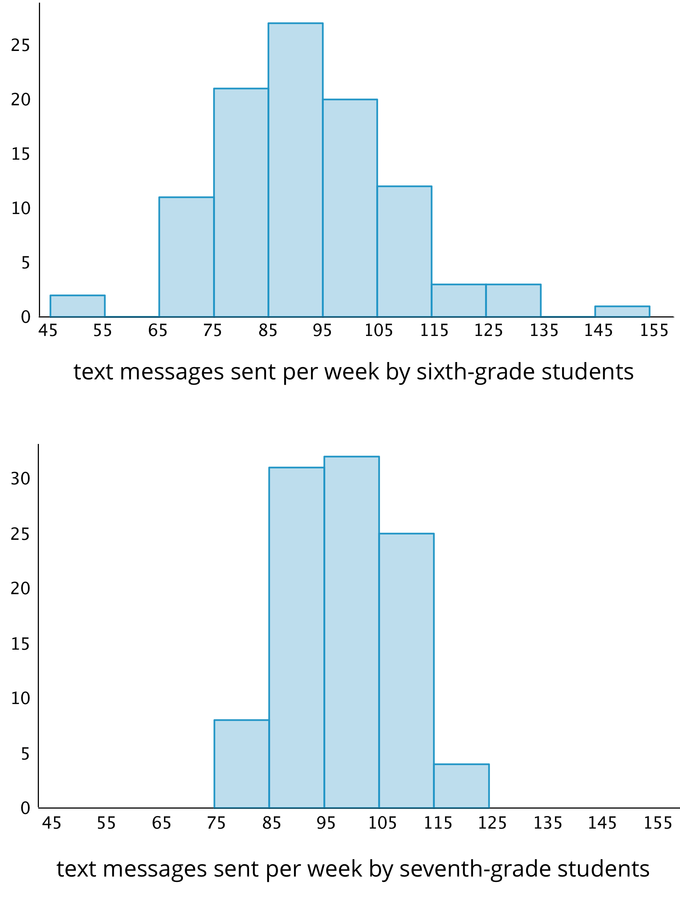
  - Do the two data sets have approximately the same center? If so, explain where the center is located. If not, which one has the greater center?
  - Which data set has greater spread? Explain your reasoning.
  - Overall, which group of students—sixth- or seventh-grade—sent more text messages?
- Forty sixth-grade students ran 1 mile. Here is a histogram that summarizes their times, in minutes. The center of the distribution is approximately 10 minutes.
- On the blank axes, draw a second histogram that has:
  - a distribution of times for a different group of 40 sixth-grade students.
  - a center at 10 minutes.
  - less variability than the distribution shown in the first histogram.
- 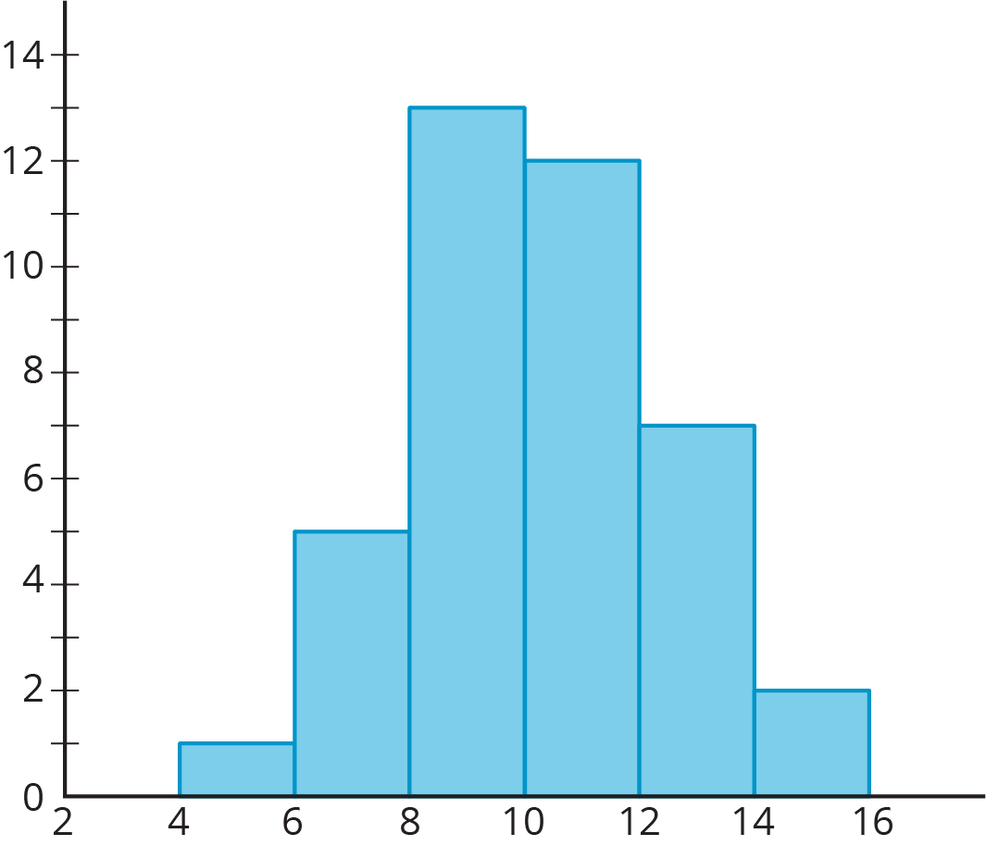
- 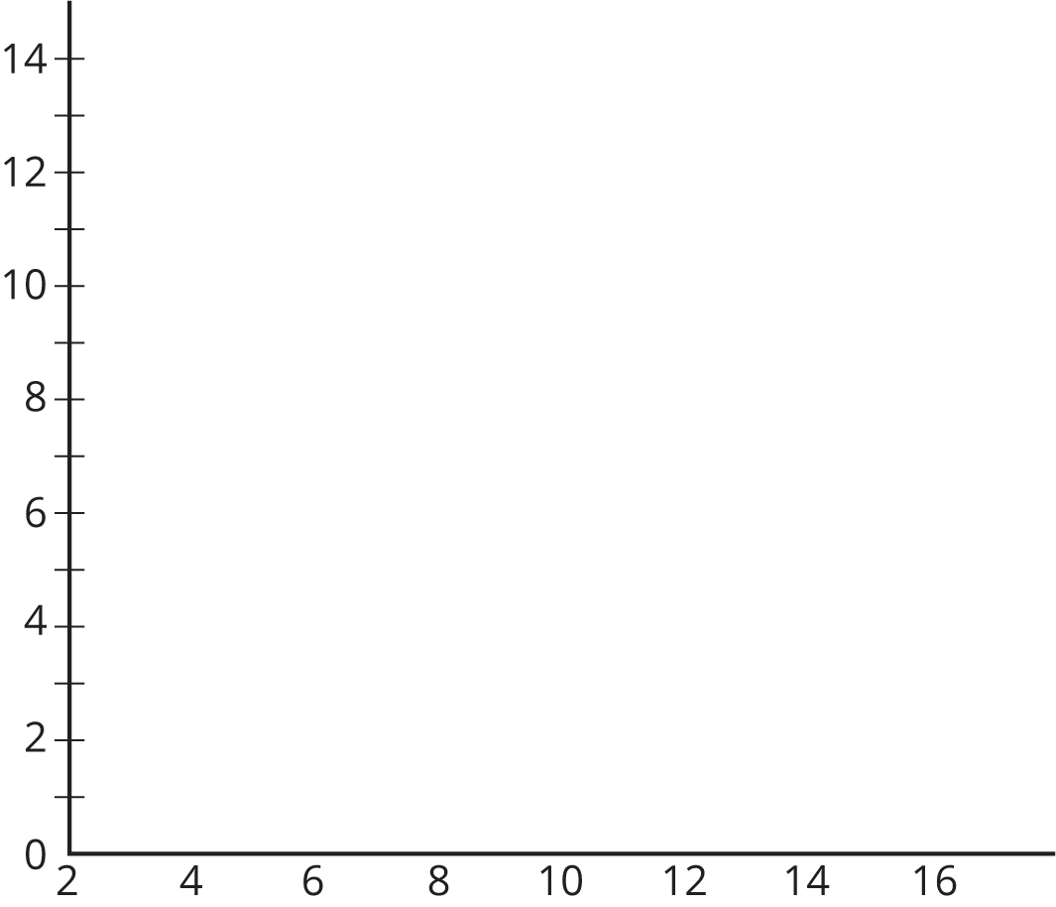
- Jada has $d$ dimes. She has more than 30 cents but less than a dollar.
  - Write two inequalities that represent how many dimes Jada has.
  - Can $d$ be 10?
  - How many possible solutions make both inequalities true? If possible, describe or list the solutions.
- (From Unit 7, Lesson 9.)
- Order these numbers from greatest to least: $\text{-}4$, $\frac{1}{4}$, 0, 4, $\text{-}3\frac{1}{2}$, $\frac{7}{4}$, $\text{-}\frac{5}{4}$
- (From Unit 7, Lesson 4.)
© CC BY Open Up Resources. Adaptations CC BY IM.

