Lesson 10 Practice Problems
- A student estimated that it would take 3 hours to write a book report, but it actually took her 5 hours. What is the percent error for her estimate?
- A radar gun measured the speed of a baseball at 103 miles per hour. If the baseball was actually going 102.8 miles per hour, what was the percent error in this measurement?
- It took 48 minutes to drive downtown. An app estimated it would be less than that. If the error was 20%, what was the app’s estimate?
- A farmer estimated that there were 25 gallons of water left in a tank. If this is an underestimate by 16%, how much water was actually in the tank?
- For each story, write an equation that describes the relationship between the two quantities.
  - Diego collected $x$ kg of recycling. Lin collected $\frac{2}{5}$ more than that.
  - Lin biked $x$ km. Diego biked $\frac{3}{10}$ less than that.
  - Diego read for $x$ minutes. Lin read $\frac{4}{7}$ of that.
- (From Unit 6, Lesson 1.)
- For each diagram, decide if $y$ is an increase or a decrease of $x$. Then determine the percentage.
- 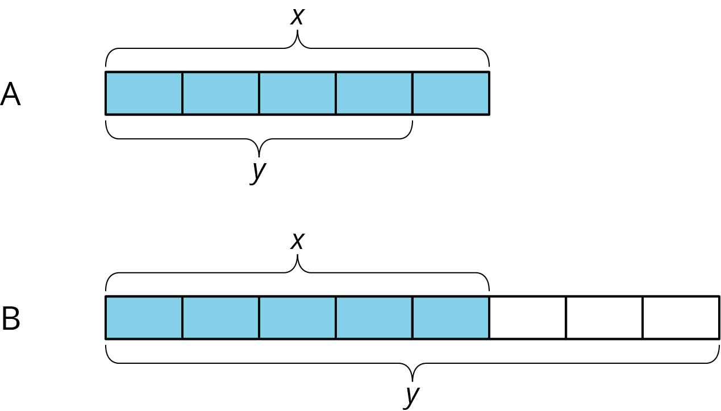

- (From Unit 6, Lesson 8.)
- Lin is making a window covering for a window that has the shape of a half circle on top of a square of side length 3 feet. How much fabric does she need?
- (From Unit 5, Lesson 19.)
© CC BY Open Up Resources. Adaptations CC BY IM.

