Unit 2 Lesson 13: Solving Systems by Substitution

1 Math Talk: Is It a Match? (Warm up)

Student Task Statement
Here are graphs of two equations in a system.
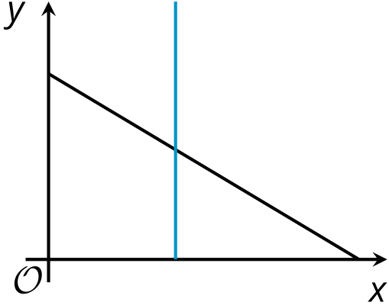
Determine if each of these systems could be represented by the graphs. Be prepared to explain how you know.
$\left\{\begin{matrix}x+2y=8 \\ x=\text{-}5\end{matrix}\right.$
$\left\{\begin{matrix}y=\text{-}7x+13 \\ y=\text{-}1\end{matrix}\right.$
$\left\{\begin{matrix}3x=8 \\ 3x+y=15\end{matrix}\right.$
$\left\{\begin{matrix}y=2x−7 \\ 4+y=12\end{matrix}\right.$

2 Four Systems

Student Task Statement
Here are four systems of equations you saw earlier. Solve each system. Then, check your solutions by substituting them into the original equations to see if the equations are true.
A$\left\{\begin{matrix}x+2y=8 \\ x=\text{-}5\end{matrix}\right.$
B$\left\{\begin{matrix}y=\text{-}7x+13 \\ y=\text{-}1\end{matrix}\right.$
C$\left\{\begin{matrix}3x=8 \\ 3x+y=15\end{matrix}\right.$
D$\left\{\begin{matrix}y=2x−7 \\ 4+y=12\end{matrix}\right.$

3 What about Now?

Student Task Statement
Solve each system without graphing.
$\left\{\begin{matrix}5x–2y=26 \\ y+4=x\end{matrix}\right.$
$\left\{\begin{matrix}2m–2p=\text{-}6 \\ p=2m+10\end{matrix}\right.$
$\left\{\begin{matrix}2d=8f \\ 18−4f=2d\end{matrix}\right.$
$\left\{\begin{matrix}w+\frac{1}{7}z=4 \\ z=3w–2\end{matrix}\right.$
© CC BY 2019 by Illustrative Mathematics®

