Lesson 20: Rational and Irrational Solutions
- Let’s consider the kinds of numbers we get when solving quadratic equations.

20.1: Rational or Irrational?
Numbers like -1.7, $\sqrt{16}$, and $\frac{5}{3}$ are known as rational numbers.
Numbers like $\sqrt{12}\text{ and }\sqrt{\frac{5}{9}}$ are known as irrational numbers.
Here is a list of numbers. Sort them into rational and irrational.
97 | -8.2 | $\sqrt{5}$ | $\text{-}\frac{3}{7}$ | $\sqrt{100}$ | $\sqrt{\frac{9}{4}}$ | $\text{-}\sqrt{18}$

20.2: Suspected Irrational Solutions
- Graph each quadratic equation using graphing technology. Identify the zeros of the function that the graph represents, and say whether you think they might be rational or irrational. Be prepared to explain your reasoning.
- equations | - zeros | - rational or irrational?
- $y=x^{2}−8$
- $y={\left(x−5\right)}^{2}−1$
- $y={\left(x−7\right)}^{2}−2$
- $y={\left(\frac{x}{4}\right)}^{2}−5$
- Find exact solutions (not approximate solutions) to each equation and show your reasoning. Then, say whether you think each solution is rational or irrational. Be prepared to explain your reasoning.
  - $x^{2}−8=0$
  - ${\left(x−5\right)}^{2}=1$
  - ${\left(x−7\right)}^{2}=2$
  - ${\left(\frac{x}{4}\right)}^{2}−5=0$

20.3: Experimenting with Rational and Irrational Numbers
Here is a list of numbers:
$2$ | $3$ | $\frac{1}{3}$ | $0$ | $\sqrt{2}$ | $\sqrt{3}$ | $\text{-}\sqrt{3}$ | $\frac{1}{\sqrt{3}}$

Here are some statements about the sums and products of numbers. For each statement, decide whether it is always true, true for some numbers but not others, or never true.
- Sums:
  - The sum of two rational numbers is rational.
  - The sum of a rational number and an irrational number is irrational.
  - The sum of two irrational numbers is irrational.
- Products:
  - The product of two rational numbers is rational.
  - The product of a rational number and an irrational number is irrational.
  - The product of two irrational numbers is irrational.
Experiment with sums and products of two numbers in the given list to help you decide.

Are you ready for more?
It can be quite difficult to show that a number is irrational. To do so, we have to explain why the number is impossible to write as a ratio of two integers. It took mathematicians thousands of years before they were finally able to show that $π$ is irrational, and they still don’t know whether or not $π^{π}$ is irrational.
Here is a way we could show that $\sqrt{2}$ can’t be rational, and is therefore irrational.
- Let's assume that $\sqrt{2}$ were rational and could be written as a fraction $\frac{a}{b}$, where $a$ and $b$ are non-zero integers.
- Let’s also assume that $a$ and $b$ are integers that no longer have any common factors. For example, to express 0.4 as $\frac{a}{b}$, we write $\frac{2}{5}$ instead of $\frac{4}{10}$ or $\frac{200}{500}$. That is, we assume that $a$ and $b$ are 2 and 5, rather than 4 and 10, or 200 and 500.
- If $\sqrt{2}=\frac{a}{b}$, then 2=300300.
- Explain why $a^{2}$ must be an even number.
- Explain why if $a^{2}$ is an even number, then $a$ itself is also an even number. (If you get stuck, consider squaring a few different integers.)
- Because $a$ is an even number, then $a$ is 2 times another integer, say, $k$. We can write $a=2k$. Substitute $2k$ for $a$ in the equation you wrote in the first question. Then, solve for $b^{2}$.
- Explain why the resulting equation shows that $b^{2}$, and therefore $b$, are also even numbers.
- We just arrived at the conclusion that $a$ and $b$ are even numbers, but given our assumption about $a$ and $b$, it is impossible for this to be true. Explain why this is.
If $a$ and $b$ cannot both be even,$\sqrt{2}$ must be equal to some number other than $\frac{a}{b}$.
Because our original assumption that we could write $\sqrt{2}$ as a fraction $\frac{a}{b}$ led to a false conclusion, that assumption must be wrong. In other words, we must not be able to write $\sqrt{2}$ as a fraction. This means $\sqrt{2}$ is irrational!

Lesson 20 Summary
The solutions to quadratic equations can be rational or irrational. Recall that:
- Rational numbers are fractions and their opposites. Numbers like 12, -3, $\frac{5}{3},\sqrt{25}$, -4.79, and $\sqrt{\frac{9}{16}}$ are rational. ($\sqrt{25}$ is a fraction, because it’s equal to $\frac{5}{1}$. The number -4.79 is the opposite of 4.79, which is $\frac{479}{100}$.)
- Any number that is not rational is irrational. Some examples are $\sqrt{2},π,\text{-}\sqrt{5}$, and $\sqrt{\frac{7}{2}}$. When an irrational number is written as a decimal, its digits do not stop or eventually make a repeating pattern, so a decimal can only approximate the value of the number.
How do we know if the solutions to a quadratic equation are rational or irrational?
If we solve a quadratic equation $ax^{2}+bx+c=0$ by graphing a corresponding function ($y=ax^{2}+bx+c$), sometimes we can tell from the $x$-coordinates of the $x$-intercepts. Other times, we can't be sure.
Let's solve $x^{2}−\frac{49}{100}=0$ and $x^{2}−5=0$ by graphing $y=x^{2}−\frac{49}{100}$ and $y=x^{2}−5$.
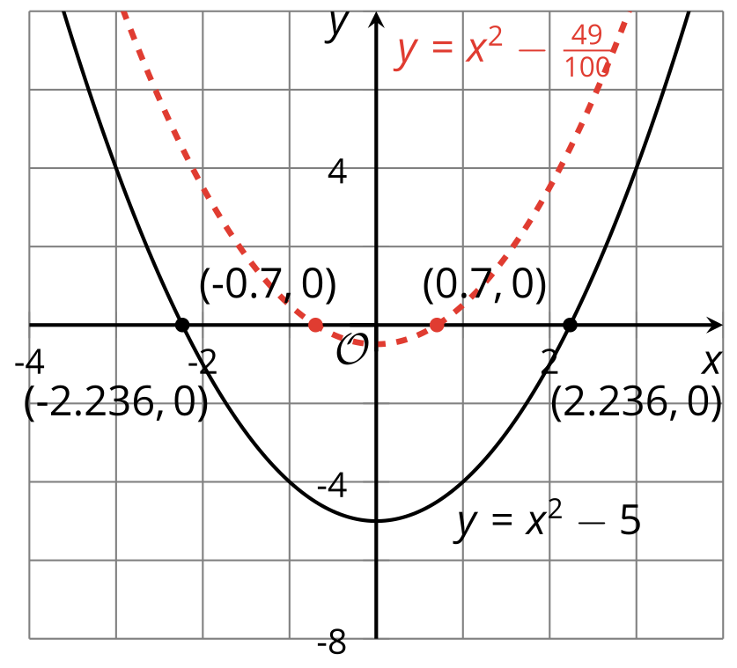
The graph of $y=x^{2}−\frac{49}{100}$ crosses the $x$-axis at -0.7 and 0.7. There are no digits after the 7, suggesting that the $x$-values are exactly $\text{-}\frac{7}{10}$ and $\frac{7}{10}$, which are rational.
To verify that these numbers are exact solutions to the equation, we can see if they make the original equation true.
${\left(0.7\right)}^{2}−\frac{49}{100}=0$ and ${\left(\text{-}0.7\right)}^{2}−\frac{49}{100}=0$, so $±0.7$ are exact solutions.
The graph of $y=x^{2}−5$, created using graphing technology, is shown to cross the $x$-axis at -2.236 and 2.236. It is unclear if the $x$-coordinates stop at three decimal places or if they continue. If they stop or eventually make a repeating pattern, the solutions would be rational. If they never stop or make a repeating pattern, the solutions would be irrational.
We can tell, though, that 2.236 is not an exact solution to the equation. Substituting 2.236 for $x$ in the original equation gives ${2.236}^{2}−5$, which we can tell is close to 0 but is not exactly 0. This means $±2.236$ are not exact solutions, and the solutions may be irrational.
To be certain whether the solutions are rational or irrational, we can solve the equations.
- The solutions to $x^{2}−\frac{49}{100}=0$ are $±0.7$, which are rational.
- The solutions to $x^{2}−5=0$ are $±\sqrt{5}$, which are irrational. (2.236 is an approximation of$\sqrt{5}$, not equal to $\sqrt{5}$.)
What about a solution like $\text{-}4+\sqrt{6}$, which is a sum of a rational number and an irrational one? Or a solution like $\frac{1}{5}\sqrt{3}$, which is a product of a rational number and an irrational number? Are they rational or irrational?
We will investigate solutions that are sums and products of different types of numbers in an upcoming lesson.
© CC BY 2019 by Illustrative Mathematics®

