Lesson 9: Side-Side-Side Triangle Congruence
- Let’s see if we can prove one more set of conditions that guarantee triangles are congruent, and apply theorems.

9.1: Dare to Be Different
Construct a triangle with the given side lengths on tracing paper.
Can you make a triangle that doesn’t look like anyone else’s?

9.2: Proving the Side-Side-Side Triangle Congruence Theorem
Priya was given this task to complete:
Use a sequence of rigid motions to take $STU$ onto $GHJ$. Given that segment $ST$ is congruent to segment $GH$, segment $TU$ is congruent to segment $HJ$, and segment $SU$ is congruent to segment $GJ$. For each step, explain how you know that one or more vertices will line up.
Help her finish the missing steps in her proof:
- $ST$ is the same length as $\underset{_}{}$, so they are congruent. Therefore, there is a rigid motion that takes $ST$ to $\underset{_}{}$.
- Apply this rigid motion to triangle $STU$. The image of $T$ will coincide with $\underset{_}{}$ , and the image of $S$ will coincide with $\underset{_}{}$.
- We cannot be sure that the image of $U$, which we will call $U^{′}$, coincides with $\underset{_}{}$ yet. If it does, then our rigid motion takes $STU$ to $GHJ$, proving that triangle $STU$ is congruent to triangle $GHJ$. If it does not, then we continue as follows.
- $HJ$ is congruent to the image of $\underset{_}{}$, because rigid motions preserve distance.
- Therefore, $H$ is equidistant from $U^{′}$ and $\underset{_}{}$.
- A similar argument shows that $G$ is equidistant from $U^{′}$ and $\underset{_}{}$ .
- $GH$ is the $\underset{_}{}$ of the segment connecting $U^{′}$ and $J$, because the $\underset{_}{}$ is determined by 2 points that are both equidistant from the endpoints of a segment.
- Reflection across the $\underset{_}{}$ of $U^{′}J$, takes $\underset{_}{}$ to $\underset{_}{}$.
- Therefore, after the reflection, all 3 pairs of vertices coincide, proving triangles $\underset{_}{}$ and $\underset{_}{}$ are congruent.
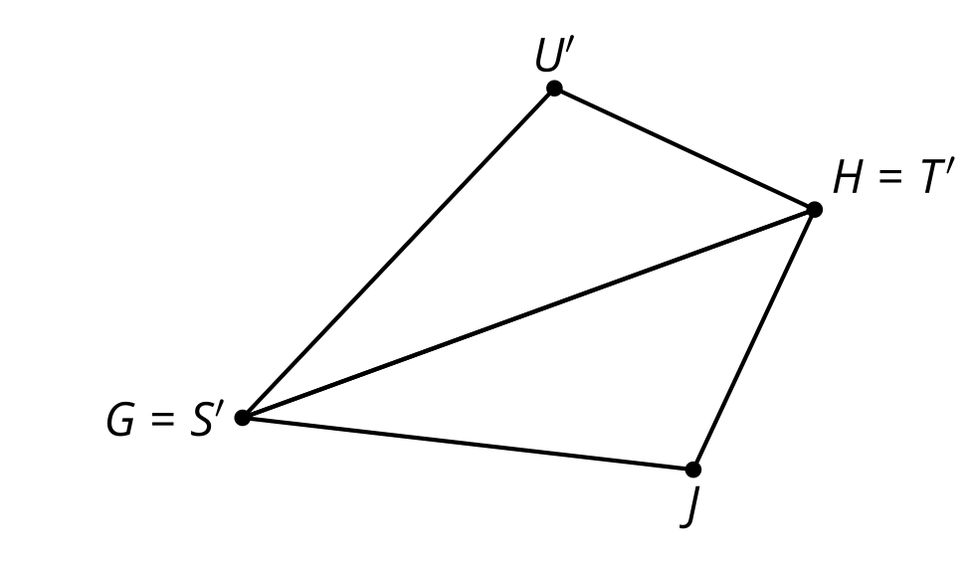
Now, help Priya by finishing a few-sentence summary of her proof. “To prove 2 triangles must be congruent if all 3 pairs of corresponding sides are congruent . . . .”

Are you ready for more?
It follows from the Side-Side-Side Triangle Congruence Theorem that, if the lengths of 3 sides of a triangle are known, then the measures of all the angles must also be determined. Suppose a triangle has two sides of length 4 cm.
- Use a ruler and protractor to make triangles and find the measure of the angle between those sides if the third side has these other measurements.
- Side Length of Third Side | - Angle Between First Two Sides
- 1 cm
- 2 cm
- 3 cm
- 4 cm
- 5 cm
- 6 cm
- 7 cm
- Do the side length and angle measures exhibit a linear relationship?

9.3: What Else Do We Know For Sure About Parallelograms?
Quadrilateral $ABCD$ is a parallelogram. By definition, that means that segment $AB$ is parallel to segment $CD$, and segment $BC$ is parallel to segment $AD$.
Prove that angle $B$ is congruent to angle $D$.
- Work on your own to make a diagram and write a rough draft of a proof.
- With your partner, discuss each other’s drafts.
  - What do you notice your partner understands about the problem?
  - What revision would help them move forward?
- Work together to revise your drafts into a clear proof that everyone in your class could follow and agree with.

Lesson 9 Summary
So far, we‘ve learned the Side-Angle-Side and Angle-Side-Angle Triangle Congruence Theorems. Sometimes, we don’t have any information about corresponding pairs of angle measures in triangles. In this case, use the Side-Side-Side Triangle Congruence Theorem: In 2 triangles, if all 3 pairs of corresponding sides are congruent, then the triangles must be congruent.
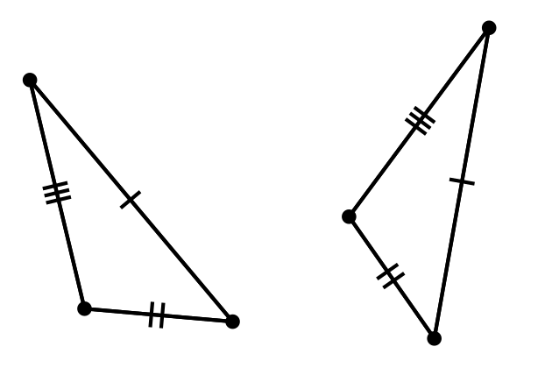
To prove that 2 triangles are congruent, look at the diagram and given information and think about whether it will be easier to find pairs of corresponding angles that are congruent or pairs of corresponding sides that are congruent. Then, check to see if all the information matches the Angle-Side-Angle, Side-Angle-Side, or Side-Side-Side Triangle Congruence Theorem.
© CC BY 2019 by Illustrative Mathematics®

