Lesson 11 Practice Problems
- Compare the weights of the backpacks for the students in these three classes.
- 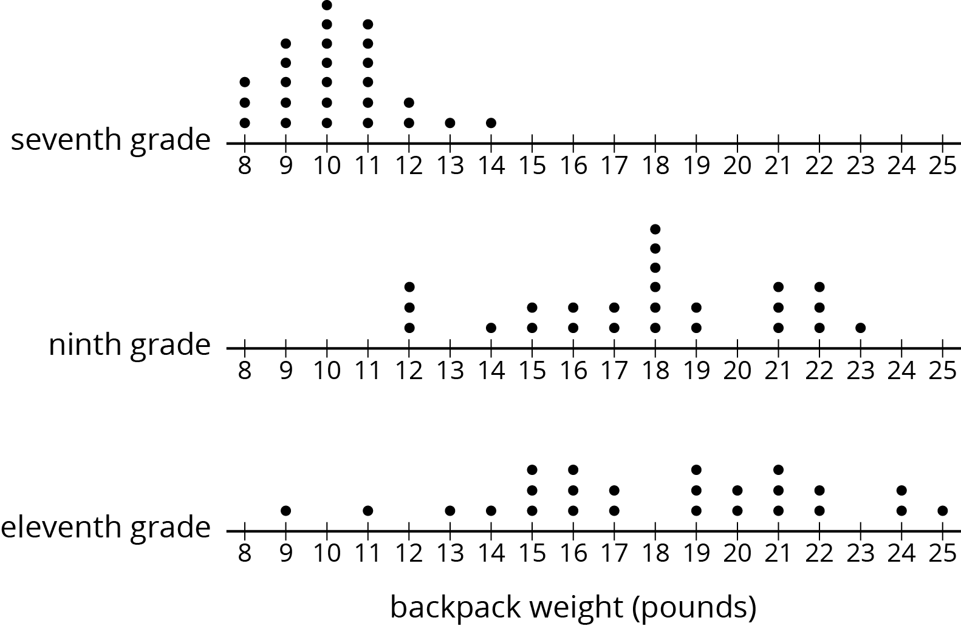

- A bookstore has marked down the price for all the books in a certain series by 15%.
  - How much is the discount on a book that normally costs $18.00?
  - After the discount, how much would the book cost?
- (From Unit 4, Lesson 11.)
- Match each expression in the first list with an equivalent expression from the second list.
  - $6\left(x+2y\right)−2\left(y−2x\right)$
  - $2.5\left(2x+4y\right)−5\left(4y−x\right)$
  - $4\left(5x−3y\right)−10x+6y$
  - $5.5\left(x+y\right)−2\left(x+y\right)+6.5\left(x+y\right)$
  - $7.9\left(5x+3y\right)−4.2\left(5x+3y\right)−1.7\left(5x+3y\right)$
  - $10\left(x−y\right)$
  - $10\left(x+y\right)$
  - $10x+6y$
  - $10x−6y$
- (From Unit 6, Lesson 22.)
- Angles $C$ and $D$ are complementary. The ratio of the measure of Angle $C$ to the measure of Angle $D$ is $2:3$. Find the measure of each angle. Explain or show your reasoning.
- (From Unit 7, Lesson 2.)
© CC BY Open Up Resources. Adaptations CC BY IM.

