Unit 8 Lesson 4 Cumulative Practice Problems
- Clare recorded the amounts of time spent doing homework, in hours per week, by students in sixth, eighth, and tenth grades. She made a dot plot of the data for each grade and provided the following summary.
  - Students in sixth grade tend to spend less time on homework than students in eighth and tenth grades.
  - The homework times for the tenth-grade students are more alike than the homework times for the eighth-grade students.
- Use Clare's summary to match each dot plot to the correct grade (sixth, eighth, or tenth).
- 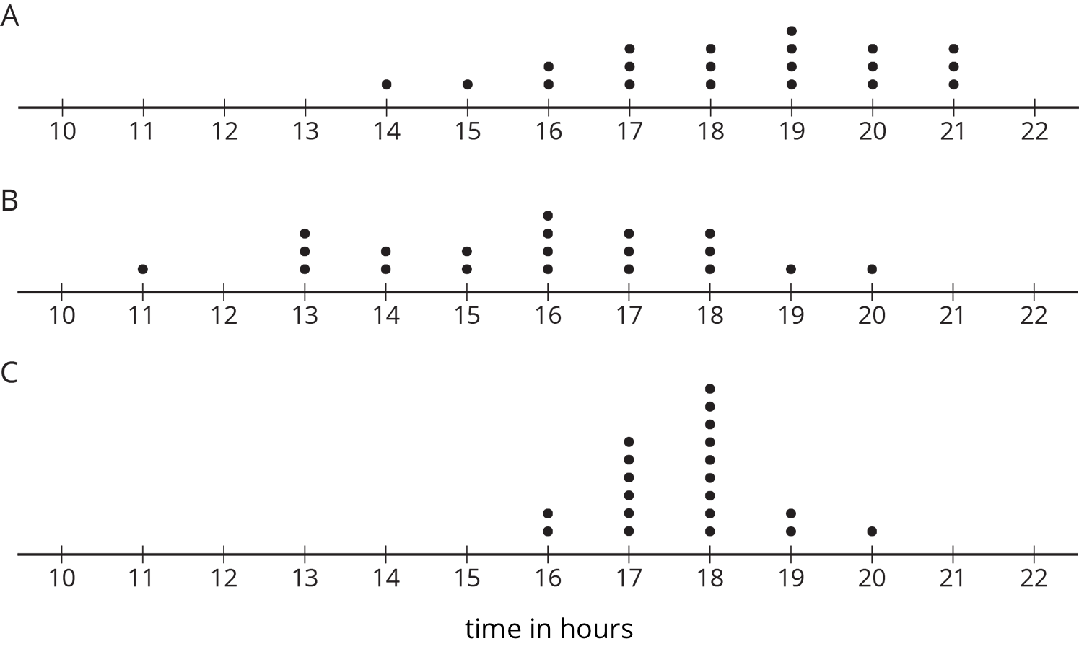
- Mai played 10 basketball games. She recorded the number of points she scored and made a dot plot. Mai said that she scored between 8 and 14 points in most of the 10 games, but one game was exceptional. During that game she scored more than double her typical score of 9 points. Use the number line to make a dot plot that fits the description Mai gave.
- 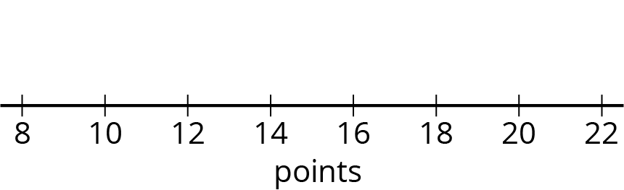
- A movie theater is showing three different movies. The dot plots represent the ages of the people who were at the Saturday afternoon showing of each of these movies.
- 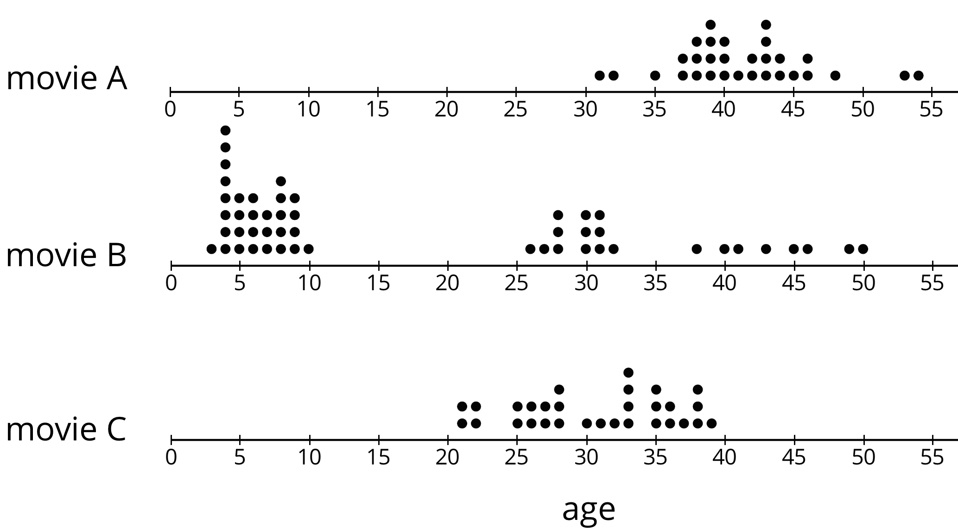
  - One of these movies was an animated movie rated G for general audiences. Do you think it was movie A, B, or C? Explain your reasoning.
  - Which movie has a dot plot with ages that that center at about 30 years?
  - What is a typical age for the people who were at Movie A?
- Find the value of each expression.
  - $3.727+1.384$
  - $3.727−1.384$
  - $5.01⋅4.8$
  - $5.01÷4.8$
- (From Unit 5, Lesson 13.)
© CC BY Open Up Resources. Adaptations CC BY IM.

