Lesson 15: Solving Systems by Elimination (Part 2)
- Let’s think about why adding and subtracting equations works for solving systems of linear equations.

15.1: Is It Still True?
Here is an equation: $50+1=51$.
- Perform each of the following operations and answer these questions: What does each resulting equation look like? Is it still a true equation?
  - Add 12 to each side of the equation.
  - Add $10+2$ to the left side of the equation and 12 to the right side.
  - Add the equation $4+3=7$ to the equation $50+1=51$.
- Write a new equation that, when added to $50+1=51$, gives a sum that is also a true equation.
- Write a new equation that, when added to $50+1=51$, gives a sum that is a false equation.

15.2: Classroom Supplies
A teacher purchased 20 calculators and 10 measuring tapes for her class and paid $495. Later, she realized that she didn’t order enough supplies. She placed another order of 8 of the same calculators and 1 more of the same measuring tape and paid $178.50.
This system represents the constraints in this situation:
$\left\{\begin{matrix}\begin{matrix}20c+10m & =495 \\ 8c+ m & =178.50\end{matrix}\end{matrix}\right.$
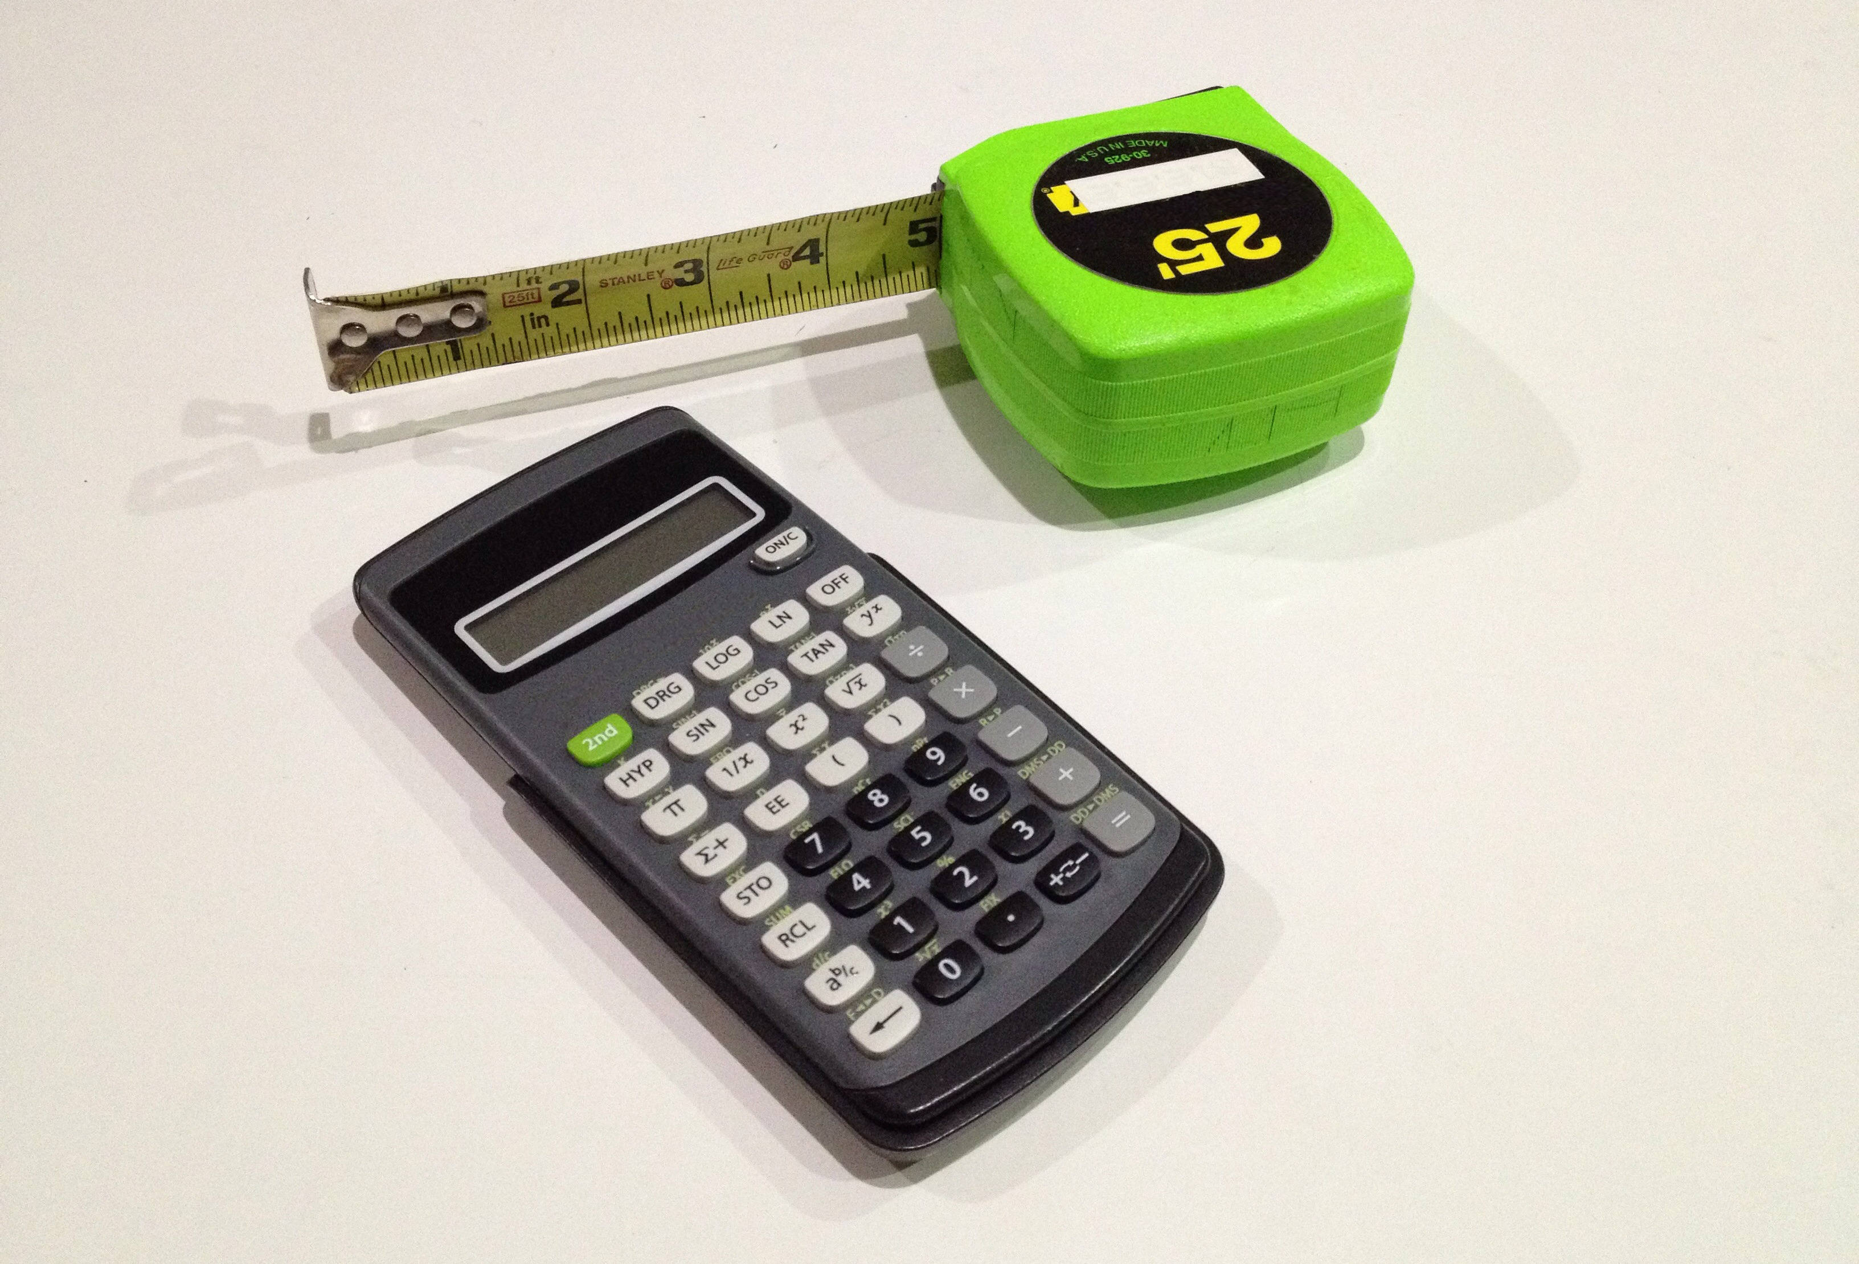
- Discuss with a partner:
  - In this situation, what do the solutions to the first equation mean?
  - What do the solutions to the second equation mean?
  - For each equation, how many possible solutions are there? Explain how you know.
  - In this situation, what does the solution to the system mean?
- Find the solution to the system. Explain or show your reasoning.
- To be reimbursed for the cost of the supplies, the teacher recorded: “Items purchased: 28 calculators and 11 measuring tapes. Amount: $673.50.”
  - Write an equation to represent the relationship between the numbers of calculators and measuring tapes, the prices of those supplies, and the total amount spent.
  - How is this equation related to the first two equations?
  - In this situation, what do the solutions of this equation mean?
  - How many possible solutions does this equation have? How many solutions make sense in this situation? Explain your reasoning.

15.3: A Bunch of Systems
Solve each system of equations without graphing and show your reasoning. Then, check your solutions.
A$\left\{\begin{matrix}\begin{matrix}2x+3y & = 7 \\ \text{-}2x+4y & =14\end{matrix}\end{matrix}\right.$
B$\left\{\begin{matrix}\begin{matrix}2x+3y & = 7 \\ 3x−3y & =3\end{matrix}\end{matrix}\right.$
C$\left\{\begin{matrix}\begin{matrix}2x+3y & =5 \\ 2x+4y & =9\end{matrix}\end{matrix}\right.$
D$\left\{\begin{matrix}\begin{matrix}2x+3y & =16 \\ 6x−5y & =20\end{matrix}\end{matrix}\right.$

Are you ready for more?
This system has three equations: $\left\{\begin{matrix}3x+2y−z=7 \\ \text{-}3x+y+2z=\text{-}14 \\ 3x+y−z=10\end{matrix}\right.$
- Add the first two equations to get a new equation.
- Add the second two equations to get a new equation.
- Solve the system of your two new equations.
- What is the solution to the original system of equations?

Lesson 15 Summary
When solving a system with two equations, why is it acceptable to add the two equations, or to subtract one equation from the other?
Remember that an equation is a statement that says two things are equal. For example, the equation $a=b$ says a number $a$ has the same value as another number $b$. The equation $10+2=12$ says that $10+2$ has the same value as 12.
If $a=b$ and $10+2=12$ are true statements, then adding $10+2$ to $a$ and adding $12$ to $b$ means adding the same amount to each side of $a=b$. The result, $a+10+2=b+12$, is also a true statement.
As long as we add an equal amount to each side of a true equation, the two sides of the resulting equation will remain equal.
We can reason the same way about adding variable equations in a system like this:
$\left\{\begin{matrix}\begin{matrix}e+f=17 \\ \text{-}2e+f=\text{-}1\end{matrix}\end{matrix}\right.$
In each equation, if $(e,f)$ is a solution, the expression on the left of the equal sign and the number on the right are equal. Because $\text{-}2e+f$ is equal to -1:
- Adding $\text{-}2e+f$ to $e+f$ and adding -1 to 17 means adding an equal amount to each side of $e+f=17$. The two sides of the new equation, $\text{-}e+2f=16$, stay equal.
- The $e$- and $f$-values that make the original equations true also make this equation true.
$\begin{matrix}e+ f & =17 \\ \text{-}2e+ f & = \text{-}1 + \\ \overline{ \text{-}e+2f} & \overline{ =16}\end{matrix}$
- Subtracting $\text{-}2e+f$ from $e+f$ and subtracting -1 from 17 means subtracting an equal amount from each side of $e+f=17$. The two sides of the new equation, $3e=18$, stay equal.
- The $f$-variable is eliminated, but the $e$-value that makes both the original equations true also makes this equation true.
$\begin{matrix}e+ f & =17 \\ \text{-}2e+ f & = \text{-}1 − \\ \overline{ 3e } & \overline{ =18}\end{matrix}$
From $3e=18$, we know that $e=6$. Because 6 is also the $e$-value that makes the original equations true, we can substitute it into one of the equations and find the $f$-value.
The solution to the system is $e=6,f=11$, or the point $(6,11)$ on the graphs representing the system. If we substitute 6 and 11 for $e$ and $f$ in any of the equations, we will find true equations. (Try it!)
© CC BY 2019 by Illustrative Mathematics®

