Lesson 11: Make Sense of Decimal Addition
- Let’s add decimals.

Warm-up: How Many Do You See: Grids
How many do you see? How do you see them?
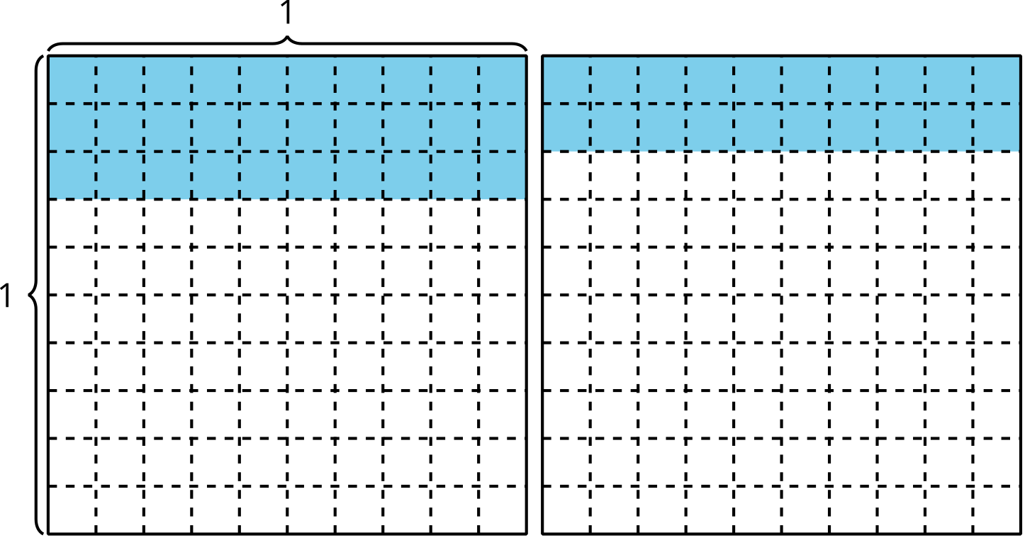
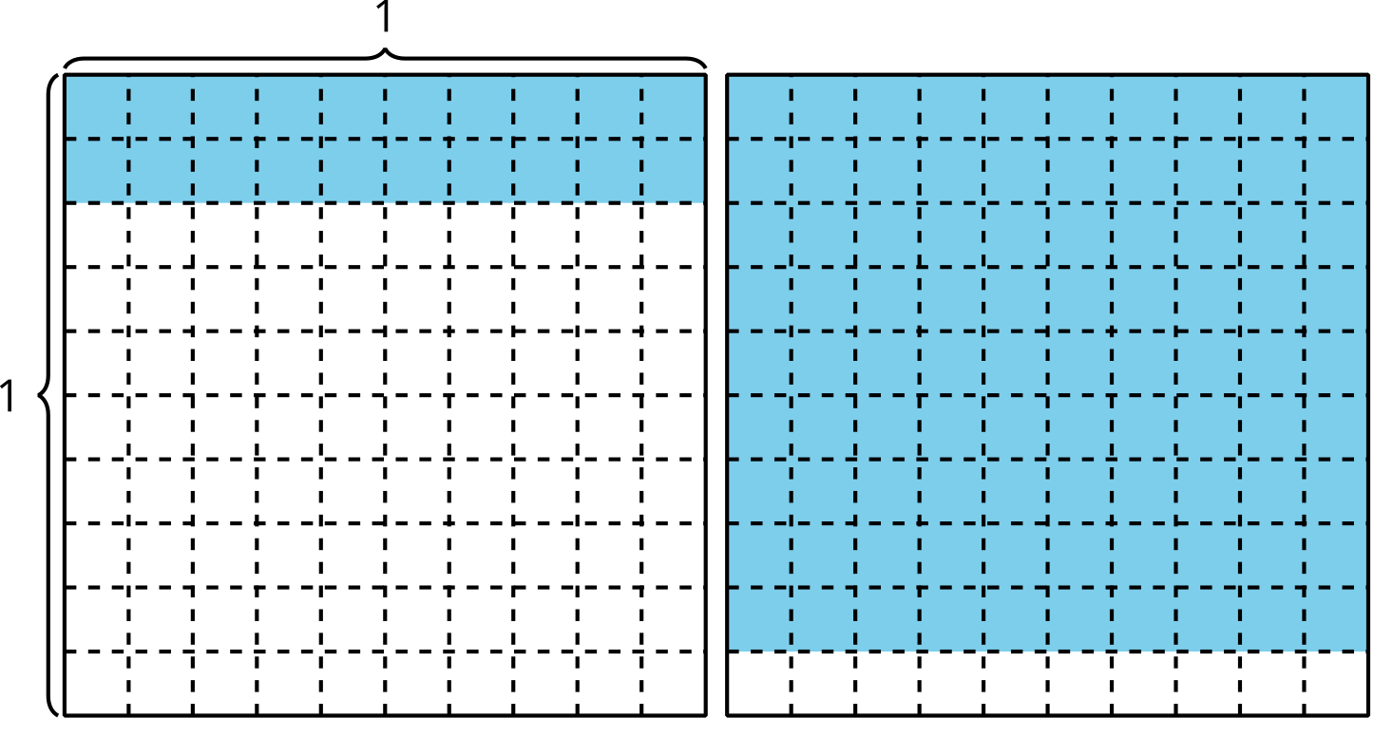
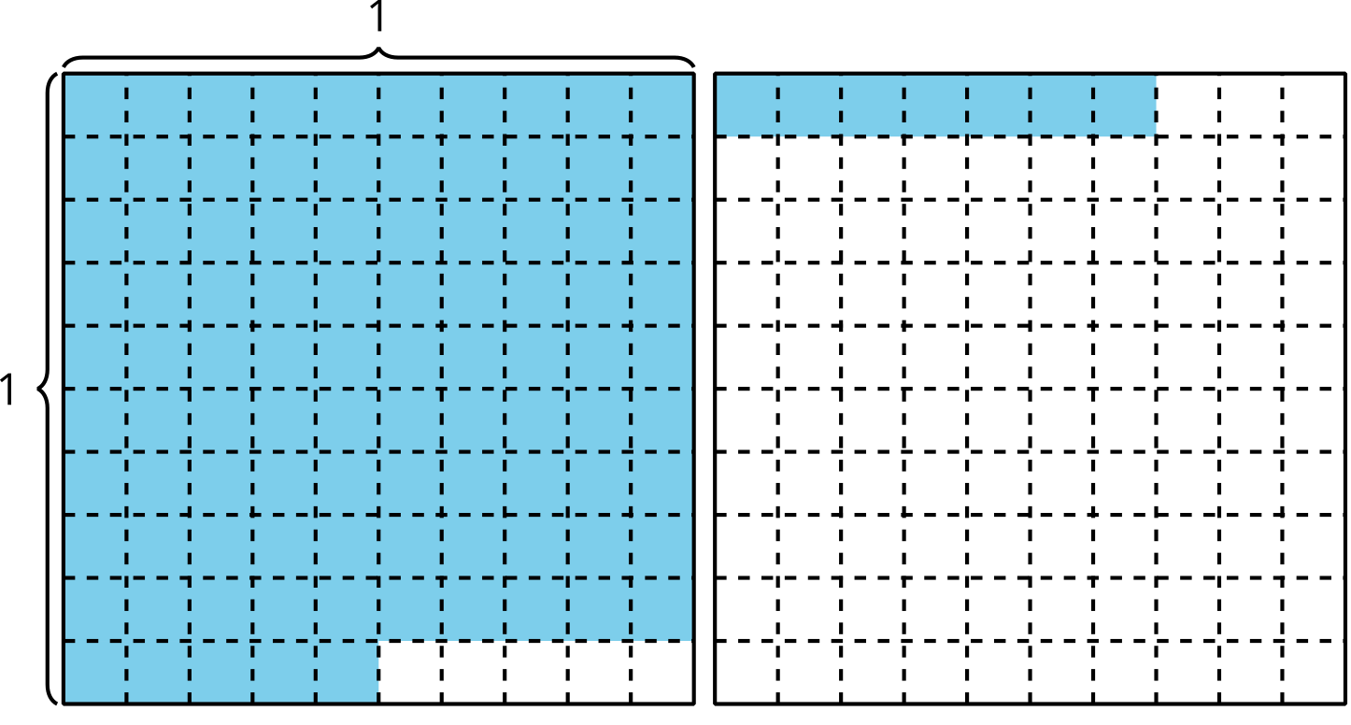
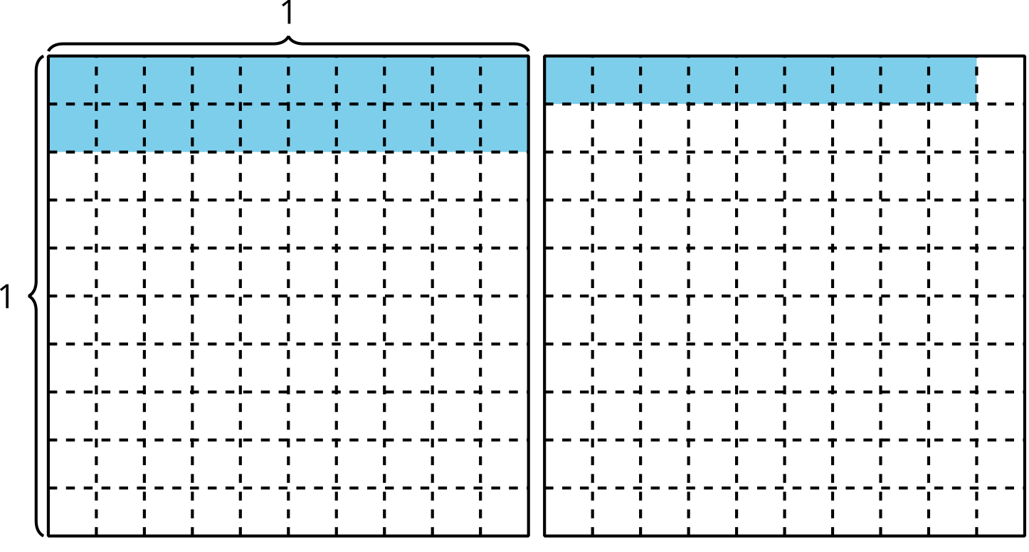

11.1: The Sum
- Find the value of the expression. Show your thinking. Organize it so it can be followed by others.
- $2.26+1.87$
- What questions do you have about adding decimals?

11.2: Target Numbers: Add Tenths or Hundredths
Directions:
- Play one round of Target Numbers.
  - Partner A
    - Start at 0. Roll the number cube. Choose whether to add that number of tenths or hundredths to your starting number.
    - Write an equation to represent the sum.
  - Take turns until you’ve played 6 rounds.
  - Each round, the sum from the previous equations becomes the starting number in the new equation.
  - The partner to get a sum closest to 1 without going over wins.
- Describe a move that you could have made differently to change the outcome of the game.
© CC BY 2021 Illustrative Mathematics®

