Lesson 10: Write Expressions and Equations to Represent Arrays

Standards Alignments
Addressing | 2.NBT.A.2, 2.OA.B.2, 2.OA.C.3, 2.OA.C.4

Teacher-facing Learning Goals
- Represent the number of objects in each column or in each row of an array using equal addend equations.

Student-facing Learning Goals
- Let’s write equations to represent arrays.

Lesson Purpose
The purpose of this lesson is for students to write equations to show the sum of the rows or columns of an array.
In a previous lesson, students matched arrays to expressions with equal addends. In this lesson, students write equations with equal addends to represent an array as the sum of the number of objects in each row or the sum of the number of objects in each column.

Access for:

Students with Disabilities
- Action and Expression (Activity 1)

English Learners
- MLR2 (Activity 1)

Instructional Routines
True or False (Warm-up)

Materials to Gather
- Counters: Activity 1, Activity 2

Lesson Timeline
Warm-up | 10 min
Activity 1 | 15 min
Activity 2 | 20 min
Lesson Synthesis | 10 min
Cool-down | 5 min

Teacher Reflection Question
What connections did students make between the structure of an array and the structure of the addition expressions they wrote? What questions did you ask to help make the connections more visible?

Cool-down
(to be completed at the end of the lesson) 5min
1 Array, 2 Equations

Standards Alignments
Addressing | 2.OA.C.4

Student-facing Task Statement
Write 2 equations that represent the array and show the number in each row or each column.
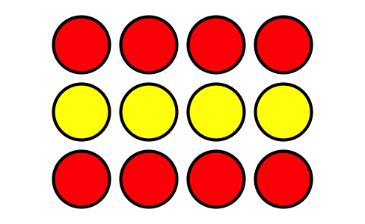
$\underset{_}{}+\underset{_}{}+\underset{_}{}=\underset{_}{}$
$\underset{_}{}+\underset{_}{}+\underset{_}{}+\underset{_}{}=\underset{_}{}$

Student Responses
$4+4+4=12$
$3+3+3+3=12$

