Lesson 6: Tell and Act Out Stories
- Let’s tell and act out stories.

Warm-up: How Many Do You See: Add To
How many do you see?
How do you see them?

6.1: What is Happening?
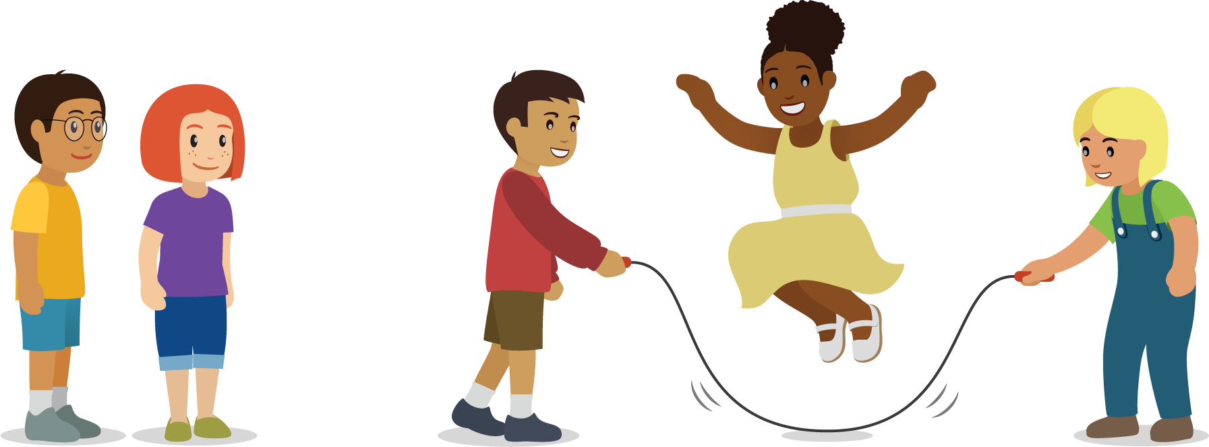

6.2: Act Out a Story
- There were 4 students jumping rope at recess.
2 more students came out to play with them.
- There were 6 students playing soccer at recess.
3 of the students had to go inside.
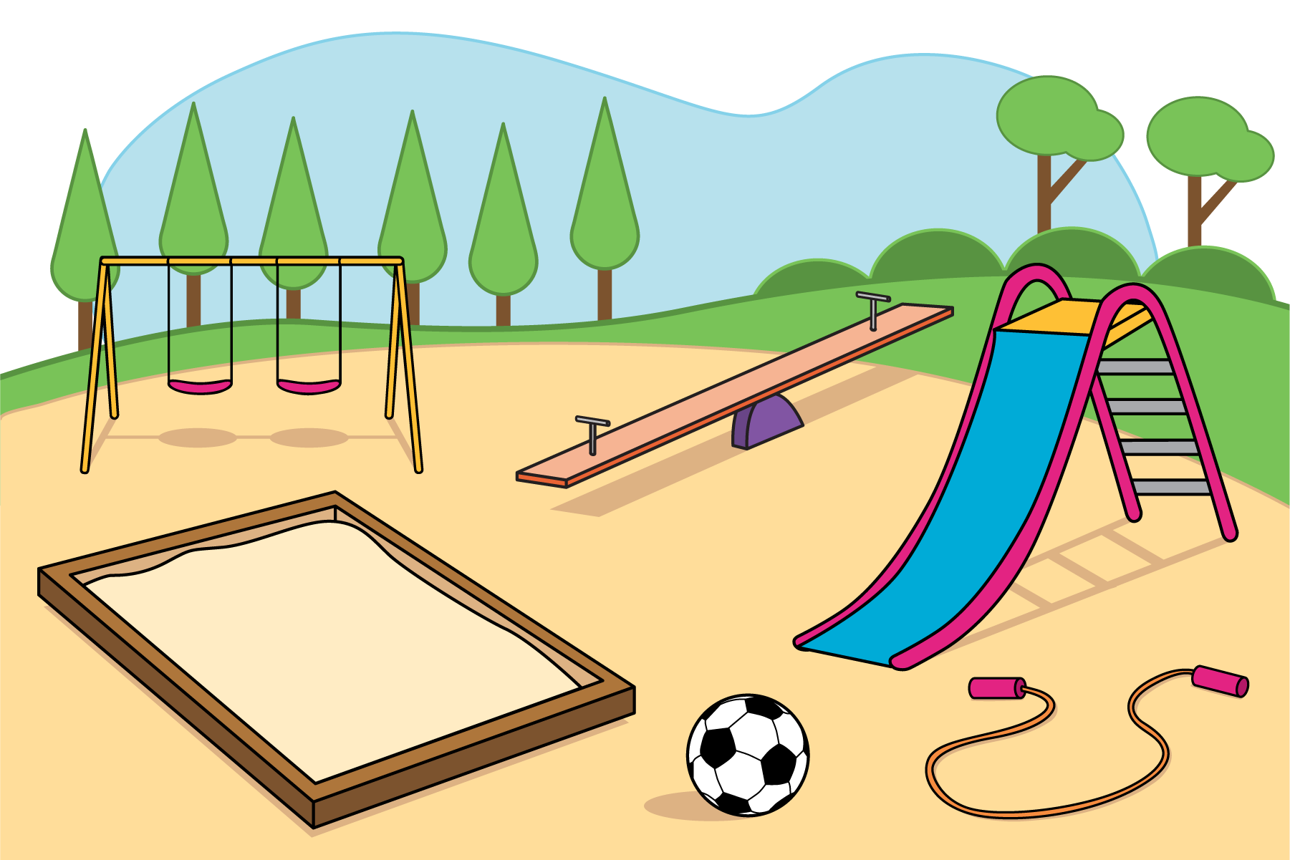

6.3: Introduce Subtraction Towers, Objects
Choose a center.
Subtraction Towers
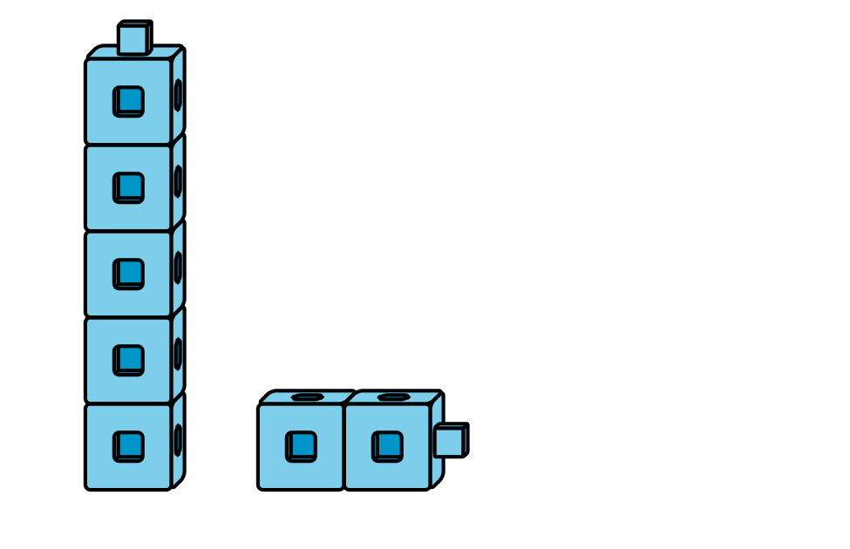
5-frames
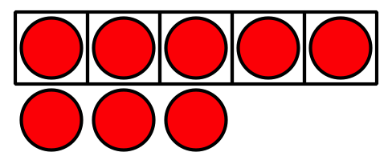
Build Shapes
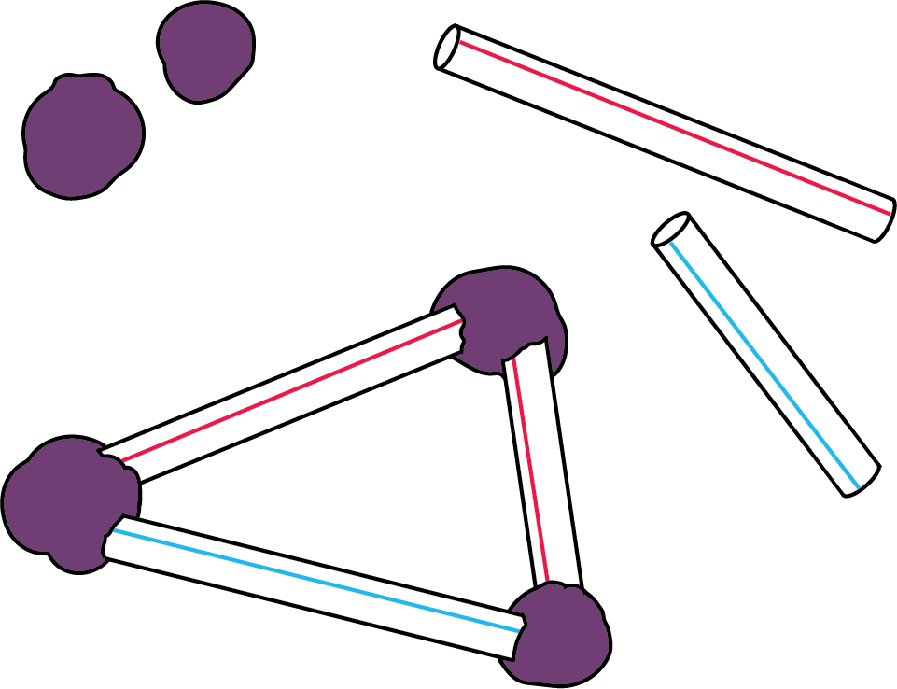
Counting Collections
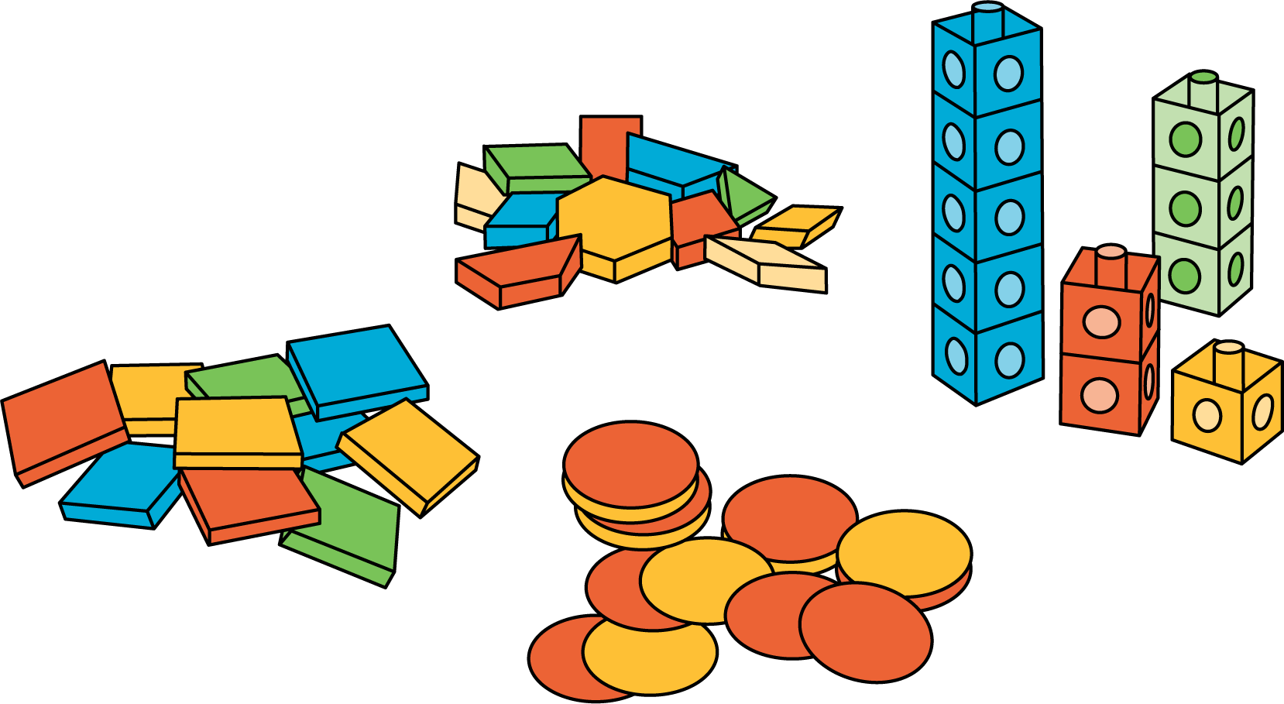
© CC BY 2021 Illustrative Mathematics®

