Unit 4 Lesson 6: Count Larger Collections

WU Choral Count: Count to 81 (Warm up)

Student Task Statement

1 Count Another Collection

Student Task Statement

2 Noah Counts a Collection

Student Task Statement
Noah organized his collection of connecting cubes.
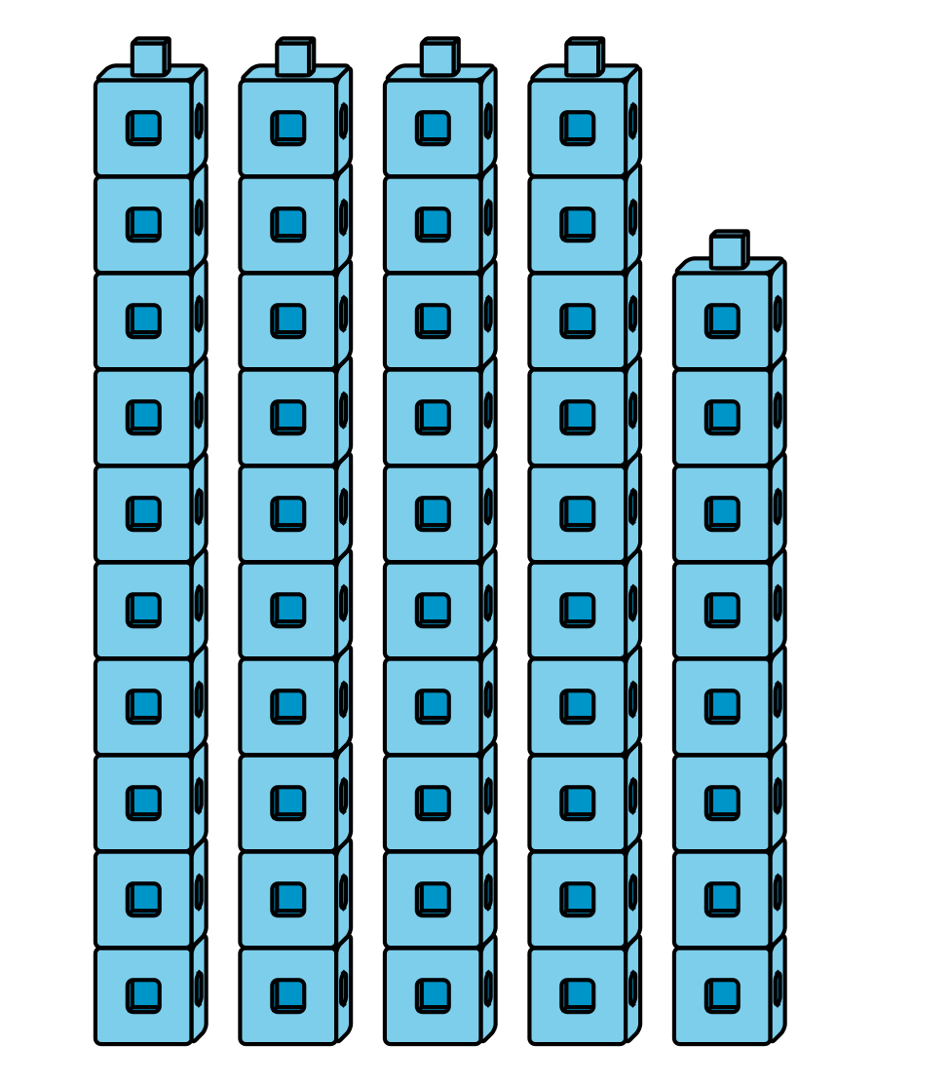
He counts and says there are 50 cubes.
Do you agree or disagree?
Explain how you know:
I ____________________ with Noah because

3 Centers: Choice Time

Student Task Statement
Choose a center.
Check It Off
Five in a Row
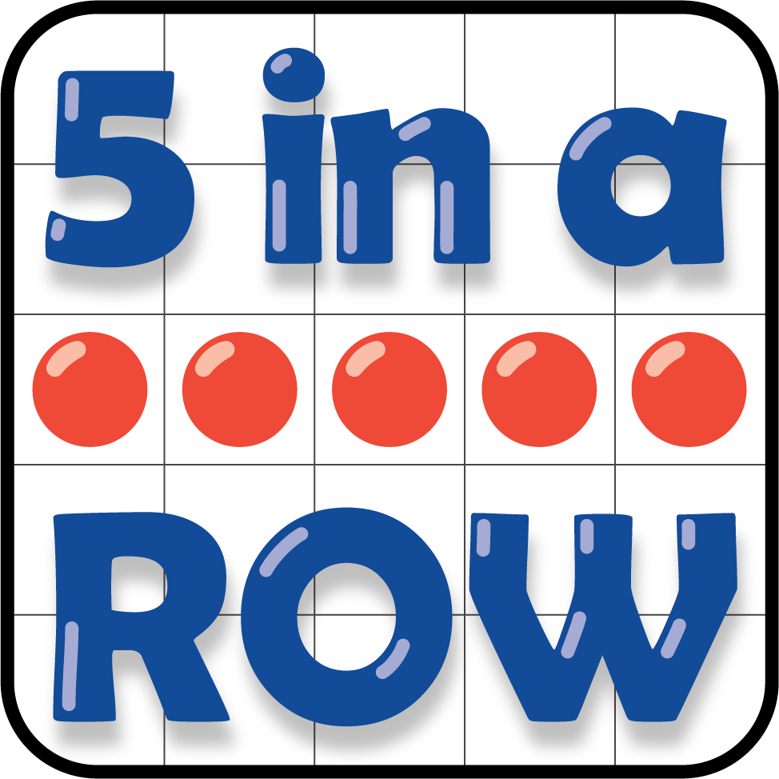
Number Puzzles
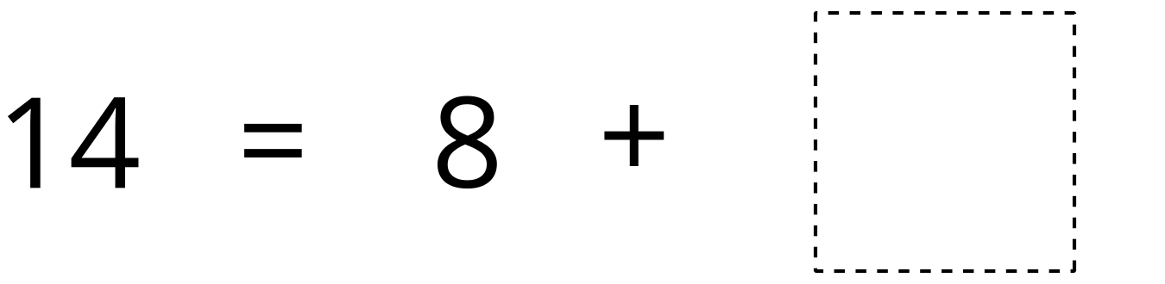
© CC BY 2021 Illustrative Mathematics®

