Lesson 9: Multiplication as Equal Groups
- Let’s work with equal groups of things.

Warm-up: Number Talk: More Addition
Find the value of each expression mentally.
- $40+35$
- $45+35$
- $45+36$
- $34+58$

9.1: From Scaled Graphs to Equal Groups
Elena collected data about the kind of signs she saw on the way home. The data is shown in this picture graph:
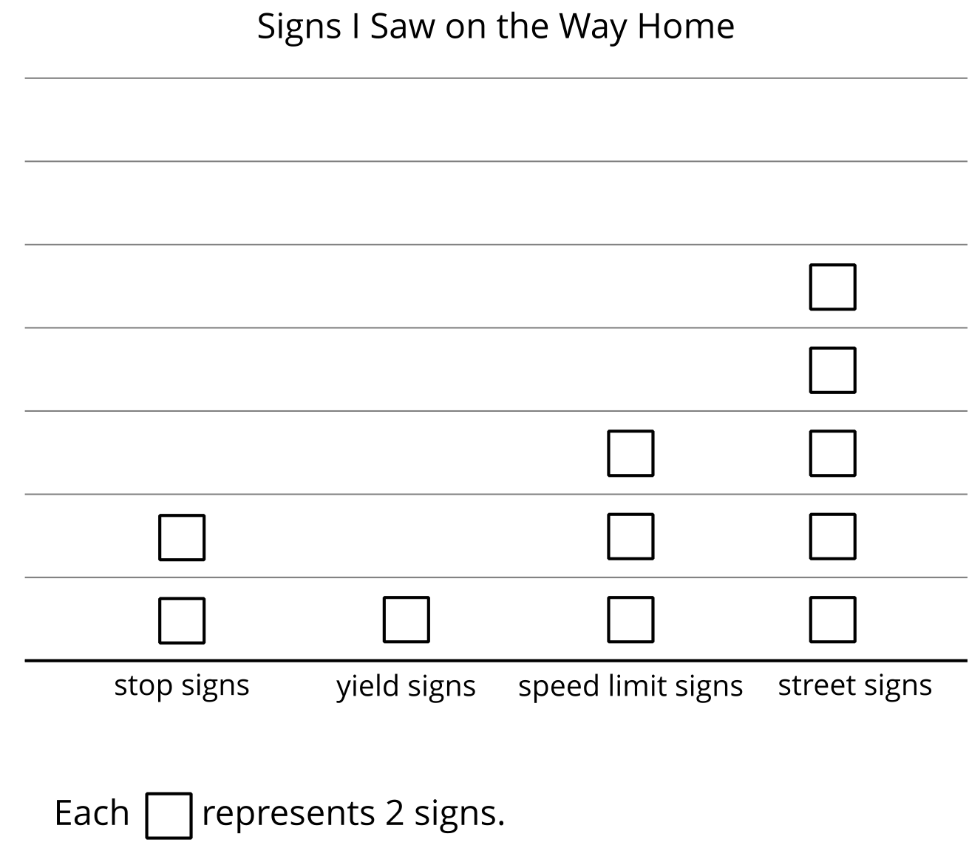
- Represent the number of speed limit signs Elena saw on the way home.
- Which statement describes the number of speed limit signs Elena saw? Explain your reasoning.
  - There are 3 pictures and each picture represents 1 speed limit sign.
  - There are 3 pictures and each picture represents 2 speed limit signs.
  - There are 2 pictures and each picture represents 2 speed limit signs.
- How could this drawing represent the street signs Elena saw on the way home?

9.2: Equal Group Situations
Represent each situation.
- There are 4 people wearing shoes. Each person is wearing 2 shoes.
- There are 2 boxes of markers. Each box has 10 markers.
- There are 3 basketball teams. Each team has 5 players.
© CC BY 2021 Illustrative Mathematics®

