Unit 3 Lesson 10 Cumulative Practice Problems
  - Find the unknown side length of the rectangle if its area is 11 m². Show your reasoning.
  - 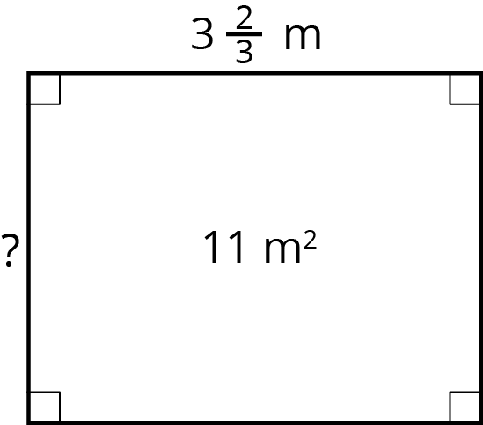
  - Check your answer by multiplying it by the given side length ($3\frac{2}{3}$). Is the resulting product 11? If not, revise your previous work.
- A worker is tiling the floor of a rectangular room that is 12 feet by 15 feet. The tiles are square with side lengths $1\frac{1}{3}$ feet. How many tiles are needed to cover the entire floor? Show your reasoning.

- The area of a rectangle is $17\frac{1}{2}$ in² and its shorter side is $3\frac{1}{2}$ in. Draw a diagram that shows this information. What is the length of the longer side?
- The triangle has an area of $7\frac{7}{8}$ cm² and a base of $5\frac{1}{4}$ cm.
- What is the length of $h$? Explain your reasoning.
- 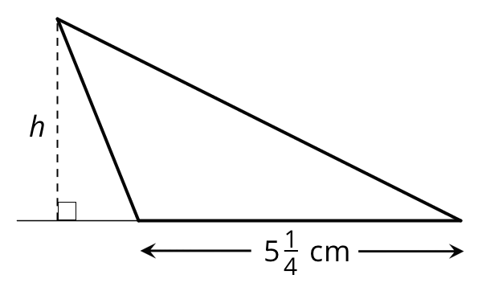
- Find the value of $\frac{5}{32}÷\frac{25}{4}$. Show your reasoning.
- (From Unit 3, Lesson 7.)
- A builder is building a fence with $6\frac{1}{4}$-inch-wide wooden boards, arranged side-by-side with no gaps or overlaps. How many boards are needed to build a fence that is 150 inches long? Show your reasoning.
- (From Unit 3, Lesson 9.)
© CC BY Open Up Resources. Adaptations CC BY IM.

