Unit 8 Lesson 5 Cumulative Practice Problems
- Three sets of data about ten sixth-grade students were used to make three dot plots. The person who made these dot plots forgot to label them. Match each dot plot with the appropriate label.
- 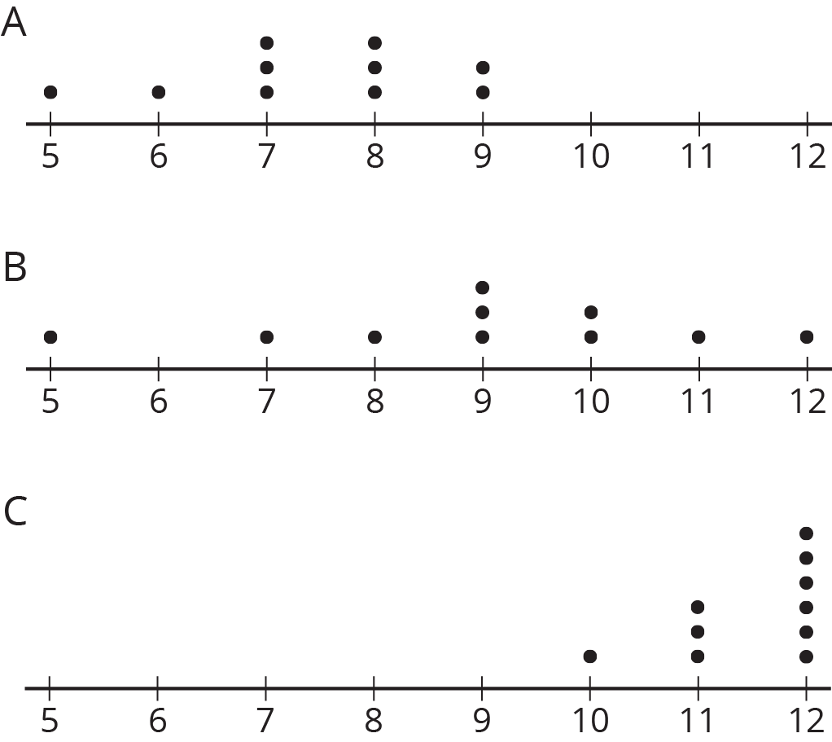
  - Dot Plot A
  - Dot Plot B
  - Dot Plot C
  - Ages in years
  - Numbers of hours of sleep on nights before school days
  - Numbers of hours of sleep on nights before non-school days
- The dot plots show the time it takes to get to school for ten sixth-grade students from the United States, Canada, Australia, New Zealand, and South Africa.
- 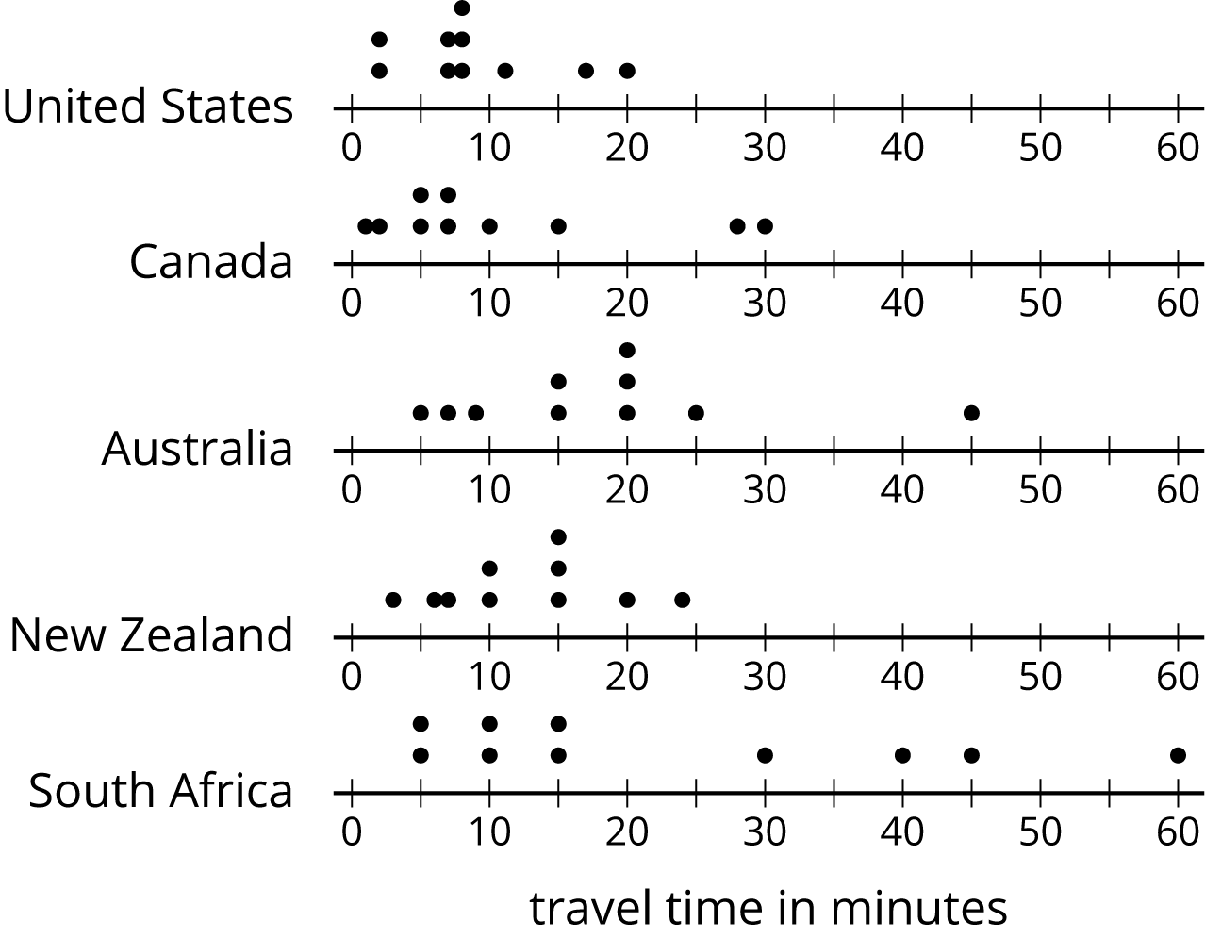
  - List the countries in order of typical travel times, from shortest to longest.
  - List the countries in order of variability in travel times, from the least variability to the greatest.
- Twenty-five students were asked to rate—on a scale of 0 to 10—how important it is to reduce pollution. A rating of 0 means “not at all important” and a rating of 10 means “very important.” Here is a dot plot of their responses.
- 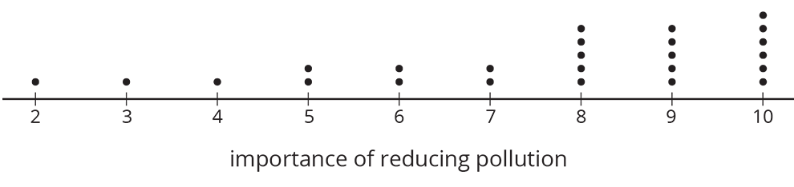
- Explain why a rating of 6 is not a good description of the center of this data set.
- Tyler wants to buy some cherries at the farmer’s market. He has $10 and cherries cost $4 per pound.
  - If $c$ is the number of pounds of cherries that Tyler can buy, write one or more inequalities or equations describing $c$.
  - Can 2 be a value of $c$? Can 3 be a value of $c$? What about -1? Explain your reasoning.
  - If $m$ is the amount of money, in dollars, Tyler can spend, write one or more inequalities or equations describing $m$.
  - Can 8 be a value of $m$? Can 2 be a value of $m$? What about 10.5? Explain your reasoning.
- (From Unit 7, Lesson 10.)
© CC BY Open Up Resources. Adaptations CC BY IM.

