Unit 3 Lesson 7: Confident Models

1 Math Talk: Ordering Decimals (Warm up)

Student Task Statement
Mentally order the numbers from least to greatest.
20.2, 18.2, 19.2
-14.6, -16.7, -15.1
-0.43, -0.87, -0.66
0.50, -0.52, 0.05

2 Ranking Models

Student Task Statement
- Here are scatter plots that represent various situations. Order the scatter plots from “A linear model is not a good fit for the data” to “A linear model is an excellent fit for the data.”

- A
- 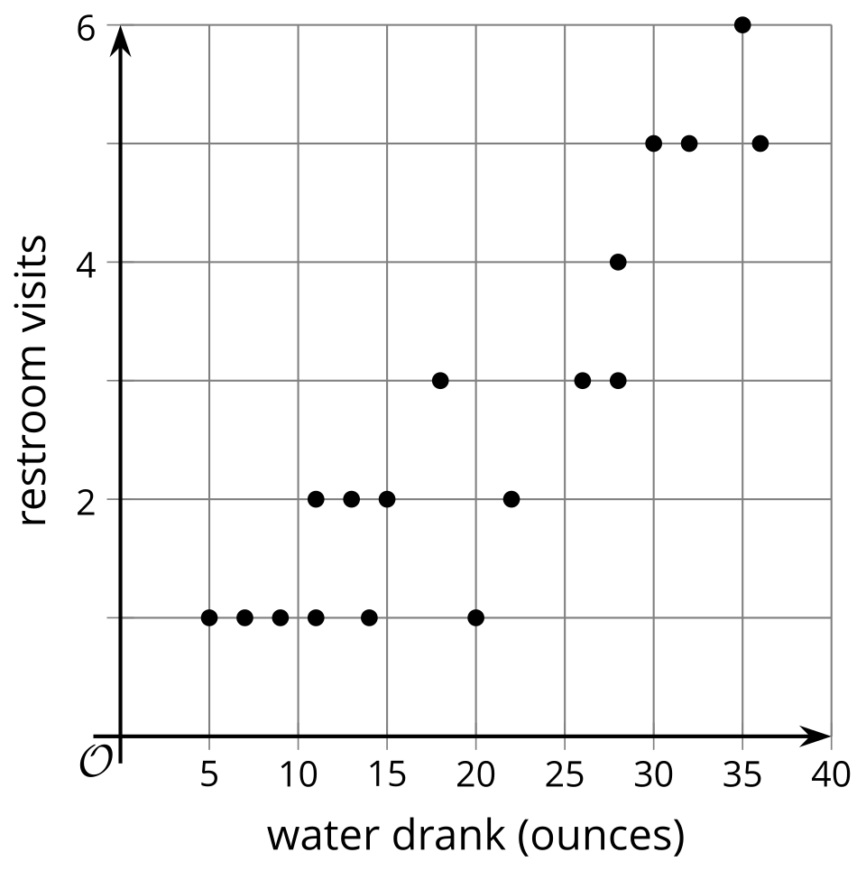

- B
- 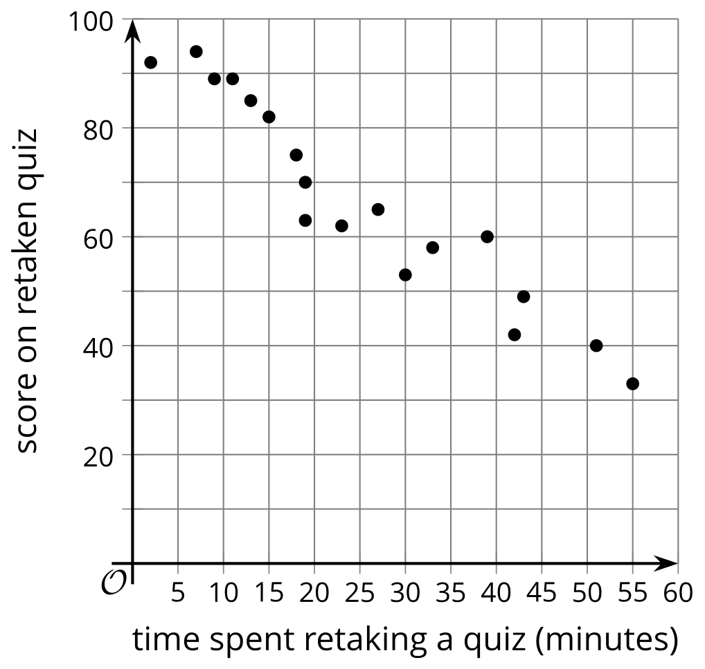

- C
- 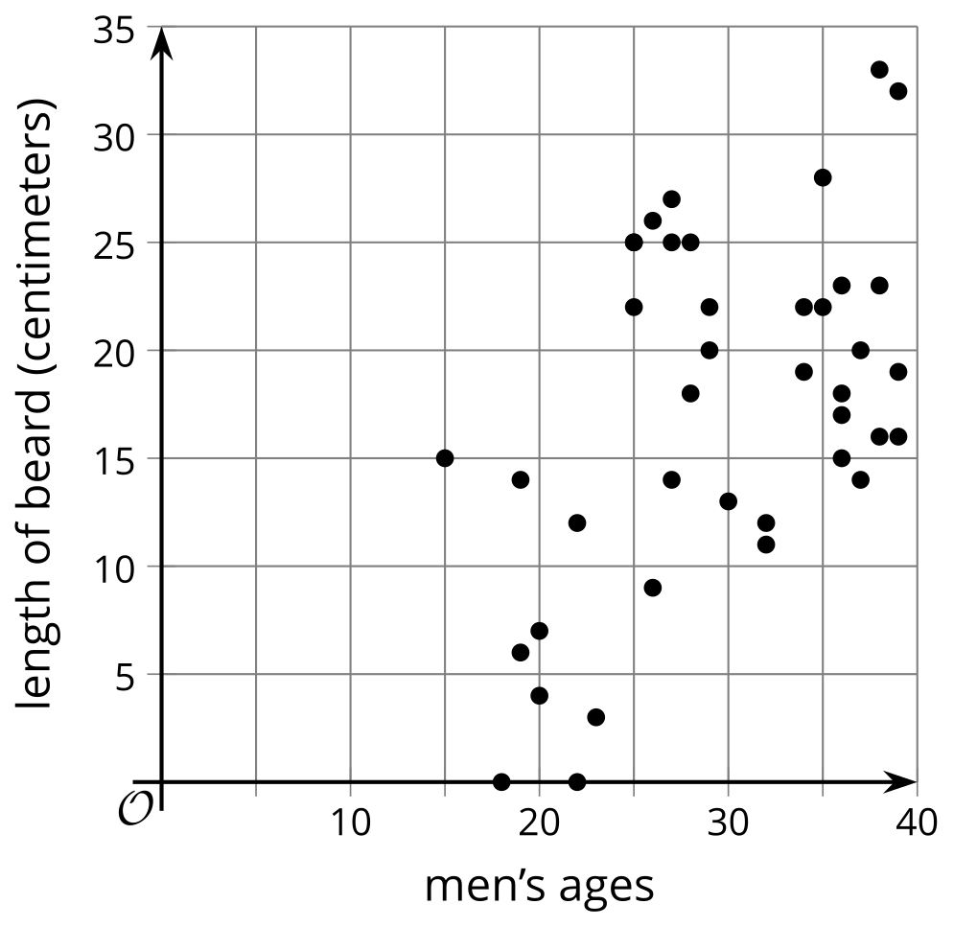

- D
- 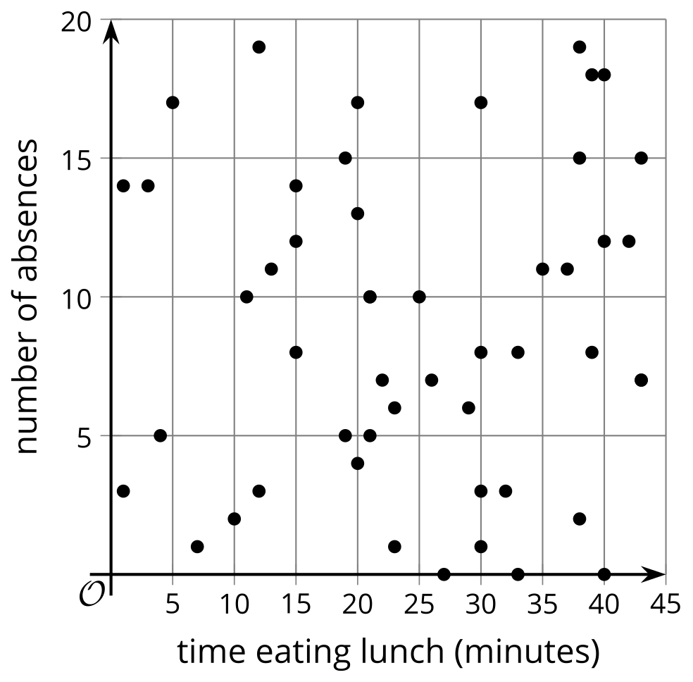

- E
- 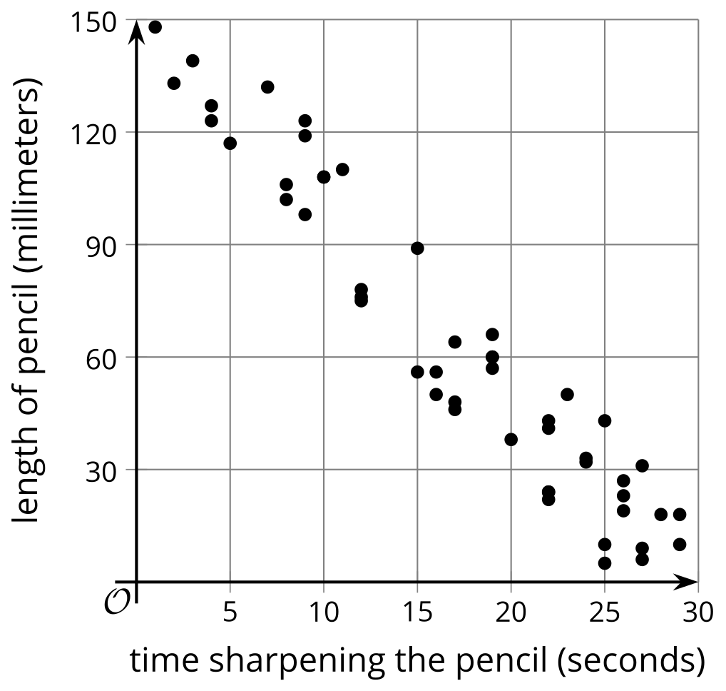

- Here are two scatter plots including a linear model. For each model, determine the $y$ when $x$ is 15. Which model prediction do you think is closer to the real data? Explain your reasoning.

Graph F. $y=150−5x$
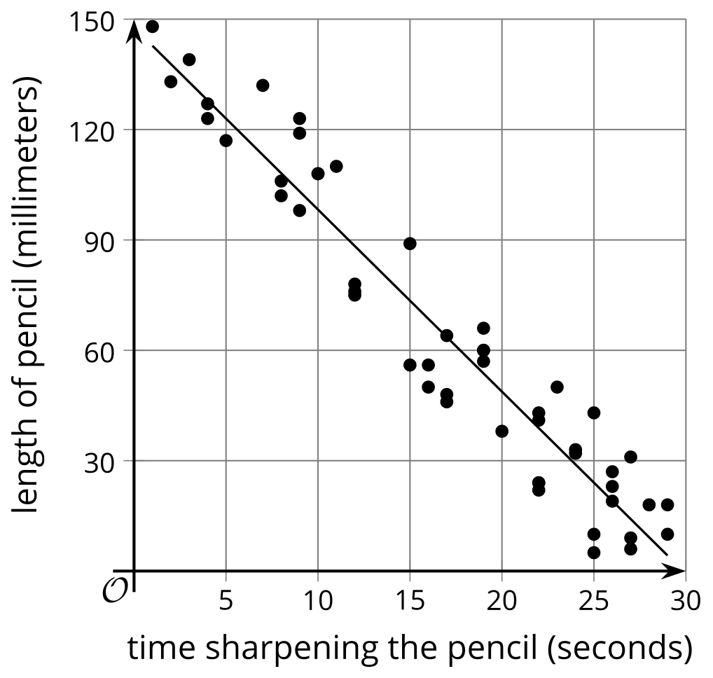

Graph G. $y=100−1.3x$
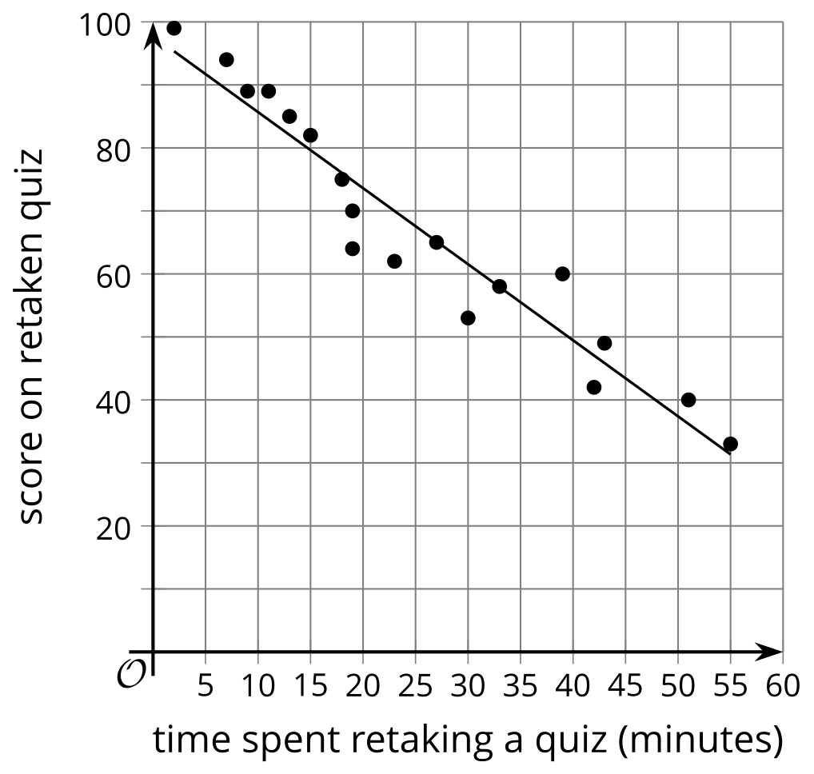

3 Predicting Value

Student Task Statement
Here are situations represented with graphs and lines of fit. Use the information given to complete the missing fields for each situation.
- The model predicts how much money, in dollars, the coach will make based on how many athletes sign up for one-on-one training. The model is represented with the equation $y=200+25x$.
- 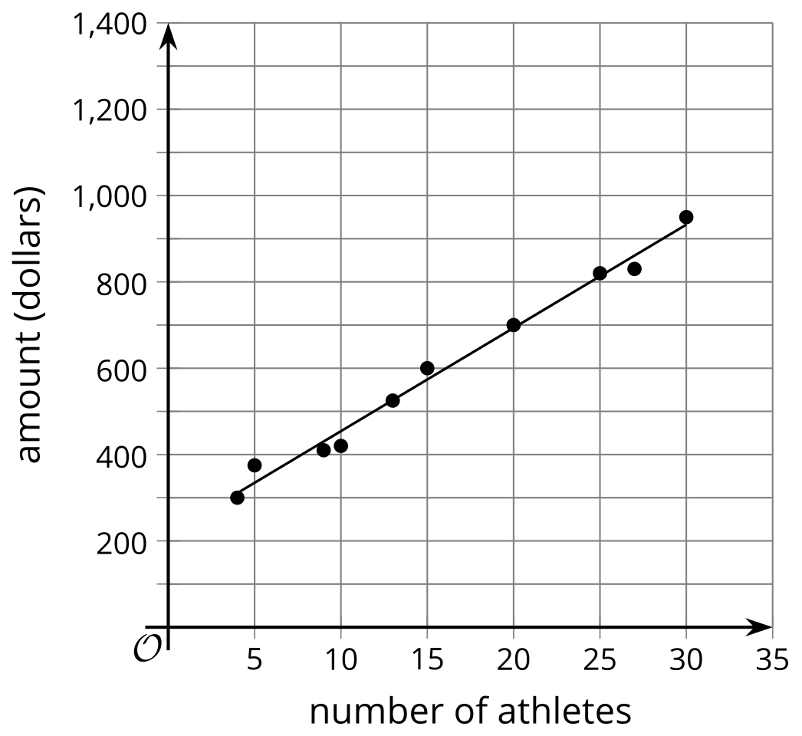
  - The slope of the model is $\underset{_}{​}$ (positive or negative).
  - What does the model predict would be the amount the coach makes when there are 10 athletes present?
  - Using the data points and the model as a reference, what is a reasonable range of money the coach will make when there are 10 athletes present?
  - This model is a $\underset{_}{​}$ (great, good, okay, or bad) fit for the data.
  - Using numbers between 0 and 1, rate your confidence in the model where 0 is no confidence and 1 is total confidence.
- The model predicts the annual salary of a worker in a certain government position based on years of experience. The model is represented with the equation $y=1.5x+35$.
- 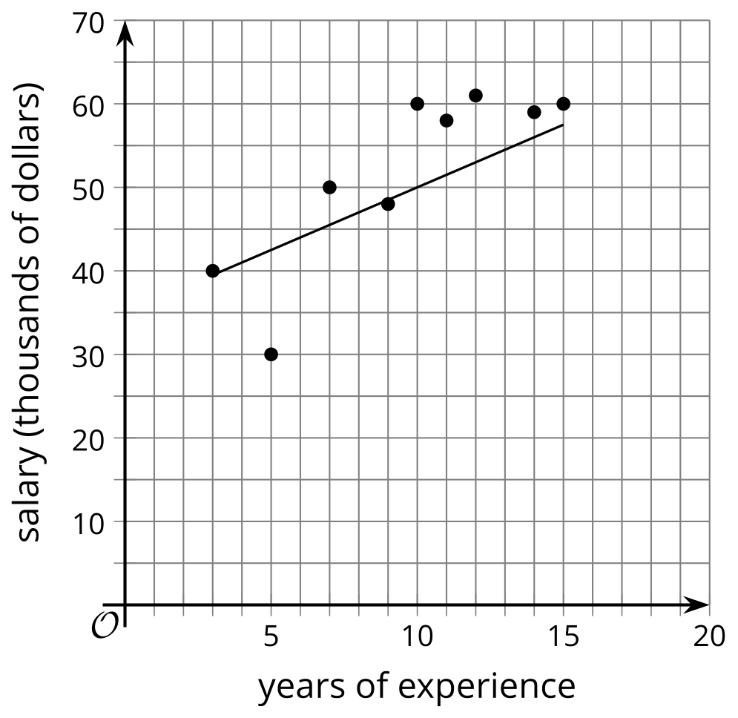
  - The slope of the model is $\underset{_}{​}$ (positive or negative).
  - What does the model predict would be the employee’s salary when the employee has 10 years of experience?
  - Using the data points and the model as a reference, what is a reasonable range for the salary of a worker based on 10 years of experience?
  - This model is a $\underset{_}{​}$ (great, good, okay, or bad) fit for the data.
  - Using numbers between 0 and 1, rate your confidence in the model where 0 is no confidence and 1 is total confidence.
- The model predicts the number of absences a school will have based on the number of incentives given per month. The model is represented with the equation $y=\text{-}2.18x+54.78$.
- 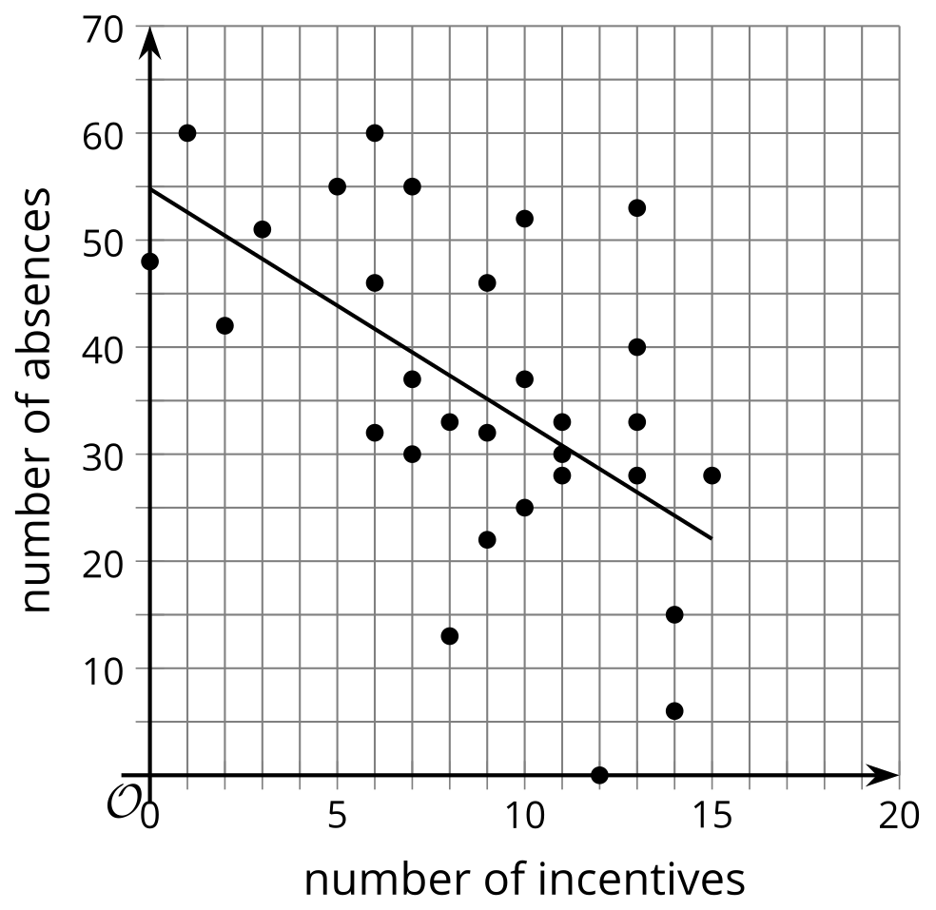
  - The slope of the model is $\underset{_}{​}$ (positive or negative).
  - What does the model predict would be the number of absences when 10 incentives are given for the month?
  - Using the data points and the model as a reference, what is a reasonable number of absences when there are 10 incentives given?
  - This model is a $\underset{_}{​}$ (great, good, okay, or bad) fit for the data.
  - Using numbers between 0 and 1, rate your confidence in the model where 0 is no confidence and 1 is total confidence.
© CC BY 2019 by Illustrative Mathematics®

