Lesson 18: Applying the Quadratic Formula (Part 2)
- Let’s use the quadratic formula and solve quadratic equations with care.

18.1: Bits and Pieces
Evaluate each expression for $a=9$, $b=\text{-}5$, and $c=\text{-}2$
- $\text{-}b$
- $b^{2}$
- $b^{2}−4ac$
- $\text{-}b±\sqrt{a}$

18.2: Using the Formula with Care
Here are four equations, followed by attempts to solve them using the quadratic formula. Each attempt contains at least one error.
- Solve 1–2 equations by using the quadratic formula.
- Then, find and describe the error(s) in the worked solutions of the same equations as the ones you solved.
Equation 1: $2x^{2}+3=8x$
Equation 2: $x^{2}+3x=10$
Equation 3: $9x^{2}−2x−1=0$
Equation 4: $x^{2}−10x+23=0$
Here are the worked solutions with errors:
Equation 1: $2x^{2}+3=8x$
$a=2, b=\text{-}8, c=3$
$\begin{matrix}x & =\frac{\text{-}b±\sqrt{b^{2}−4ac}}{2a} & & \\ x & =\frac{\text{-}\left(\text{-}8\right)±\sqrt{{\left(\text{-}8\right)}^{2}−4\left(2\right)\left(3\right)}}{2\left(2\right)} & & \\ x & =\frac{8±\sqrt{64−24}}{4} & & \\ x & =\frac{8±\sqrt{40}}{4} & & \\ x & =2±\sqrt{10} & & \end{matrix}$
Equation 2: $x^{2}+3x=10$
$a=1, b=3, c=10$
$\begin{matrix}x & =\frac{\text{-}b±\sqrt{b^{2}−4ac}}{2a} \\ x & =\frac{\text{-}3±\sqrt{3^{2}−4\left(1\right)\left(10\right)}}{2\left(1\right)} \\ x & =\frac{\text{-}3±\sqrt{9−40}}{2} \\ x & =\frac{\text{-}3±\sqrt{\text{-}31}}{2} \\ & \text{No solutions}\end{matrix}$
Equation 3: $9x^{2}−2x−1=0$
$a=9, b=\text{-}2, c=\text{-}1$
$\begin{matrix}x & =\frac{\text{-}b±\sqrt{b^{2}−4ac}}{2a} \\ x & =\frac{2±\sqrt{{\left(\text{-}2\right)}^{2}−4\left(9\right)\left(\text{-}1\right)}}{2} \\ x & =\frac{2±\sqrt{4+36}}{2} \\ x & =\frac{2±\sqrt{40}}{2}\end{matrix}$
Equation 4: $x^{2}−10x+23=0$
$a=1, b=\text{-}10, c=23$
$\begin{matrix}x & =\frac{\text{-}b±\sqrt{b^{2}−4ac}}{2a} \\ x & =\frac{\text{-}10±\sqrt{{\left(\text{-}10\right)}^{2}−4\left(1\right)\left(23\right)}}{2} \\ x & =\frac{\text{-}10±\sqrt{\text{-}100−92}}{2} \\ x & =\frac{\text{-}10±\sqrt{\text{-}192}}{2} \\ & \text{No solutions}\end{matrix}$

18.3: Sure About That?
- The equation $h\left(t\right)=2+30t−5t^{2}$ represents the height, as a function of time, of a pumpkin that was catapulted up in the air. Height is measured in meters and time is measured in seconds.
  - The pumpkin reached a maximum height of 47 meters. How many seconds after launch did that happen? Show your reasoning.
  - Suppose someone was unconvinced by your solution. Find another way (besides the steps you already took) to show your solution is correct.
- The equation $r\left(p\right)=80p−p^{2}$ models the revenue a band expects to collect as a function of the price of one concert ticket. Ticket prices and revenues are in dollars.
- A band member says that a ticket price of either $15.50 or $74.50 would generate approximately $1,000 in revenue. Do you agree? Show your reasoning.

Are you ready for more?
Function $g$ is defined by the equation $g\left(t\right)=2+30t−5t^{2}−47$. Its graph opens downward.
- Find the zeros of function $g$ without graphing. Show your reasoning.
- Explain or show how the zeros you found can tell us the vertex of the graph of $g$.
- Study the expressions that define functions $g$ and $h$ (which defined the height of the pumpkin). Explain how the maximum of function $h$, once we know it, can tell us the maximum of $g$.

Lesson 18 Summary
The quadratic formula has many parts in it. A small error in any one part can lead to incorrect solutions.
Suppose we are solving $2x^{2}−6=11x$. To use the formula, let's rewrite it in the form of $ax^{2}+bx+c=0$, which gives: $2x^{2}−11x−6=0$.
Here are some common errors to avoid:
- Using the wrong values for $a$, $b$, and $c$ in the formula.
- $x=\frac{\text{-}b±\sqrt{b^{2}−4ac}}{2a}$
- $x=\frac{\text{-}11±\sqrt{{\left(\text{-}11\right)}^{2}−4\left(2\right)\left(\text{-}6\right)}}{2\left(2\right)}$
- Nope! $b$ is -11, so $\text{-}b$ is $\text{-}\left(\text{-}11\right)$, which is 11, not -11.
- $x=\frac{11±\sqrt{{\left(\text{-}11\right)}^{2}−4\left(2\right)\left(\text{-}6\right)}}{2\left(2\right)}$
- That’s better!
- Forgetting to multiply 2 by $a$ for the denominator in the formula.
- $x=\frac{11±\sqrt{{\left(\text{-}11\right)}^{2}−4\left(2\right)\left(\text{-}6\right)}}{2}$
- Nope! The denominator is $2a$, which is $2\left(2\right)$ or 4.
- $x=\frac{11±\sqrt{{\left(\text{-}11\right)}^{2}−4\left(2\right)\left(\text{-}6\right)}}{2\left(2\right)}$
- That’s better!
- Forgetting that squaring a negative number produces a positive number.
- $x=\frac{11±\sqrt{\text{-}121−4\left(2\right)\left(\text{-}6\right)}}{4}$
- Nope! ${\left(\text{-}11\right)}^{2}$ is 121, not -121.
- $x=\frac{11±\sqrt{121−4\left(2\right)\left(\text{-}6\right)}}{4}$
- That’s better!
- Forgetting that a negative number times a positive number is a negative number.
- $x=\frac{11±\sqrt{121−48}}{4}$
- Nope! $4\left(2\right)\left(\text{-}6\right)=\text{-}48$ and $121−\left(\text{-}48\right)$ is $121+48$.
- $x=\frac{11±\sqrt{121+48}}{4}$
- That’s better!
- Making calculation errors or not following the properties of algebra.
- $x=\frac{11±\sqrt{169}}{4}$
- $x=11±\sqrt{42.25}$
- Nope! Both parts of the numerator, the 11 and the $\sqrt{169}$, get divided by 4. Also, $\frac{\sqrt{169}}{4}$ is not $\sqrt{42.25}$.
- $x=\frac{11±13}{4}$
- That’s better!
Let’s finish by evaluating $\frac{11±13}{4}$ correctly:
$\begin{matrix}x & =\frac{11+13}{4} & \text{or} & x=\frac{11−13}{4} \\ x & =\frac{24}{4} & \text{or} & x=\text{-}\frac{2}{4} \\ x & =6 & \text{or} & x=\text{-}\frac{1}{2}\end{matrix}$
To make sure our solutions are indeed correct, we can substitute the solutions back into the original equations and see whether each solution keeps the equation true.
Checking 6 as a solution:
$\begin{matrix}2x^{2}−6 & =11x \\ 2{\left(6\right)}^{2}−6 & =11\left(6\right) \\ 2\left(36\right)−6 & =66 \\ 72−6 & =66 \\ 66 & =66\end{matrix}$
Checking $\text{-}\frac{1}{2}$ as a solution:
$\begin{matrix}2x^{2}−6 & =11x \\ 2{\left(\text{-}\frac{1}{2}\right)}^{2}−6 & =11\left(\text{-}\frac{1}{2}\right) \\ 2\left(\frac{1}{4}\right)−6 & =\text{-}\frac{11}{2} \\ \frac{1}{2}−6 & =\text{-}5\frac{1}{2} \\ \text{-}5\frac{1}{2} & =\text{-}5\frac{1}{2}\end{matrix}$
We can also graph the equation $y=2x^{2}−11x−6$ and find its $x$-intercepts to see whether our solutions to $2x^{2}−11x−6=0$ are accurate (or close to accurate).
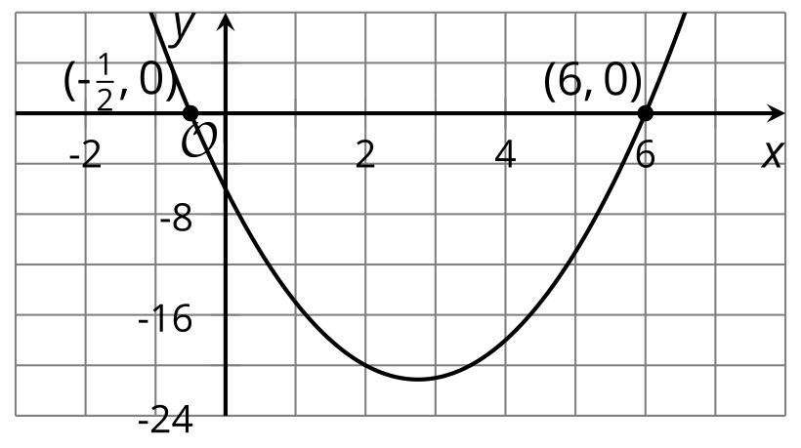
​​​​​​
© CC BY 2019 by Illustrative Mathematics®

