Lesson 7: Angle-Side-Angle Triangle Congruence
- Let’s see if we can prove other sets of measurements that guarantee triangles are congruent, and apply those theorems.

7.1: Notice and Wonder: Assertion
Assertion: Through 2 distinct points passes a unique line. Two lines are said to be distinct if there is at least 1 point that belongs to one but not the other. Otherwise, we say the lines are the same. Lines that have no point in common are said to be parallel.
Therefore, we can conclude: given 2 distinct lines, either they are parallel, or they have exactly 1 point in common.
What do you notice? What do you wonder?

7.2: Proving the Angle-Side-Angle Triangle Congruence Theorem
- Two triangles have 2 pairs of corresponding angles congruent, and the corresponding sides between those angles are congruent. Sketch 2 triangles that fit this description.
- Label the triangles $WXY$ and $DEF$, so that angle $W$ is congruent to angle $D$, angle $X$ is congruent to angle $E$, and side $WX$ is congruent to side $DE$.
- Use a sequence of rigid motions to take triangle $WXY$ onto triangle $DEF$. For each step, explain how you know that one or more vertices will line up.

7.3: Find the Missing Angle Measures
Lines $ℓ$ and $m$ are parallel. $a=42$. Find $b$, $c$, $d$, $e$, $f$, $g$, and $h$.

$ℓ∥m$
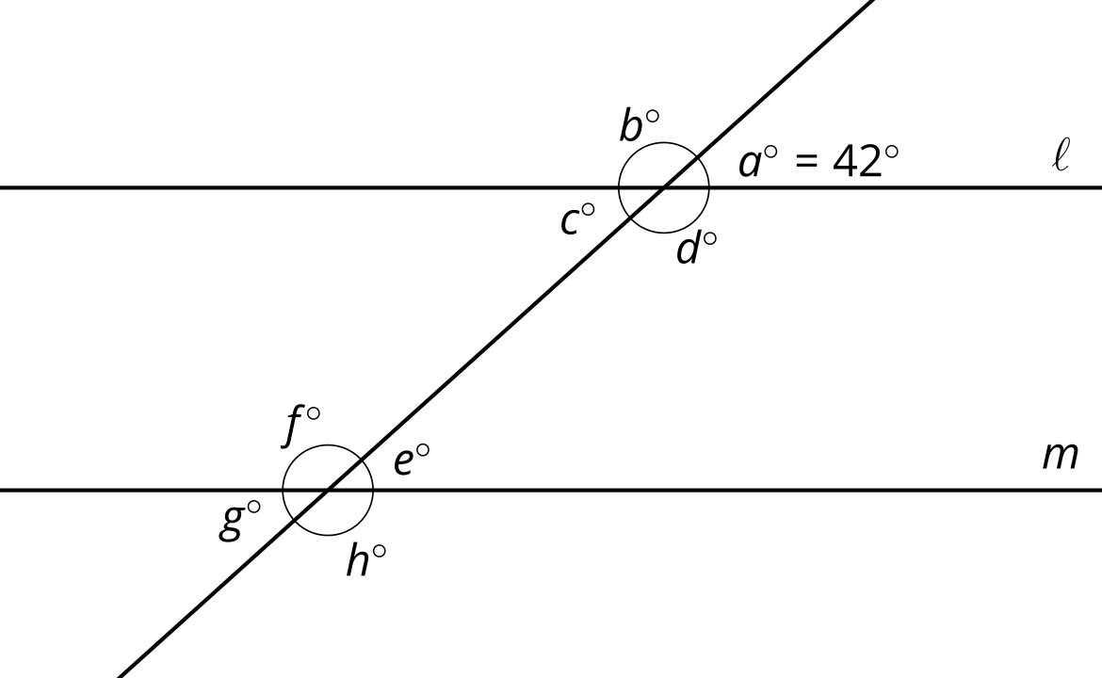

7.4: What Do We Know For Sure About Parallelograms?
Quadrilateral $ABCD$ is a parallelogram. By definition, that means that segment $AB$ is parallel to segment $CD$, and segment $BC$ is parallel to segment $AD$.
- Sketch parallelogram $ABCD$ and then draw an auxiliary line to show how $ABCD$ can be decomposed into 2 triangles.
- Prove that the 2 triangles you created are congruent, and explain why that shows one pair of opposite sides of a parallelogram must be congruent.

Are you ready for more?
When we have 3 consecutive vertices of a polygon $A$, $B$, and $C$ so that the triangle $ABC$ lies entirely inside the polygon, we call $B$ an ear of the polygon.
- How many ears does a parallelogram have?
- Draw a quadrilateral that has fewer ears than a parallelogram.
- In 1975, Gary Meisters proved that every polygon has at least 2 ears. Draw a hexagon with only 2 ears.

Lesson 7 Summary
We know that in 2 triangles, if 2 pairs of corresponding sides and the pair of corresponding angles between the sides are congruent, then the triangles must be congruent. But we don’t always know that 2 pairs of corresponding sides are congruent. For example, when proving that opposite sides are congruent in any parallelogram, we only have information about 1 pair of corresponding sides. That is why we need other ways than the Side-Angle-Side Triangle Congruence Theorem to prove triangles are congruent.
In 2 triangles, if 2 pairs of corresponding angles and the pair of corresponding sides between the angles are congruent, then the triangles must be congruent. This is called the Angle-Side-Angle Triangle Congruence Theorem.
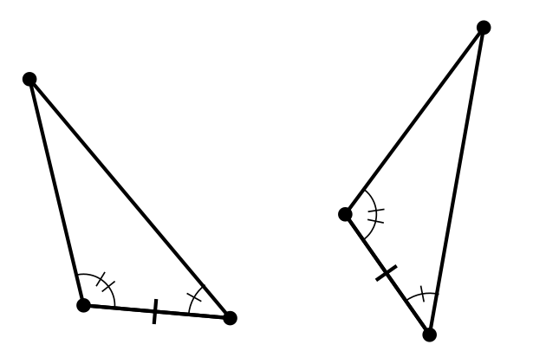
When proving that 2 triangles are congruent, look at the diagram and given information and think about whether it will be easier to find 2 pairs of corresponding angles that are congruent or 2 pairs of corresponding sides that are congruent. Then check if there is enough information to use the Angle-Side-Angle Triangle Congruence Theorem or the Side-Angle-Side Triangle Congruence Theorem.
The Angle-Side-Angle Triangle Congruence Theorem can be used to prove that, in a parallelogram, opposite sides are congruent. A parallelogram is defined to be a quadrilateral with 2 pairs of opposite sides parallel.
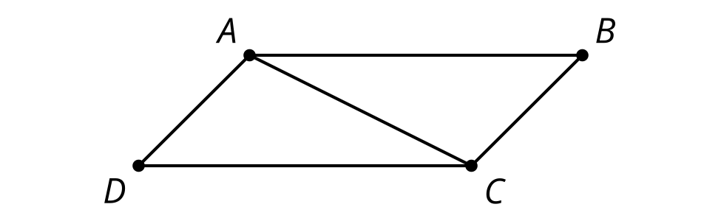
We could prove that triangles $ABC$ and $CDA$ are congruent by the Angle-Side-Angle Triangle Congruence Theorem. Then we can say segment $AD$ is congruent to segment $CB$ because they are corresponding parts of congruent triangles.
© CC BY 2019 by Illustrative Mathematics®

