Lesson 7: Use Objects to Represent Stories
- Let’s use objects to show what is happening in the story.

Warm-up: Notice and Wonder: Balls and Counters
What do you notice?
What do you wonder?
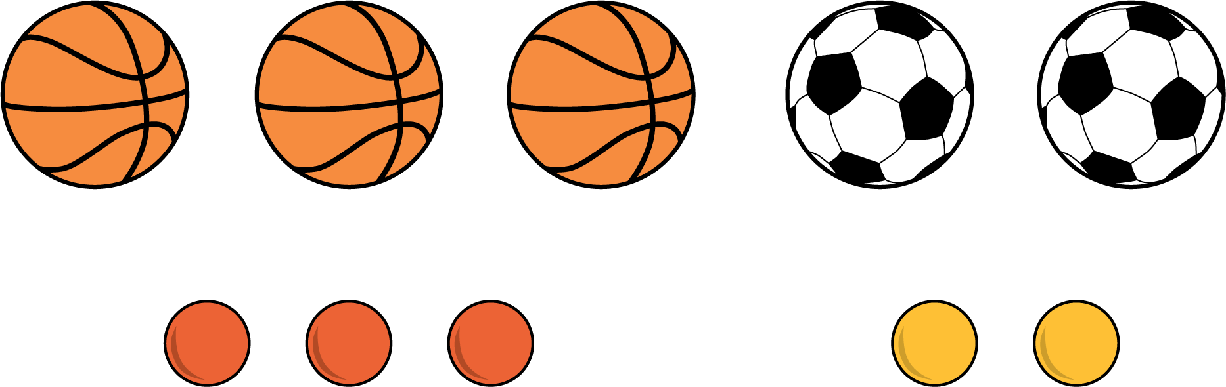

7.1: Playing on the Playground
- There were 5 students playing basketball at recess.
2 of the students went inside to get some water.
- There were 3 students playing on the swings at recess.
1 more student came over to play on the swings.
- There were 5 students playing tag at recess.
4 of the students went inside.
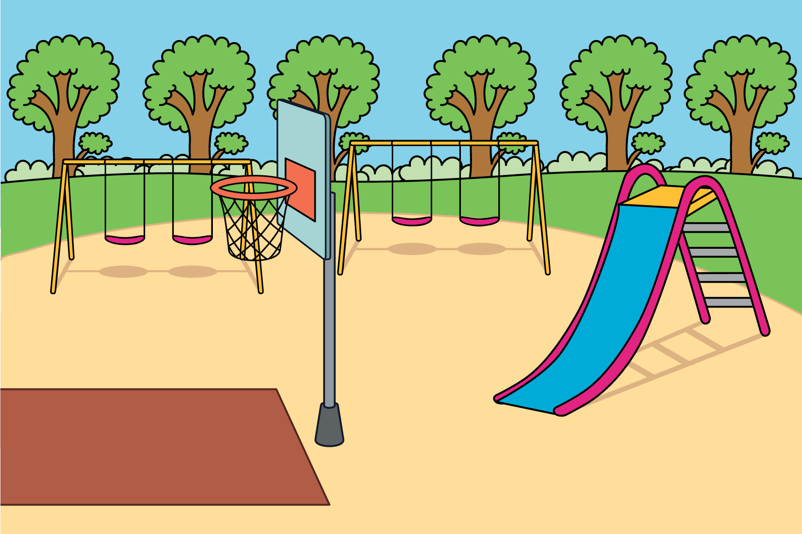

7.2: Finish the Story
- There were 7 kids playing tag on the field.
- There were 2 kids eating at the picnic table.
- 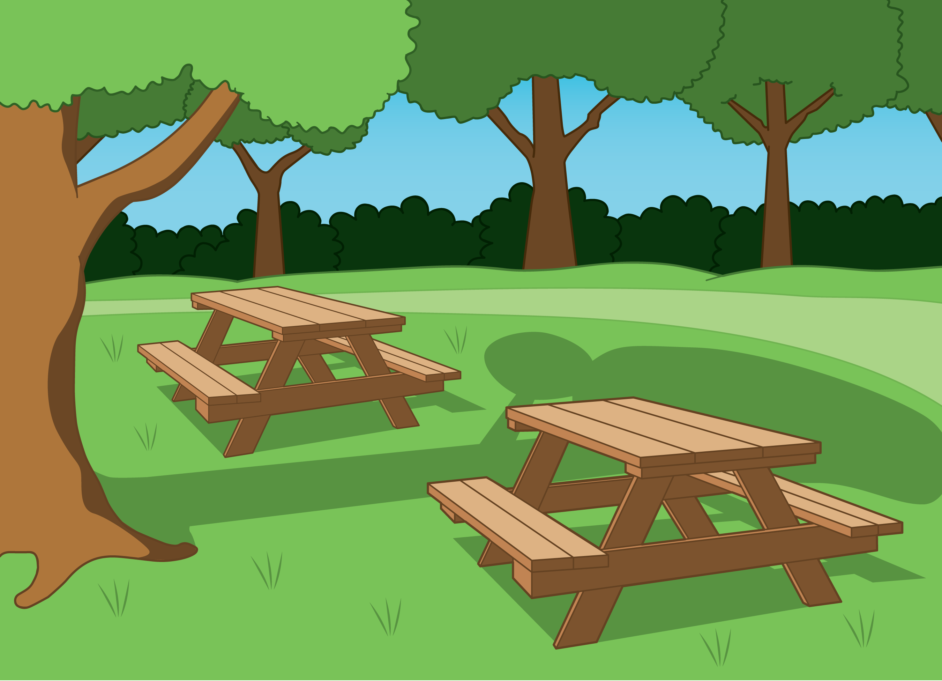
- There were 4 ducks swimming in the lake.
- 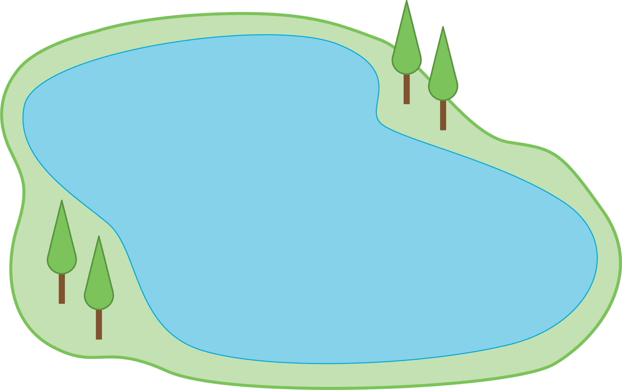
- There were 5 kids playing hopscotch.
- 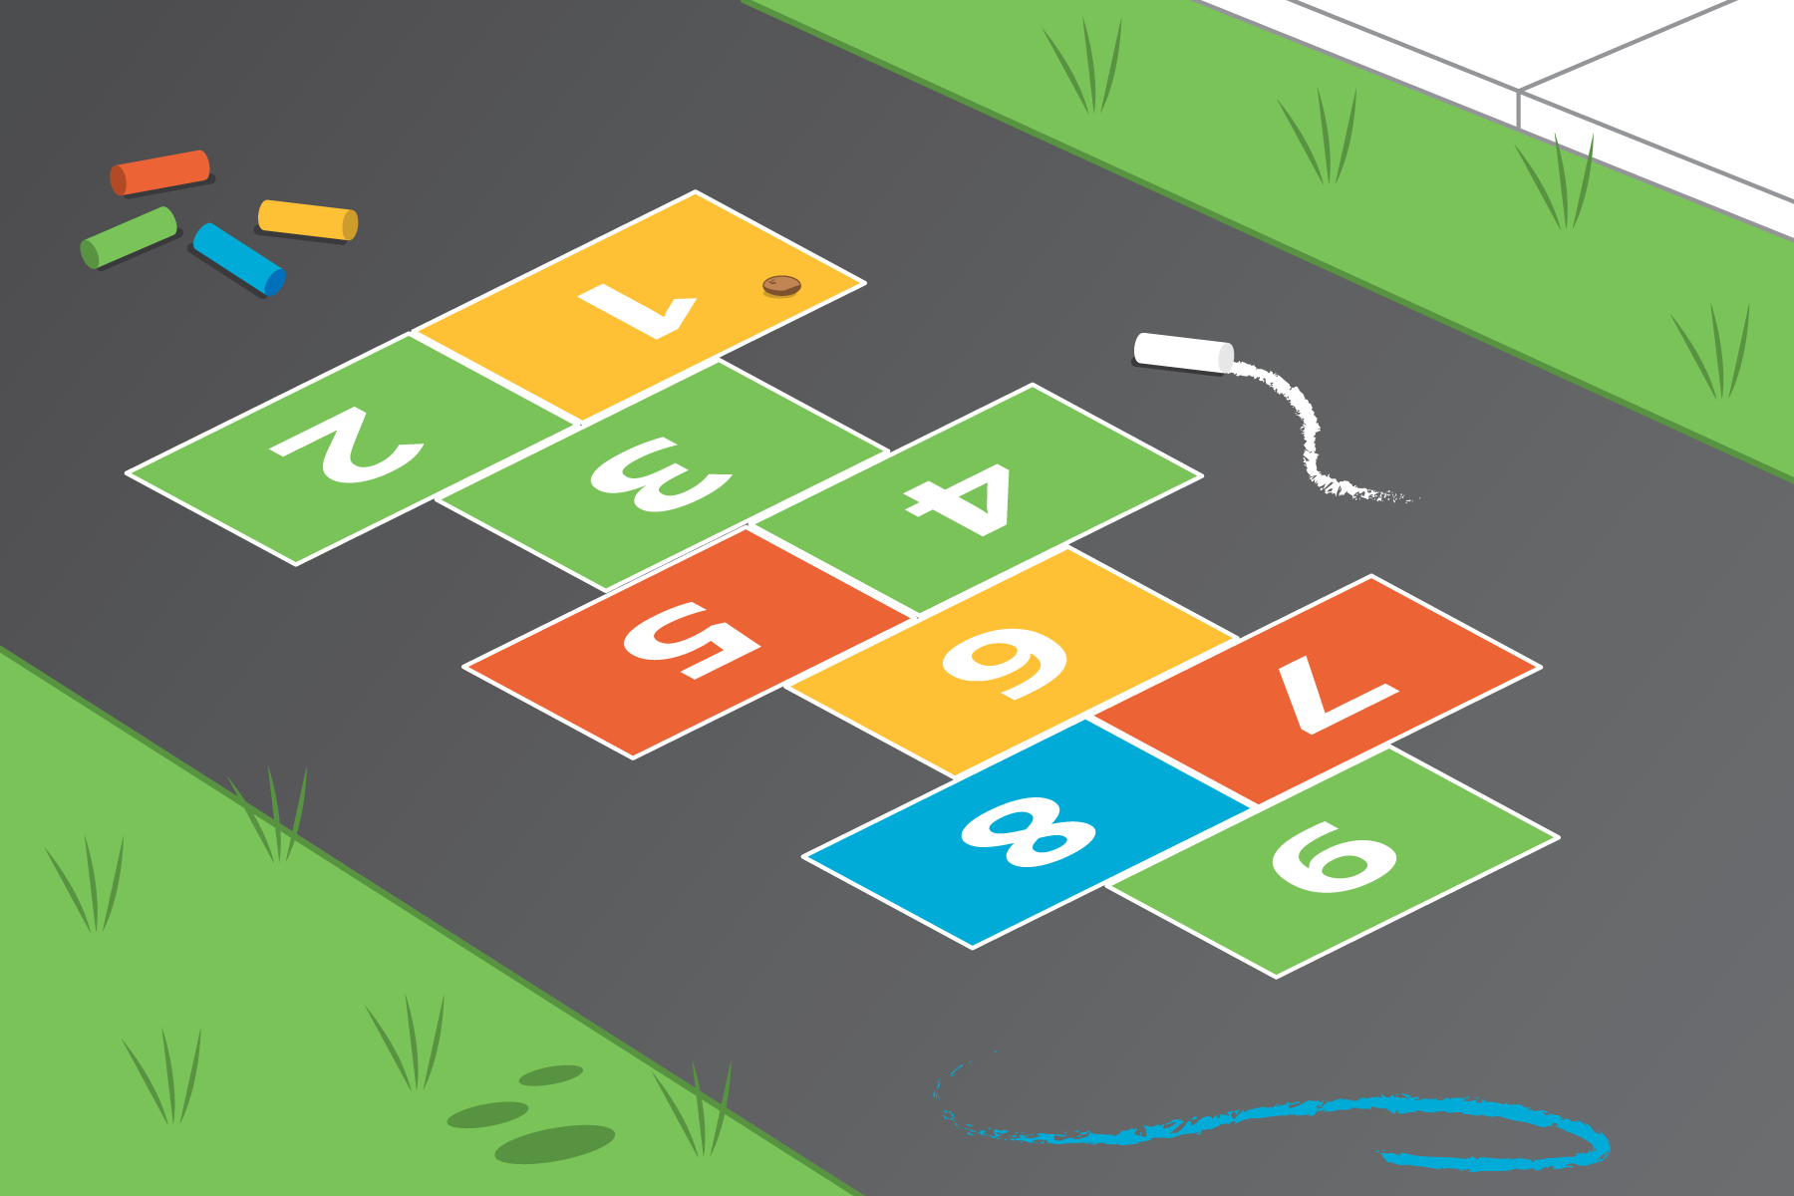

7.3: Introduce Math Stories, Act It Out
Choose a center.
Math Stories
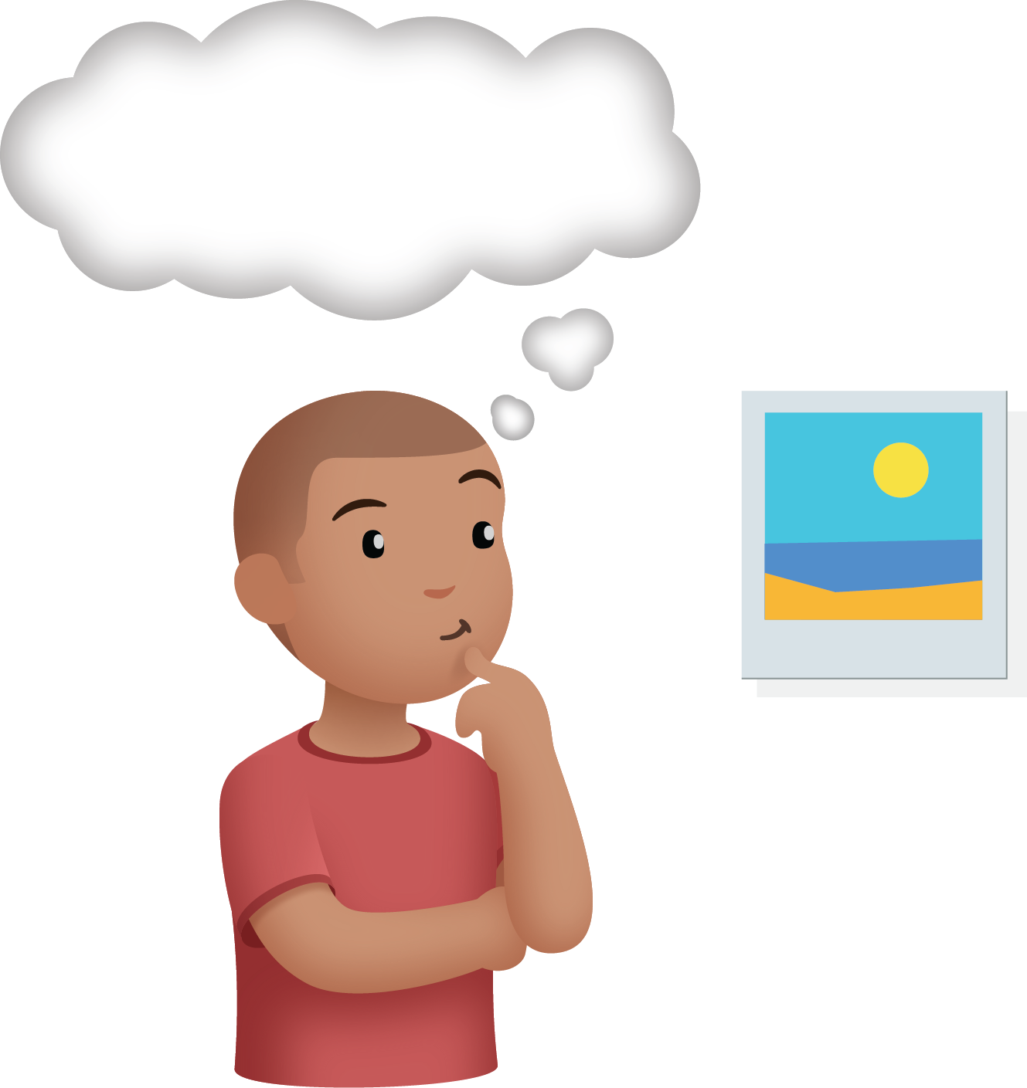
Subtraction Towers
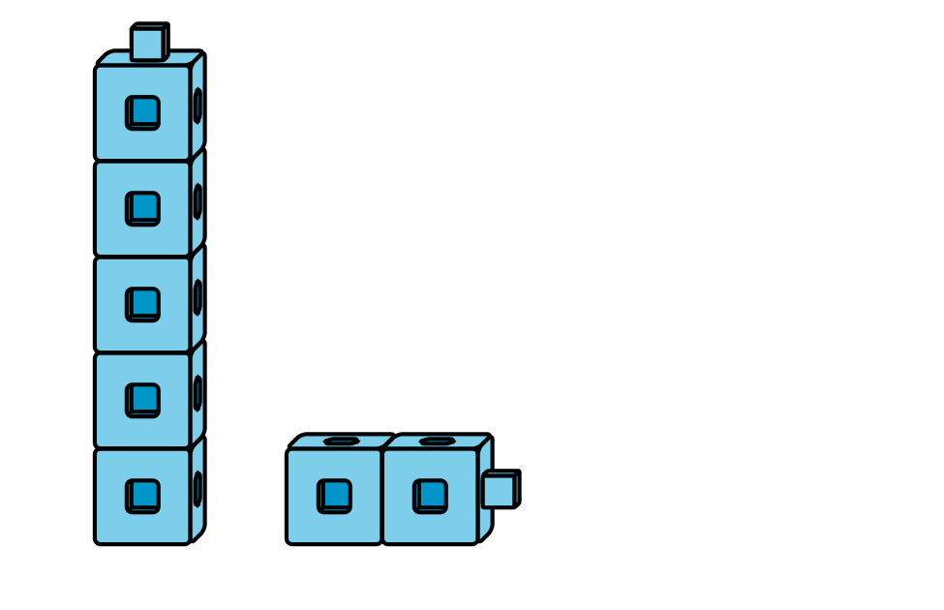
5-frames
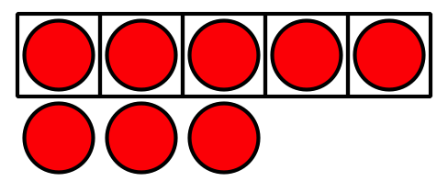
Build Shapes
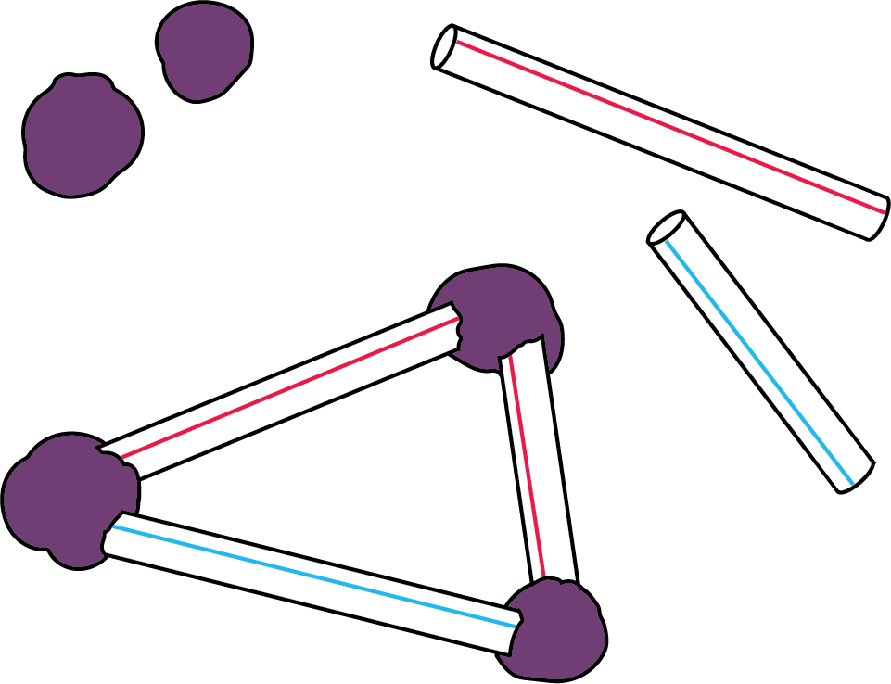
Counting Collections
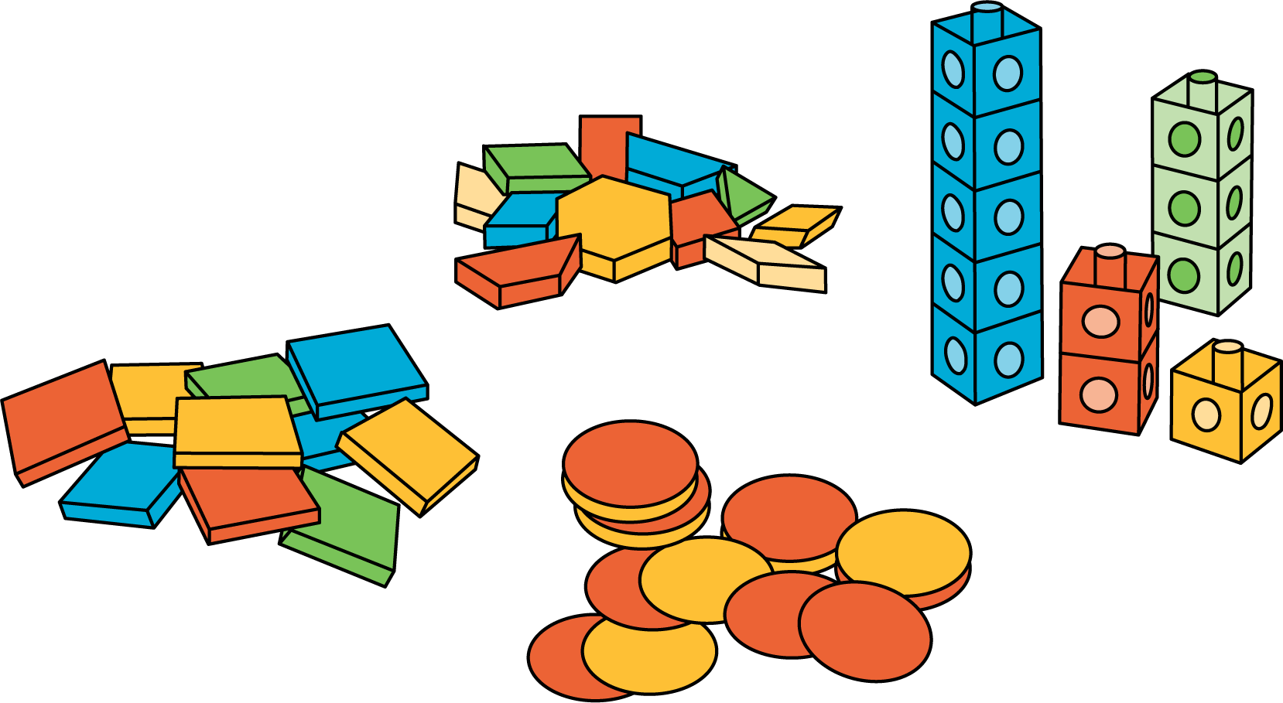
© CC BY 2021 Illustrative Mathematics®

