Unit 4 Lesson 7: Numbers With Tens and Ones

WU Notice and Wonder: One-and Two-digit Numbers (Warm up)

Student Task Statement
Set A
0
1
2
3
4
5
6
7
8
9
Set B
10
23
45
76
89

1 Make It: Tens and Ones

Student Task Statement
- Partner 1 draws 2 number cards and uses them to make a two-digit number.
- Each partner says the number.
- Partner 2 builds the number using cubes.
- Partner 1 checks to see if they agree.
- Each partner makes a drawing of the number and records how many tens and ones.
- Switch roles and repeat.

2 Who Do You Agree With?

Student Task Statement
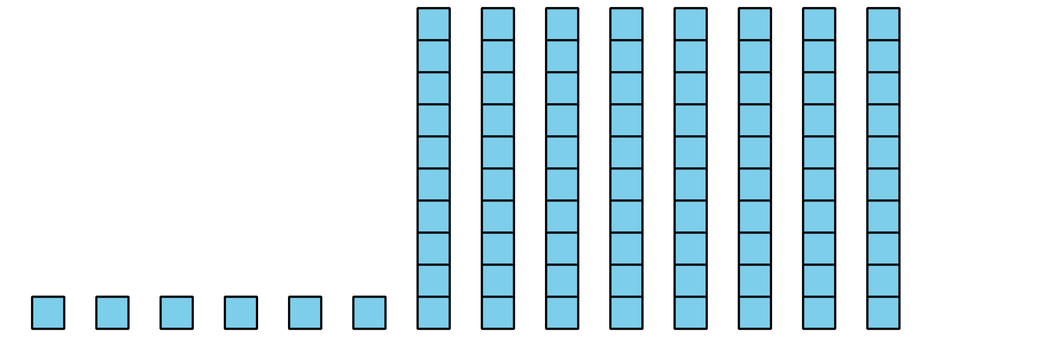
Clare says this shows 68 (sixty-eight).
Diego says this shows 86 (eighty-six).
Who do you agree with?
How do you know they are correct?
I agree with __________________________ because

3 Centers: Choice Time

Student Task Statement
Choose a center.
Shake and Spill
How Close
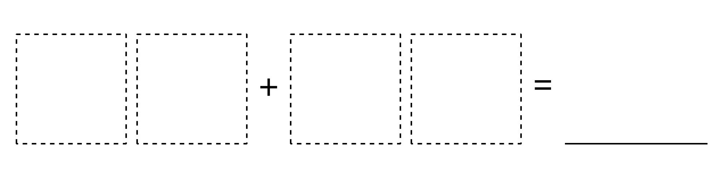
Check It Off
© CC BY 2021 Illustrative Mathematics®

