Lesson 10: Drawings, Situations, and Diagrams, Oh My!
- Let’s represent equal groups.

Warm-up: Notice and Wonder: Socks
What do you notice? What do you wonder?
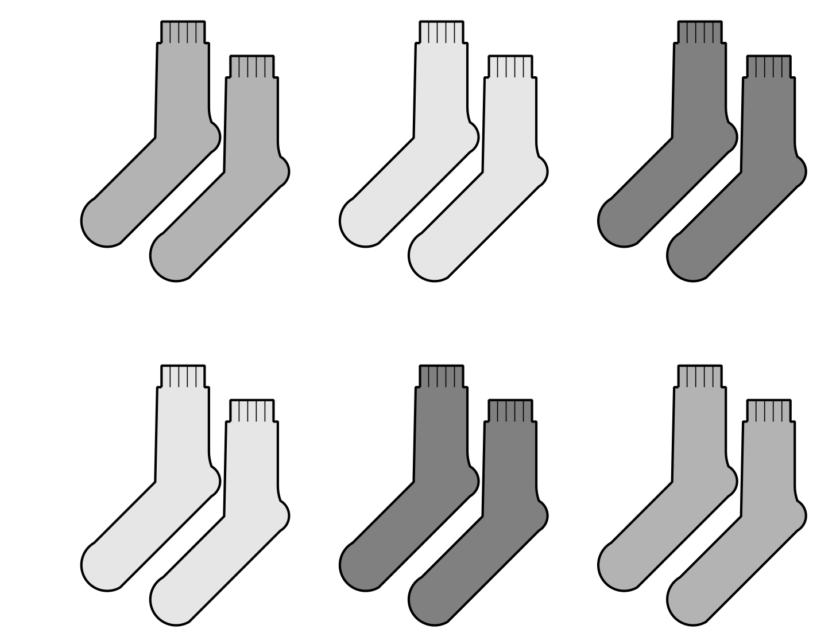

10.1: Scaled Picture Graph to Diagram
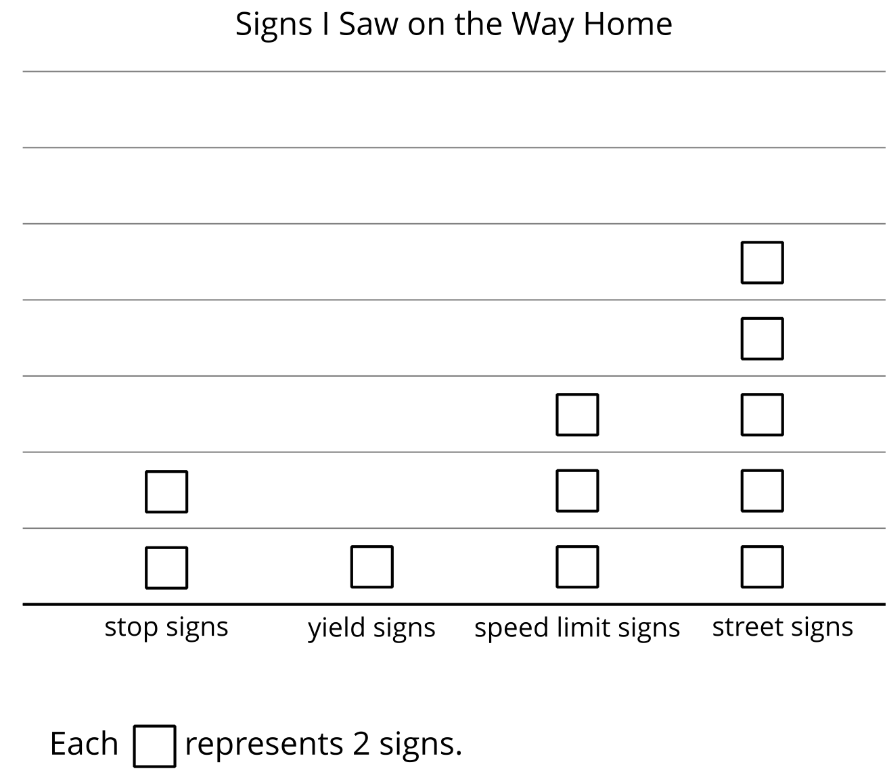
- How does the diagram show the speed limit signs that Elena saw on the way home?
- Represent the data from another category in the graph with your own drawing or diagram.

10.2: Card Sort: Equal Groups
- Your teacher will give you a set of cards that show drawings, situations, and diagrams. Find the cards that match. Be ready to explain your reasoning.
- 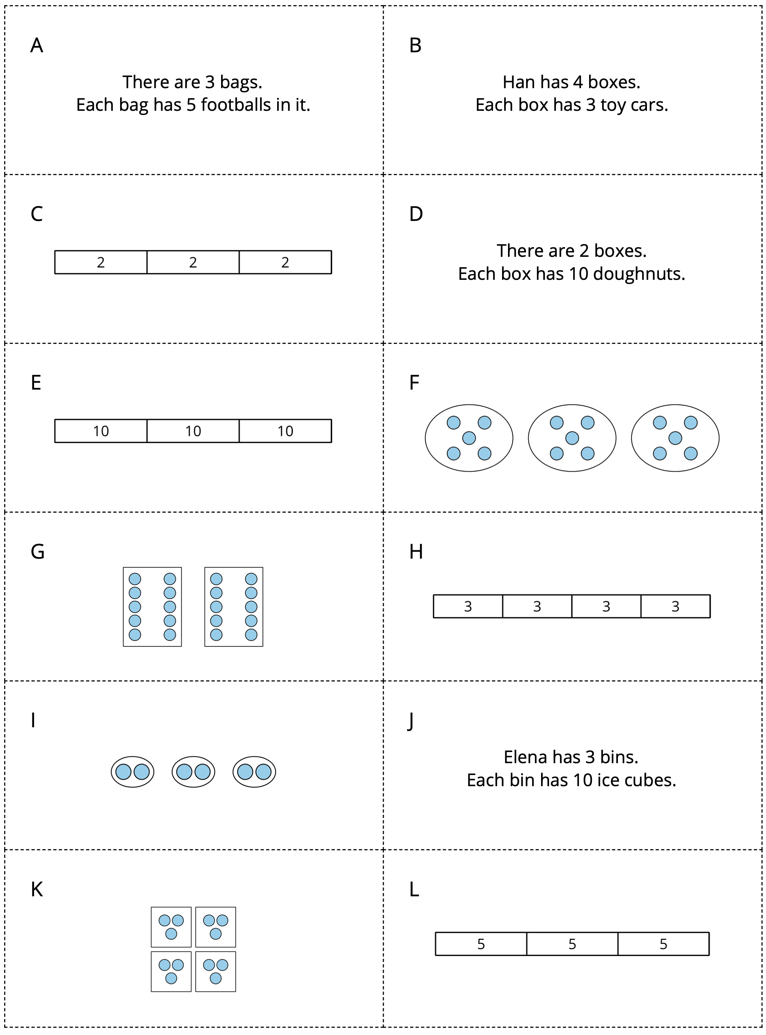
- Create a drawing or diagram for each situation.
  - There are 4 bags. Each bag has 2 strawberries.
  - There are 4 hands. Each hand has 5 fingers.
© CC BY 2021 Illustrative Mathematics®

