Unit 5 Lesson 24: Using Data Displays to Find Associations

1 Sports and Musical Instruments (Warm up)

Student Task Statement
For a survey, students in a class answered these questions:
- Do you play a sport?
- Do you play a musical instrument?
- Here is a two-way table that gives some results from the survey. Complete the table, assuming that all students answered both questions.
 | - plays instrument | - does not play instrument | - total
- plays sport | - 5 |  | - 16
- does not play sport
- total |  | - 15 | - 25
- To the nearest percentage point, what percentage of students who play a sport don’t play a musical instrument?
- To the nearest percentage point, what percentage of students who don’t play a sport also don’t play a musical instrument?

2 Sports and Music Association

Student Task Statement
Your teacher will give you a two-way table with information about the number of people in your class who play sports or musical instruments.
- Complete this table to make a two-way table for the data from earlier. The table will show relative frequencies by row.
 | - plays instrument | - does not play instrument | - row total
- plays sport |  |  | - 100%
- does not play sport |  |  | - 100%

- Make a segmented bar graph for the table. Use one bar of the graph for each row of the table.
- 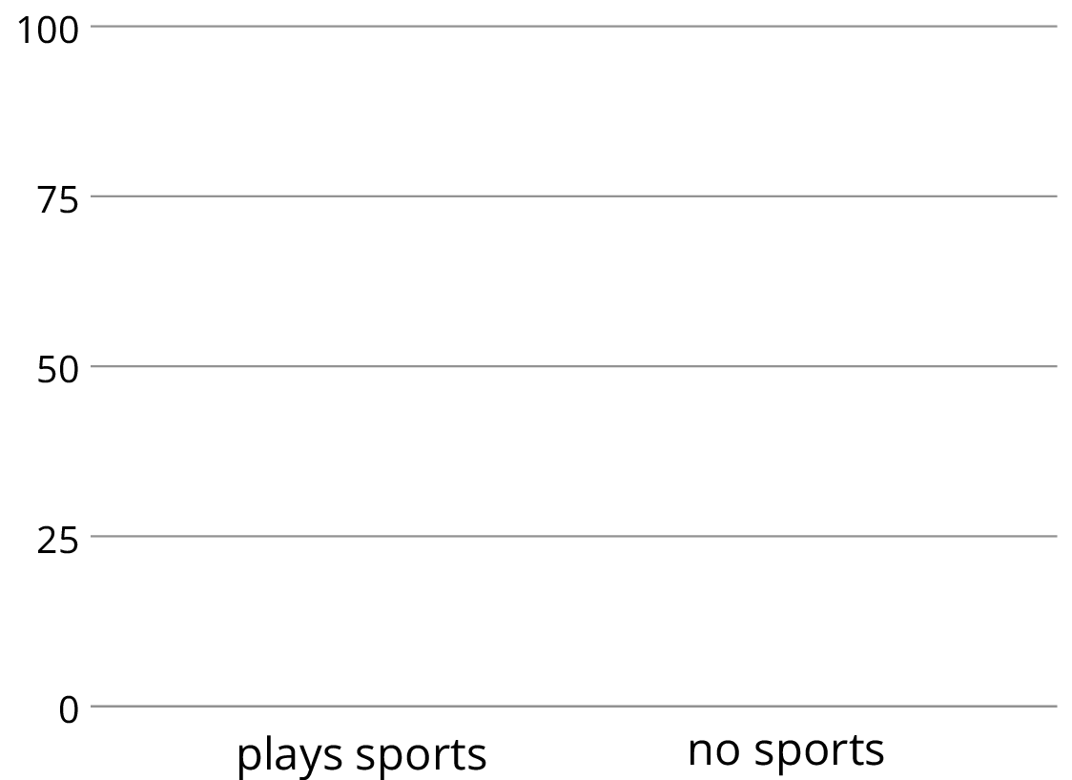
- Complete the table to make a two-way table for the data from earlier. The table will show relative frequencies by column.
 | - plays instrument | - does not play instrument
- plays sport
- does not play sport
- column total | - 100% | - 100%

- Using the values in the table, make a segmented bar graph. Use one bar of the graph for each column of the table.
- 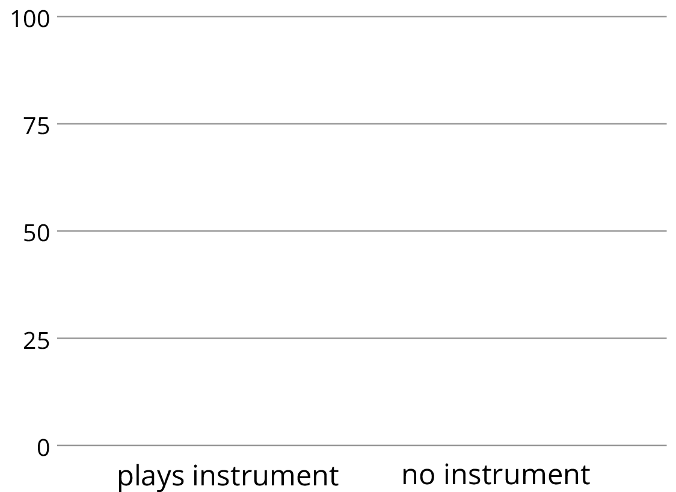
- Based on the two-way tables and segmented bar graphs, do you think there is an association between playing a sport and playing a musical instrument? Explain how you know.

3 Colored Erasers

Student Task Statement
An eraser factory has five machines. One machine makes the eraser shapes. Then each shape goes through the red machine, blue machine, yellow machine, or green machine to have a side colored.
The manager notices that an uncolored side of some erasers is flawed at the end of the process and wants to know which machine needs to be fixed: the shape machine or some of the color machines. The manager collected data on the number of flawed and unflawed erasers of each color.
 | unflawed | flawed | total
red | 285 | 15 | 300
blue | 223 | 17 | 240
yellow | 120 | 80 | 200
green | 195 | 65 | 260
total | 823 | 177 | 1000
- Work with a partner. Each of you should make one segmented bar graph for the data in the table. One segmented bar graph should have a bar for each row of the table. The other segmented bar graph should have one bar for each column of the table.
- Are the flawed erasers associated with certain colors? If so, which colors? Explain your reasoning.
© CC BY Open Up Resources. Adaptations CC BY IM.

