Unit 3 Lesson 11 Cumulative Practice Problems
- A pool in the shape of a rectangular prism is being filled with water. The length and width of the pool is 24 feet and 15 feet. If the height of the water in the pool is $1\frac{1}{3}$ feet, what is the volume of the water in cubic feet?
  - Here is a right triangle. What is its area?
  - What is the height $h$ for the base that is $\frac{5}{4}$ units long? Show your reasoning.
- 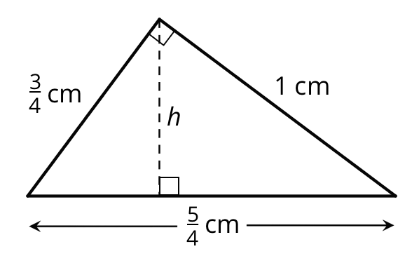
- (From Unit 3, Lesson 10.)
  - Which expression can be used to find how many cubes with edge length of $\frac{1}{3}$ unit fit in a prism that is 5 units by 5 units by 8 units? Explain or show your reasoning.
    - $(5⋅\frac{1}{3})⋅(5⋅\frac{1}{3})⋅(8⋅\frac{1}{3})$
    - $5⋅5⋅8$
    - $(5⋅3)⋅(5⋅3)⋅(8⋅3)$
    - $(5⋅5⋅8)⋅(\frac{1}{3})$
  - Mai says that we can also find the answer by multiplying the edge lengths of the prism and then multiplying the result by 27. Do you agree with her? Explain your reasoning.
- (From Unit 3, Lesson 10.)
- A rectangular prism measures $2\frac{2}{5}$ inches by $3\frac{1}{5}$ inches by 2 inch.
  - Priya said, “It takes more cubes with edge length$\frac{2}{5}$ inch than cubes with edge length $\frac{1}{5}$ inch to pack the prism.” Do you agree with Priya? Explain or show your reasoning.
  - How many cubes with edge length $\frac{1}{5}$ inch fit in the prism? Show your reasoning.
  - Explain how you can use your answer in the previous question to find the volume of the prism in cubic inches.
- To give their animals essential minerals and nutrients, farmers and ranchers often have a block of salt—called “salt lick”—available for their animals to lick.
  - A rancher is ordering a box of cube-shaped salt licks. The edge lengths of each salt lick are $\frac{5}{12}$ foot. Is the volume of one salt lick greater or less than 1 cubic foot? Explain your reasoning.
  - 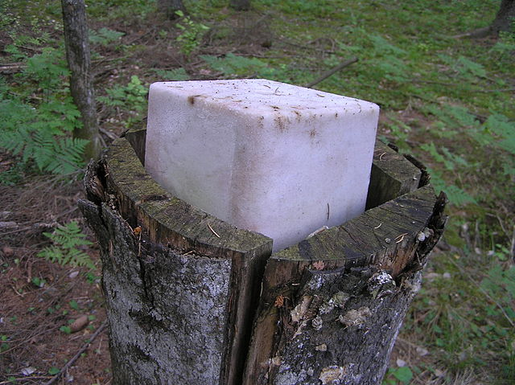
  - The box that contains the salt lick is $1\frac{1}{4}$ feet by $1\frac{2}{3}$ feet by $\frac{5}{6}$ feet. How many cubes of salt lick fit in the box? Explain or show your reasoning.
- Consider the problem: A bucket contains $11\frac{2}{3}$ gallons of water and is $\frac{5}{6}$ full. How many gallons of water would be in a full bucket?
- Write a multiplication and a division equation to represent the situation. Then, find the answer and show your reasoning.

- (From Unit 3, Lesson 7.)
- There are 80 kids in a gym. 75% are wearing socks. How many are not wearing socks? If you get stuck, consider using a tape diagram.
- (From Unit 2, Lesson 21.)
© CC BY Open Up Resources. Adaptations CC BY IM.

