Lesson 9 Practice Problems
- Match each number to its name.
  - 1,000,000
  - 0.01
  - 1,000,000,000
  - 0.000001
  - 0.001
  - 10,000
  - One hundredth
  - One thousandth
  - One millionth
  - Ten thousand
  - One million
  - One billion
- Write each expression as a multiple of a power of 10:
  - 42,300
  - 2,000
  - 9,200,000
  - Four thousand
  - 80 million
  - 32 billion
- Each statement contains a quantity. Rewrite each quantity using a power of 10.
  - There are about 37 trillion cells in an average human body.
  - The Milky Way contains about 300 billion stars.
  - A sharp knife is 23 millionths of a meter thick at its tip.
  - The wall of a certain cell in the human body is 4 nanometers thick. (A nanometer is one billionth of a meter.)
- A fully inflated basketball has a radius of 12 cm. Your basketball is only inflated halfway. How many more cubic centimeters of air does your ball need to fully inflate? Express your answer in terms of $π$. Then estimate how many cubic centimeters this is by using 3.14 to approximate $π$.
- (From Unit 5, Lesson 20.)
- Solve each of these equations. Explain or show your reasoning.
- $2\left(3−2c\right)=30$
- $3x−2=7−6x$
- $31=5\left(b−2\right)$
- (From Unit 4, Lesson 5.)
- Graph the line going through $\left(\text{-}6,1\right)$ with a slope of $\frac{\text{-}2}{3}$ and write its equation.
- 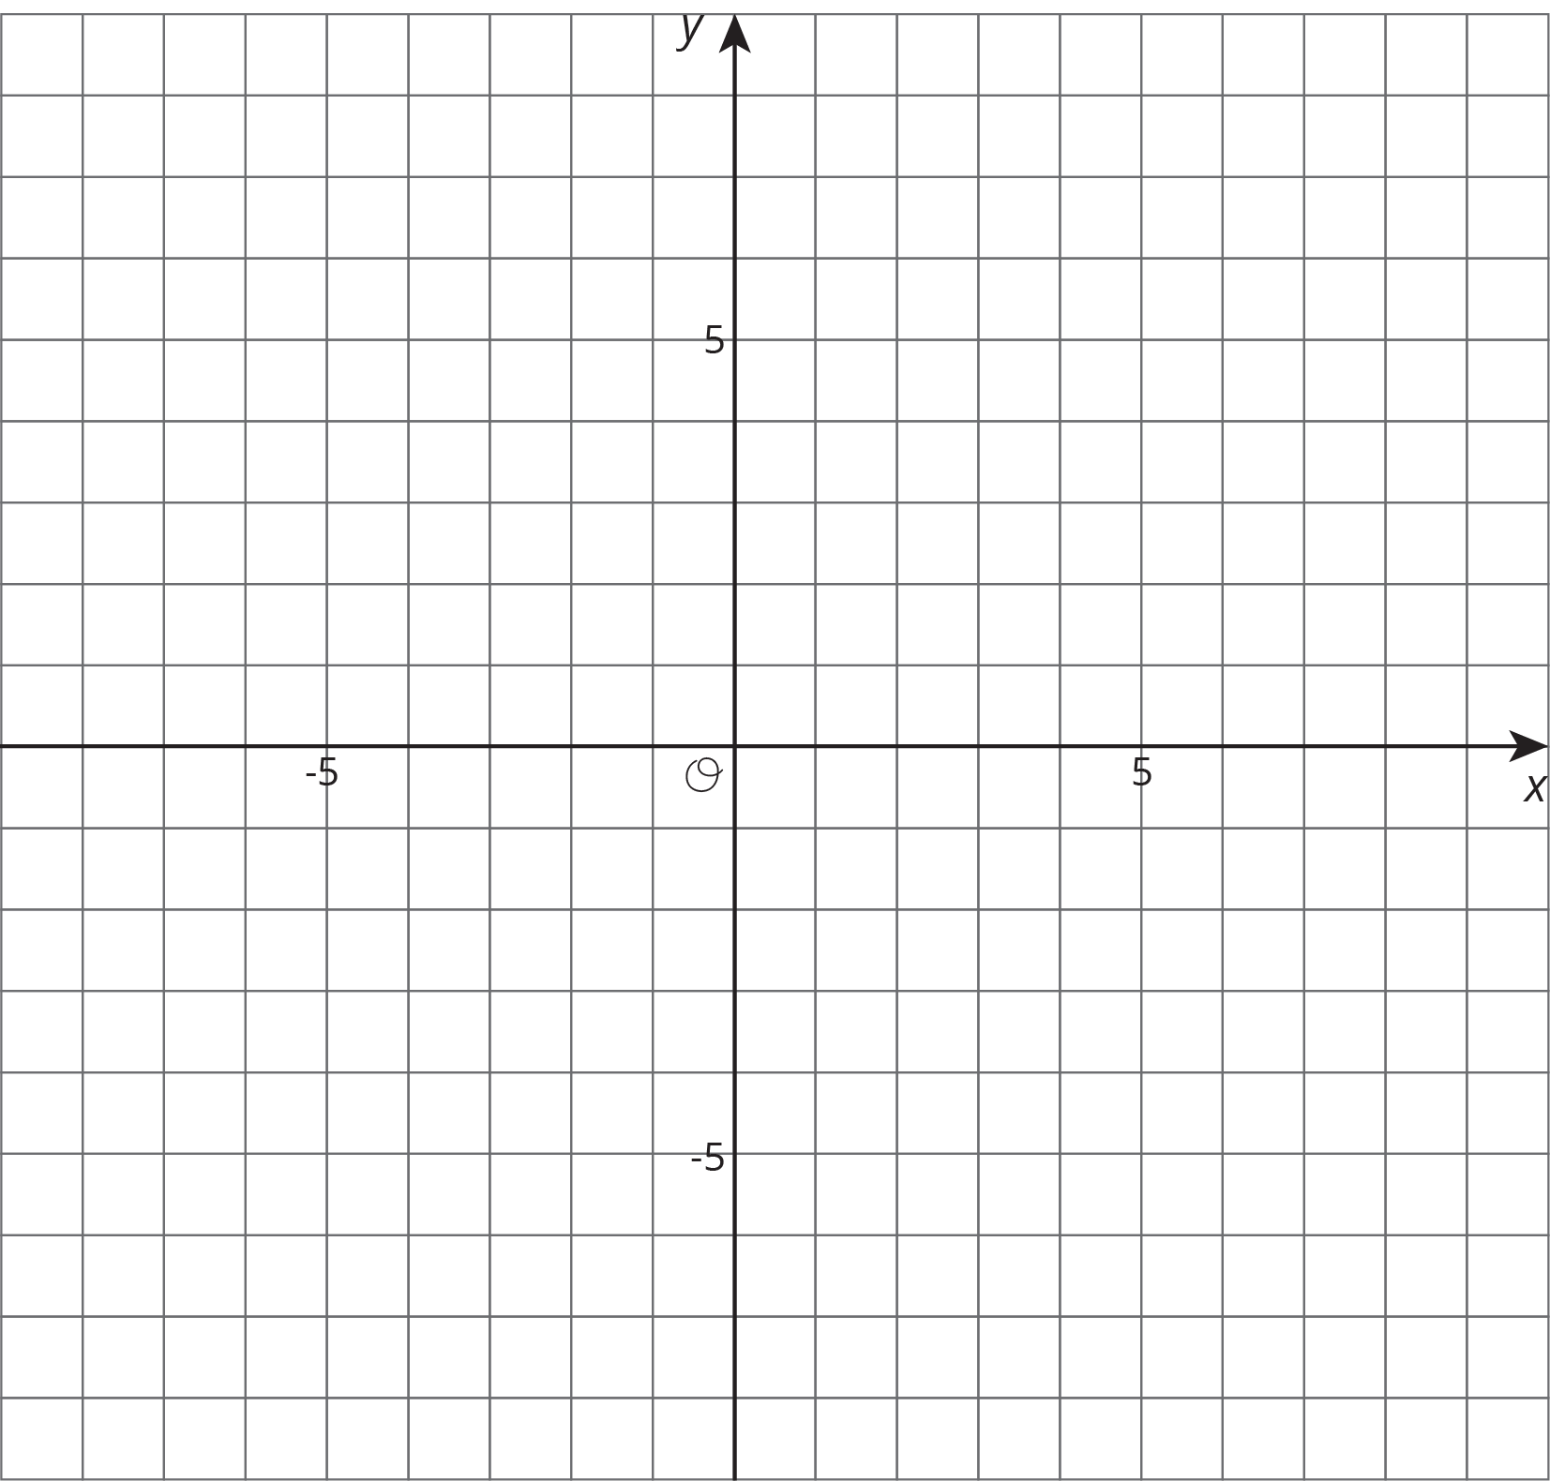
- (From Unit 3, Lesson 10.)
© CC BY Open Up Resources. Adaptations CC BY IM.

