Unit 3 Lesson 8: Correlations

1 Notice and Wonder: Correlations (Warm up)

Student Task Statement
What do you notice? What do you wonder?
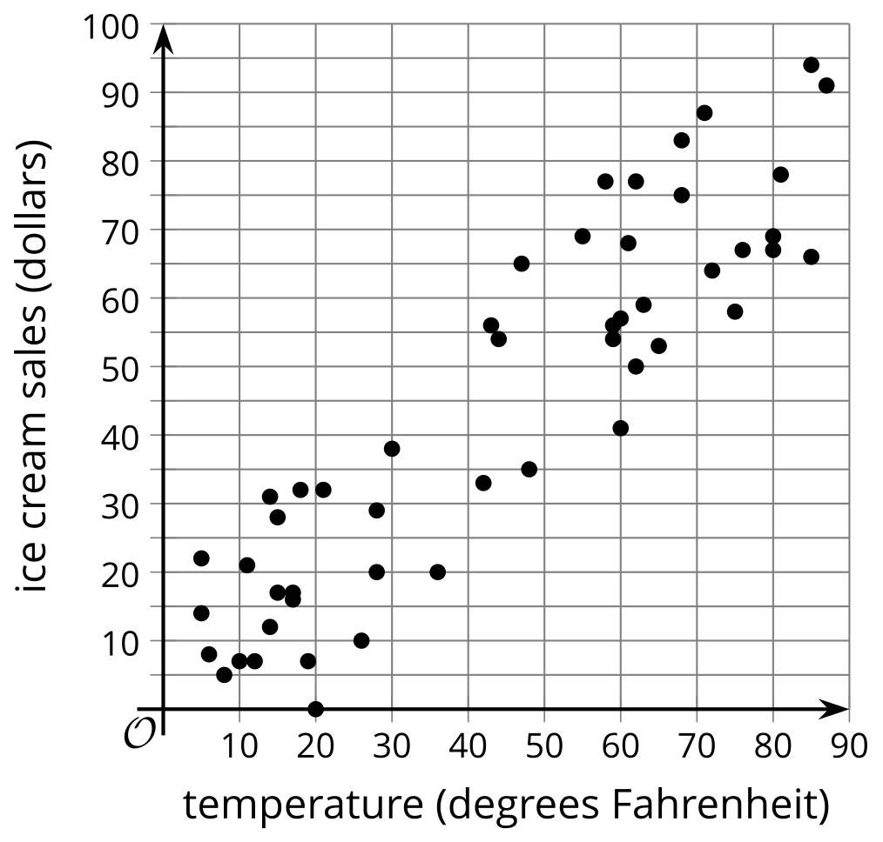
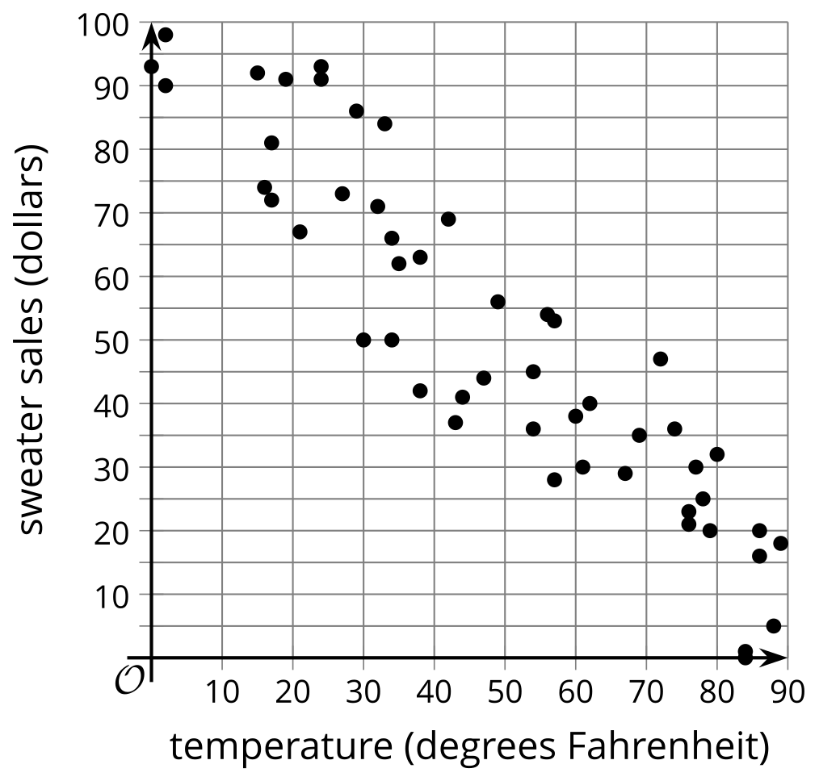
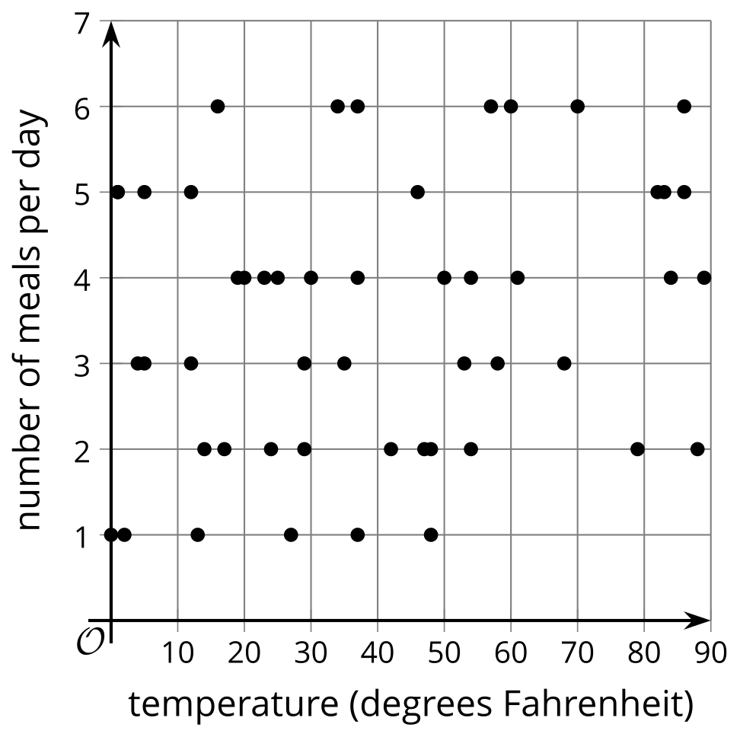

2 Variable Relationships

Student Task Statement
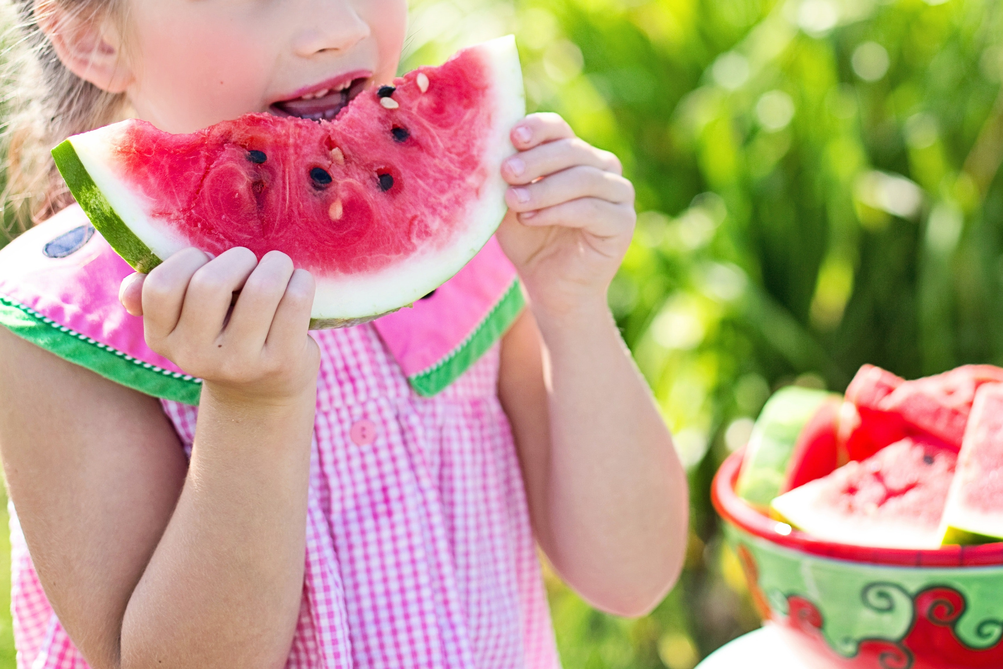
- For each pair of variables, do you expect there to be a relationship? That is, do you think a change in one variable is accompanied by a change in the other variable? How do you expect the second variable to change if the first variable is increased?
  - hours of sleep and energy level
  - length of hair and energy level
  - number of school events each week and time spent watching videos online each week
  - temperature and watermelon sales
- Some data is collected for each pair of variables listed and represented by a scatter plot. For each pair of variables, how do the scatter plots support or contradict your answers from the previous question?
  - 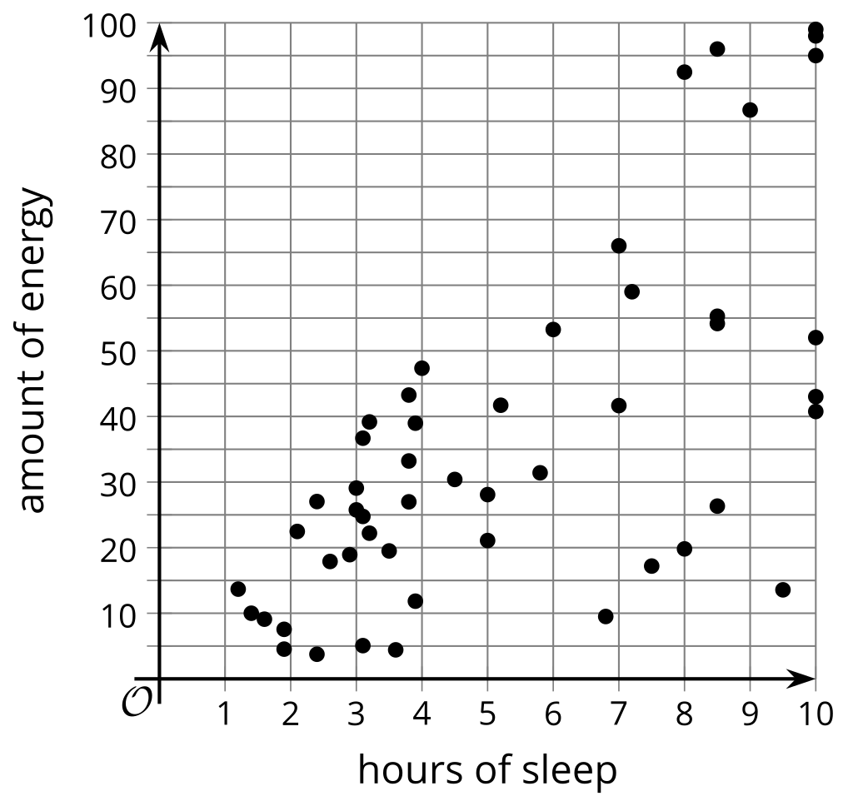
  - 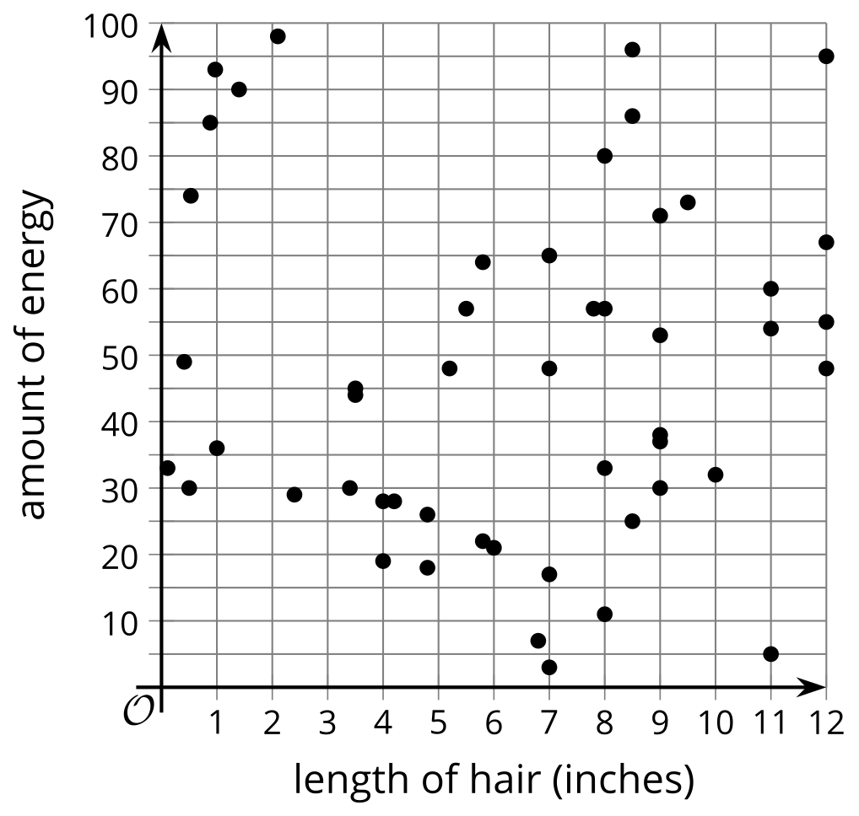
  - 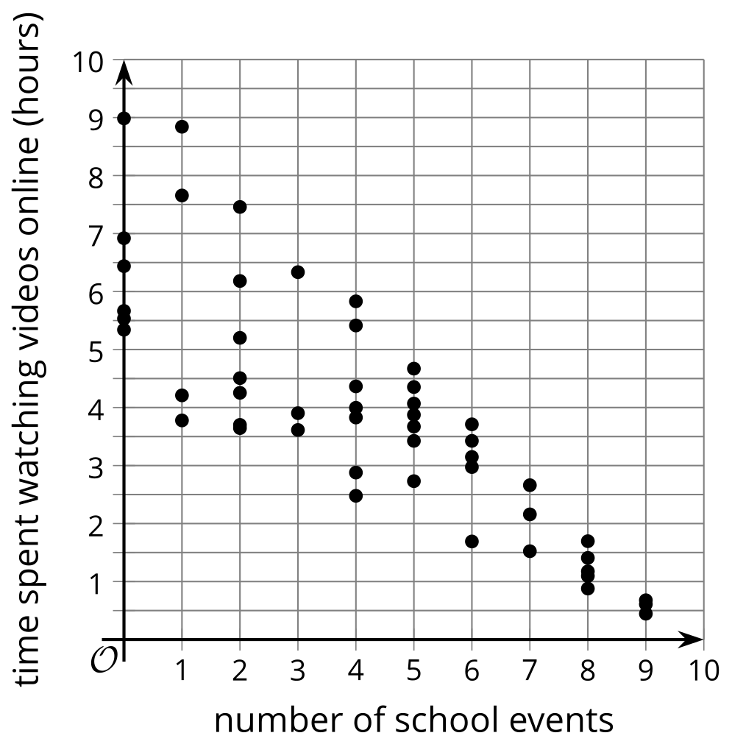
  - 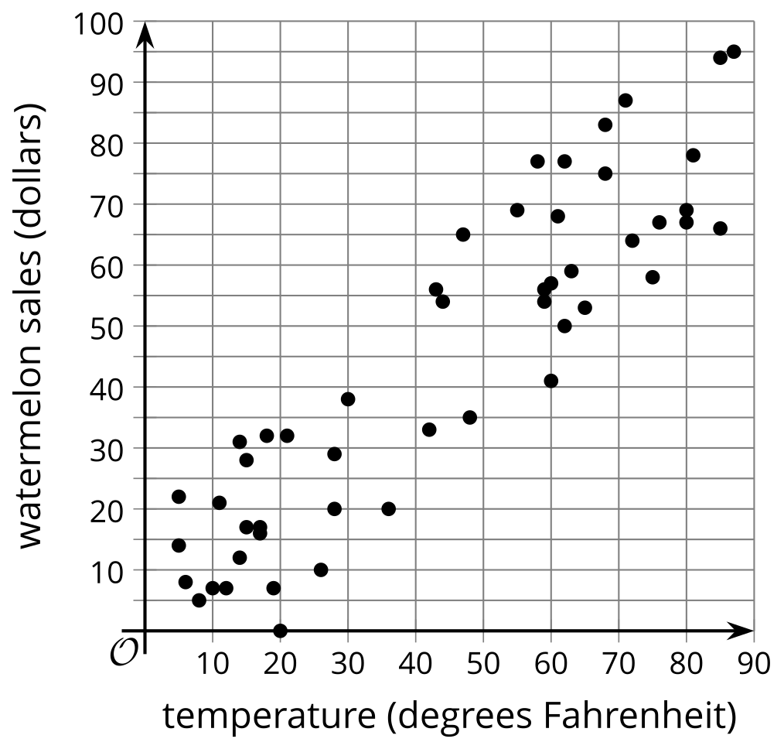

3 Card Sort: Correlations

Student Task Statement
Your teacher will give you a set of cards. Match each scatter plot with a pair of variables. Be prepared to explain your reasoning.
© CC BY 2019 by Illustrative Mathematics®

