Lesson 17: Systems of Linear Equations and Their Solutions
- Let's find out how many solutions a system of equations could have.

17.1: A Curious System
Andre is trying to solve this system of equations: $\left\{\begin{matrix}x+y=3 \\ 4x=12−4y\end{matrix}\right.$
Looking at the first equation, he thought, "The solution to the system is a pair of numbers that add up to 3. I wonder which two numbers they are."
- Choose any two numbers that add up to 3. Let the first one be the $x$-value and the second one be the $y$-value.
- The pair of values you chose is a solution to the first equation. Check if it is also a solution to the second equation. Then, pause for a brief discussion with your group.
- How many solutions does the system have? Use what you know about equations or about solving systems to show that you are right.

17.2: What's the Deal?
A recreation center is offering special prices on its pool passes and gym memberships for the summer. On the first day of the offering, a family paid $96 for 4 pool passes and 2 gym memberships. Later that day, an individual bought a pool pass for herself, a pool pass for a friend, and 1 gym membership. She paid $72.
- Write a system of equations that represents the relationships between pool passes, gym memberships, and the costs. Be sure to state what each variable represents.
- Find the price of a pool pass and the price of a gym membership by solving the system algebraically. Explain or show your reasoning.
- Use graphing technology to graph the equations in the system. Make 1-2 observations about your graphs.

17.3: Card Sort: Sorting Systems
Your teacher will give you a set of cards. Each card contains a system of equations.
Sort the systems into three groups based on the number of solutions each system has. Be prepared to explain how you know where each system belongs.

Are you ready for more?
- In the cards, for each system with no solution, change a single constant term so that there are infinitely many solutions to the system.
- For each system with infinitely many solutions, change a single constant term so that there are no solutions to the system.
- Explain why in these situations it is impossible to change a single constant term so that there is exactly one solution to the system.

17.4: One, Zero, Infinitely Many
Here is an equation: $5x−2y=10$.
Create a second equation that would make a system of equations with:
- One solution
- No solutions
- Infinitely many solutions

Lesson 17 Summary
We have seen many examples of a system where one pair of values satisfies both equations. Not all systems, however, have one solution. Some systems have many solutions, and others have no solutions.
Let's look at three systems of equations and their graphs.
System 1: $\left\{\begin{matrix}3x+4y=8 \\ 3x−4y=8\end{matrix}\right.$
The graphs of the equations in System 1 intersect at one point. The coordinates of the point are the one pair of values that are simultaneously true for both equations. When we solve the equations, we get exactly one solution.
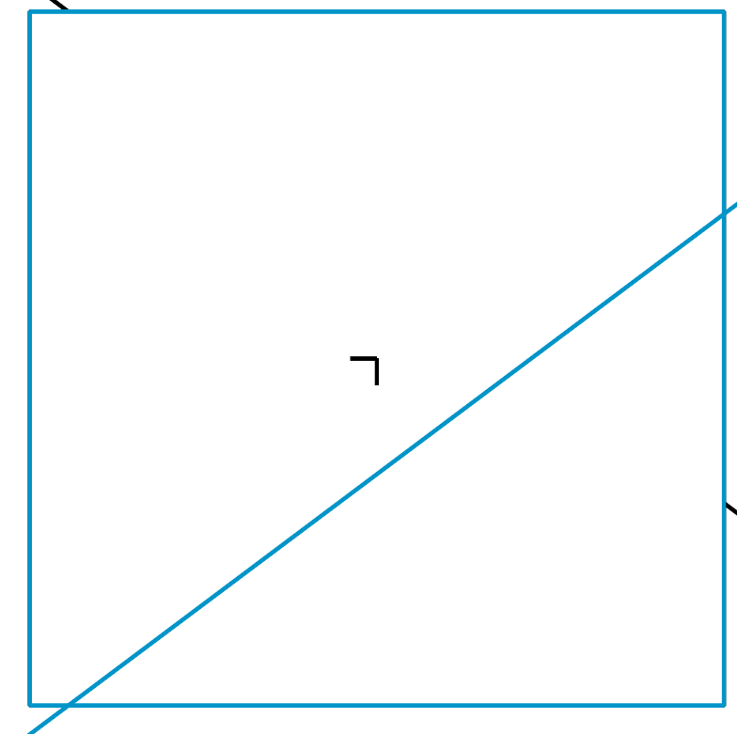
System 2: $\left\{\begin{matrix}3x+4y=8 \\ 6x+8y=16\end{matrix}\right.$
The graphs of the equations in System 2 appear to be the same line. This suggests that every point on the line is a solution to both equations, or that the system has infinitely many solutions.​​​​​​
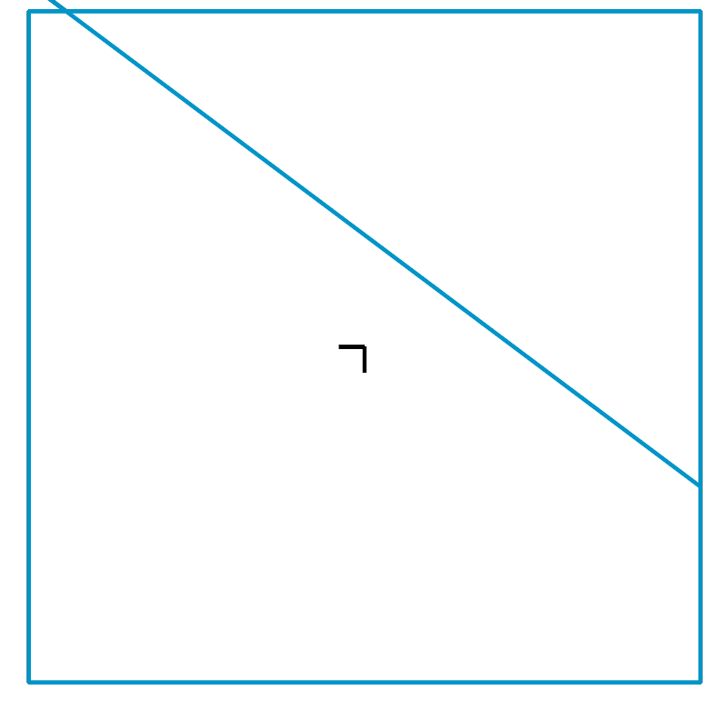
System 3:$\left\{\begin{matrix}3x+4y=8 \\ 3x+4y=\text{-}4\end{matrix}\right.$
The graphs of the equations in System 3 appear to be parallel. If the lines never intersect, then there is no common point that is a solution to both equations and the system has no solutions.
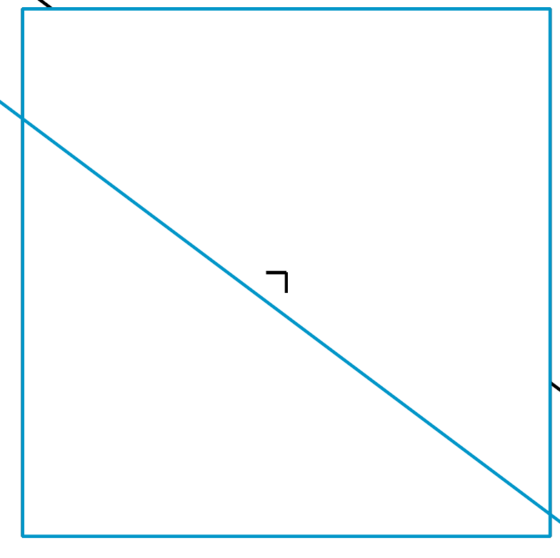
How can we tell, without graphing, that System 2 indeed has many solutions?
- Notice that $3x+4y=8$ and $6x+8y=16$ are equivalent equations. Multiplying the first equation by 2 gives the second equation. Multiplying the second equation by $\frac{1}{2}$ gives the first equation. This means that any solution to the first equation is a solution to the second.
- Rearranging $3x+4y=8$ into slope-intercept form gives $y=\frac{8−3x}{4}$, or $y=2−\frac{3}{4}x$. Rearranging $6x+8y=16$ gives $y=\frac{16−6x}{8}$, which is also $y=2−\frac{3}{4}x$. Both lines have the same slope and the same $y$-value for the vertical intercept!
How can we tell, without graphing, that System 3 has no solutions?
- Notice that in one equation $3x+4y$ equals 8, but in the other equation it equals -4. Because it is impossible for the same expression to equal 8 and -4, there must not be a pair of $x$- and $y$-values that are simultaneously true for both equations. This tells us that the system has no solutions.
- Rearranging each equation into slope-intercept form gives $y=2−\frac{3}{4}x$ and $y=\text{-}1−\frac{3}{4}x$. The two graphs have the same slope but the $y$-values of their vertical intercepts are different. This tells us that the lines are parallel and will never cross.
© CC BY 2019 by Illustrative Mathematics®

