Lesson 8: The Perpendicular Bisector Theorem
- Let’s convince ourselves that what we’ve conjectured about perpendicular bisectors must be true.

8.1: Which One Doesn’t Belong: Intersecting Lines
Which one doesn’t belong?

A
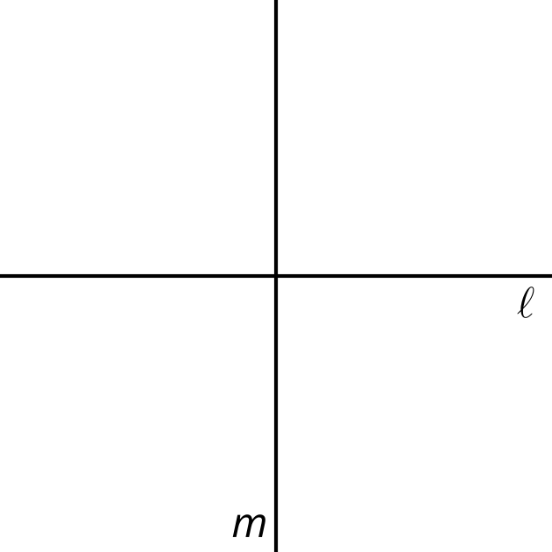

B
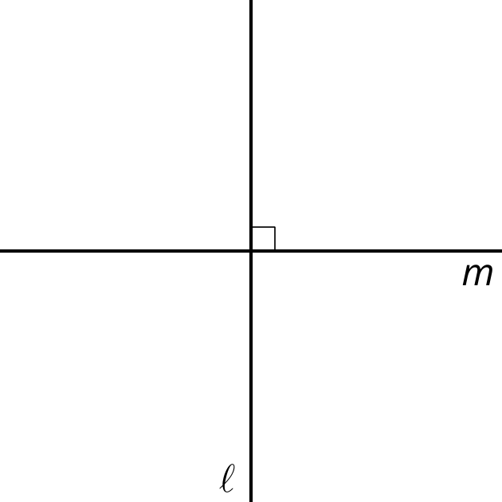

C
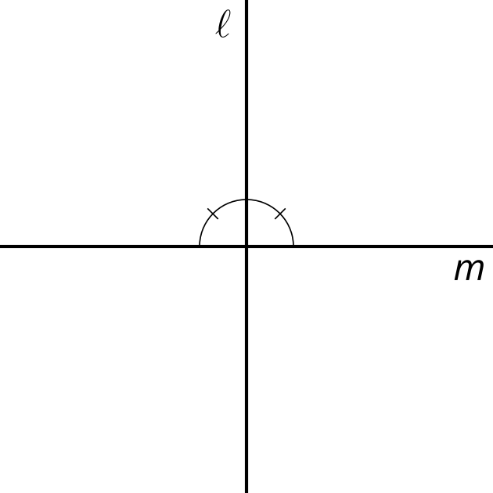

D
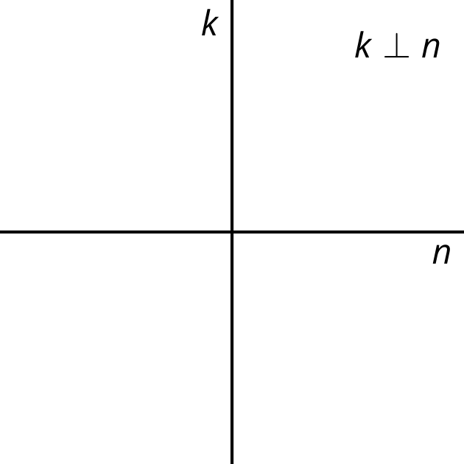

8.2: Lots of Lines
Diego, Jada, and Noah were given the following task:
Prove that if a point $C$ is the same distance from $A$ as it is from $B$, then $C$ must be on the perpendicular bisector of $AB$.
At first they were really stuck. Noah asked, “How do you prove a point is on a line?” Their teacher gave them the hint, “Another way to think about it is to draw a line that you know $C$ is on, and prove that line has to be the perpendicular bisector.”
They each drew a line and thought about their pictures. Here are their rough drafts.
Diego’s approach: “I drew a line through $C$ that was perpendicular to $AB$ and through the midpoint of $AB$. That line is the perpendicular bisector of $AB$ and $C$ is on it, so that proves $C$ is on the perpendicular bisector.”
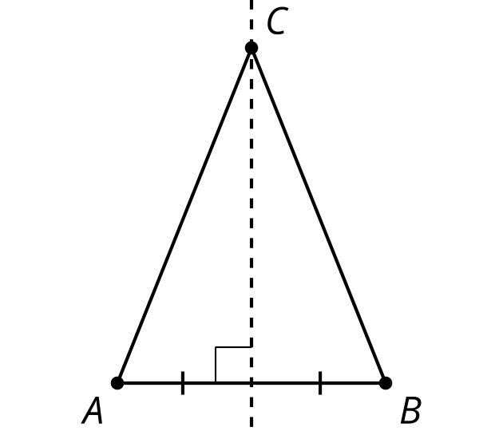
Jada’s approach: “I thought the line through $C$ would probably go through the midpoint of $AB$ so I drew that and labeled the midpoint $D$. Triangle $ACB$ is isosceles, so angles $A$ and $B$ are congruent, and $AC$ and $BC$ are congruent. And $AD$ and $DB$ are congruent because $D$ is a midpoint. That made two congruent triangles by the Side-Angle-Side Triangle Congruence Theorem. So I know angle $ADC$ and angle $BDC$ are congruent, but I still don’t know if $DC$ is the perpendicular bisector of $AB$.”
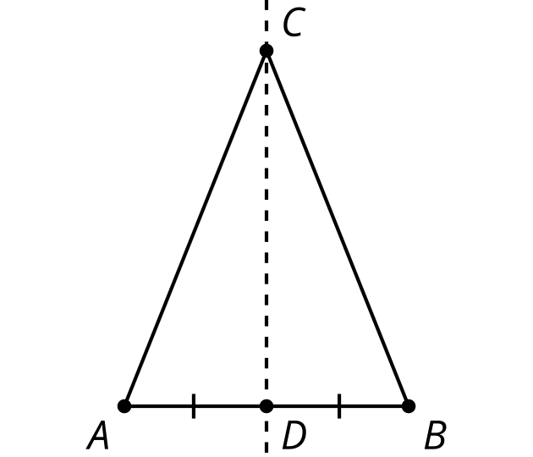
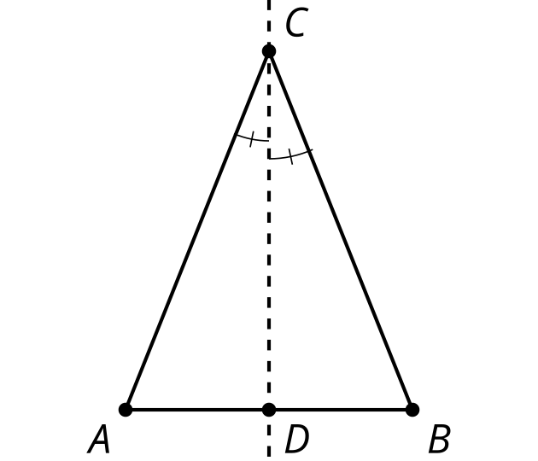
Noah’s approach: “In the Isosceles Triangle Theorem proof, Mai and Kiran drew an angle bisector in their isosceles triangle, so I’ll try that. I’ll draw the angle bisector of angle $ACB$. The point where the angle bisector hits $AB$ will be $D$. So triangles $ACD$ and $BCD$ are congruent, which means $AD$ and $BD$ are congruent, so $D$ is a midpoint and $CD$ is the perpendicular bisector.”
- With your partner, discuss each student’s approach.
  - What do you notice that this student understands about the problem?
  - What question would you ask them to help them move forward?
- Using the ideas you heard and the ways you think each student could make their explanation better, write your own explanation for why $C$ must be on the perpendicular bisector of $A$ and $B$.

Are you ready for more?
Elena has another approach: “I drew the line of reflection. If you reflect across $C$, then $A$ and $B$ will switch places, meaning $A^{′}$coincides with $B$, and $B^{′}$ coincides with $A$. $C$ will stay in its place, so the triangles will be congruent.”
1. What feedback would you give Elena?
2. Write your own explanation based on Elena‘s idea.

8.3: Not Too Close, Not Too Far
- Work on your own to make a diagram and write a rough draft of a proof for the statement:
- If $P$ is a point on the perpendicular bisector of $AB$, prove that the distance from $P$ to $A$ is the same as the distance from $P$ to $B$.
- With your partner, discuss each other’s drafts. Record your partner‘s feedback for your proof.
  - What do you notice that your partner understands about the problem?
  - What question would you ask them to help them move forward?

Lesson 8 Summary
The perpendicular bisector of a line segment is exactly those points that are the same distance from both endpoints of the line segment. This idea can be broken down into 2 statements:
- If a point is on the perpendicular bisector of a segment, then it must be the same distance from both endpoints of the line segment.
- If a point is the same distance from both endpoints of a line segment, then it must be on the perpendicular bisector of the segment.
These statements are converses of one another. Two statements are converses if the “if” part and the “then” part are swapped. The converse of a true statement isn‘t always true, but in this case, both statements are true parts of the Perpendicular Bisector Theorem.
A line of reflection is the perpendicular bisector of segments connecting points in the original figure with corresponding points in the image. Therefore, these 3 lines are all the same:
- The perpendicular bisector of a segment.
- The set of points equidistant from the 2 endpoints of a segment.
- The line of reflection that takes the 2 endpoints of the segment onto each other, and the segment onto itself.
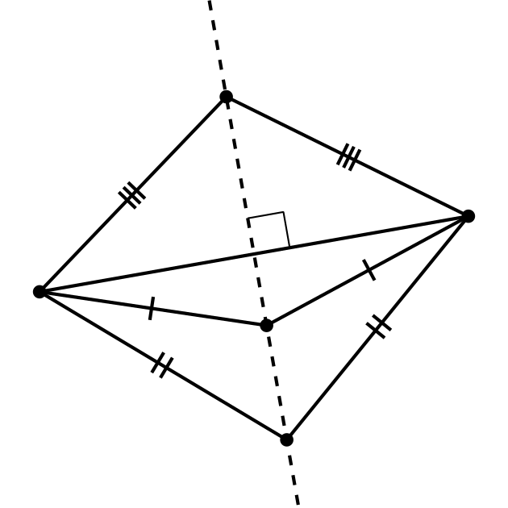
It is useful to know that the perpendicular bisector of a line segment is also all the points which are the same distance from both endpoints of the line segment, because then:
- If 2 points are both equidistant from the endpoints of a segment, then the line through those points must be the perpendicular bisector of the segment (because 2 points define a unique line).
- If 2 points are both equidistant from the endpoints of a segment, then the line through those must be the line of reflection that takes the segment to itself and swaps the endpoints.
- If a point is on the line of reflection, then it is the same distance from that point to a point in the original figure and to its corresponding point in the image.
- If a point is on the perpendicular bisector of a segment, then it is the same distance from that point to both endpoints of the segment.
© CC BY 2019 by Illustrative Mathematics®

