Lesson 13: Analyze Addition Mistakes
- Let’s use place value strategies to add decimals.

Warm-up: Estimation Exploration: Many Places
$1,​987.89+658.54$
Record an estimate that is:
too low | about right | too high

13.1: Compare Calculations
- Find the value of $621.45+72.3$. Explain or show your reasoning.
- Elena and Andre found the value of $621.45+72.3$. Who do you agree with? Explain or show your reasoning.
- 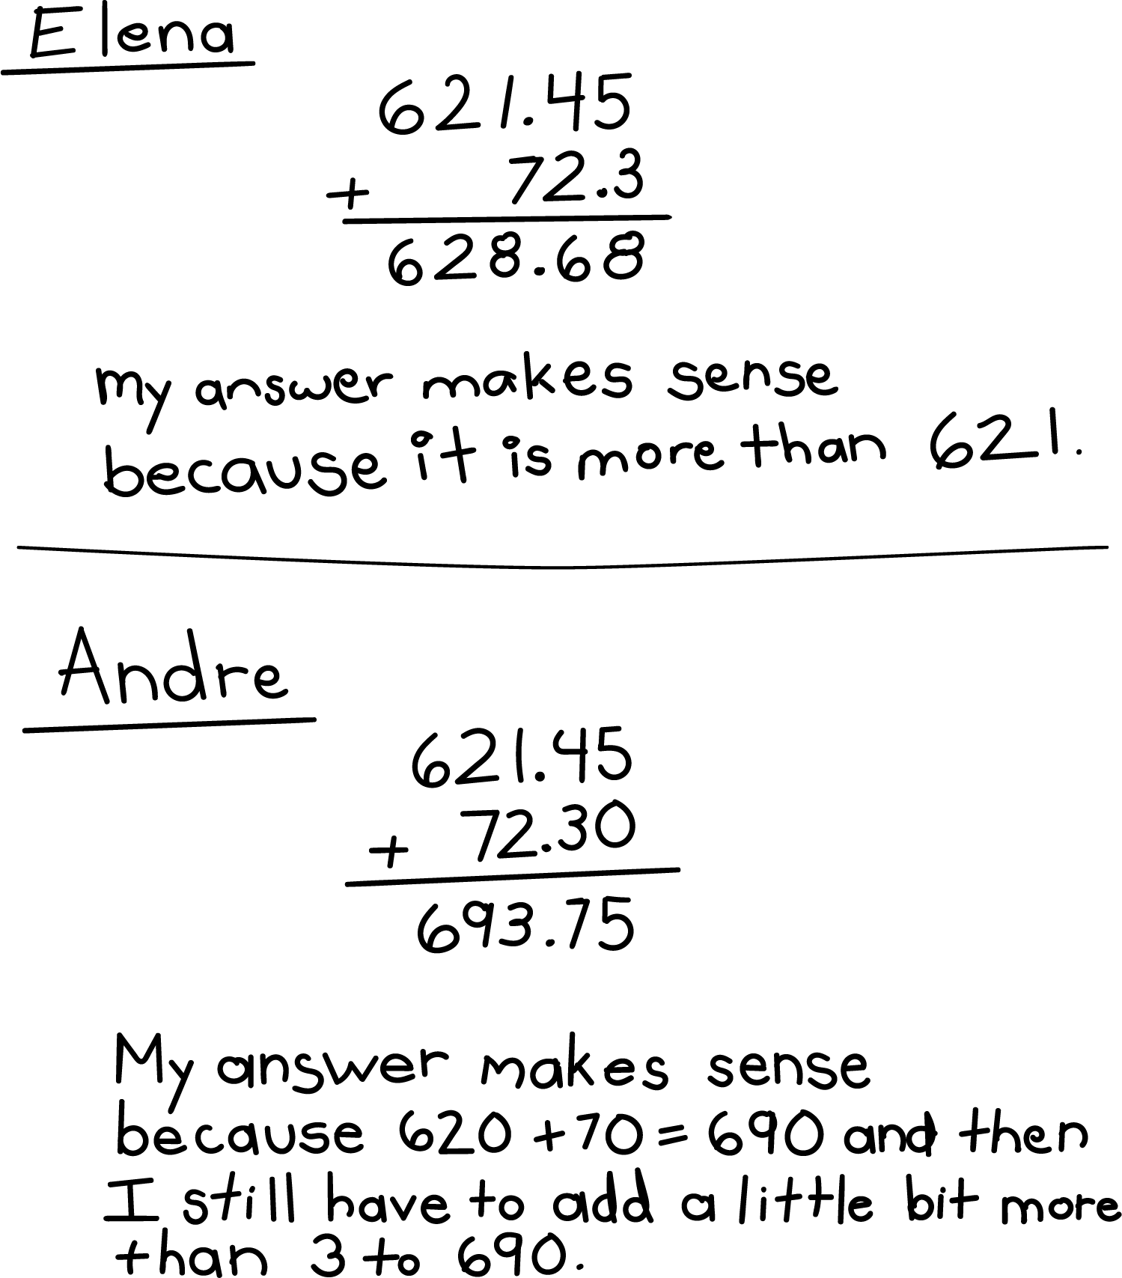

13.2: Same Digits, Different Sums
Find the value of each expression. Explain or show your reasoning.
- $2.63+7.74$
- $26.3+774$
- $46.3+31.42$
- $463+3.14$
© CC BY 2021 Illustrative Mathematics®

