Unit 3 Lesson 20: How Much in the Group?

WU Estimation Exploration: What Number Goes in the Blank? (Warm up)

Student Task Statement
What number goes in the blank?
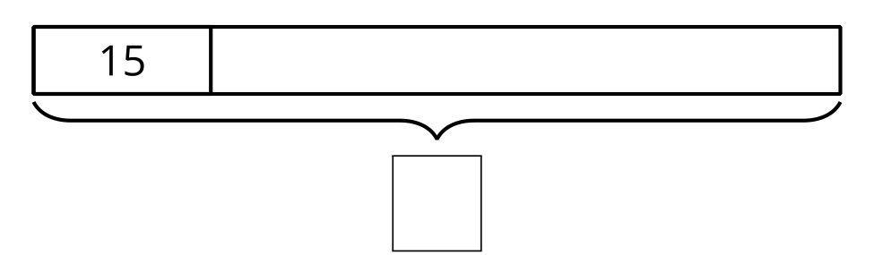
Record an estimate that is:
too low | about right | too high

1 Different Equations

Student Task Statement
- If $\frac{1}{3}$ of the class is 9 students, how many students are in the class?
- Explain or show your reasoning.
- Explain how each of these equations represents this situation.
  - $\frac{1}{3}×\underset{_}{}=9$
  - $\underset{_}{}÷3=9$
  - $3×9=\underset{_}{}$

2 How Big is the Class?

Student Task Statement
- Jada’s class has 24 students in it. That is $\frac{1}{4}$ of the total students in the 5th grade. How many students are in the 5th grade? Explain or show your reasoning.
- Select all the equations that represent this situation.
  - $\frac{1}{4}×24=\underset{_}{}$
  - $\underset{_}{}÷4=24$
  - $\frac{1}{4}÷24=\underset{_}{}$
  - $24=\frac{1}{4}×\underset{_}{}$

3 How Many in One Group?

Student Task Statement
Solve each problem. Show or explain your reasoning.
- 250 mg of calcium is $\frac{1}{4}$ of the daily recommended allowance. What is the daily recommended allowance of calcium? Show or explain your reasoning.
- A rocket took 60 days to get $\frac{1}{5}$ of the way to Mars. How many days did it take the rocket to get to Mars? Show or explain your reasoning.
© CC BY 2021 Illustrative Mathematics®

