Lesson 8: Represent and Solve Story Problems
- Let’s show what happens in a story problem and solve it.

Warm-up: Act It Out: Birds in a Fountain
8 birds were splashing in the fountain.
3 of the birds flew away.
How can you act out this story?
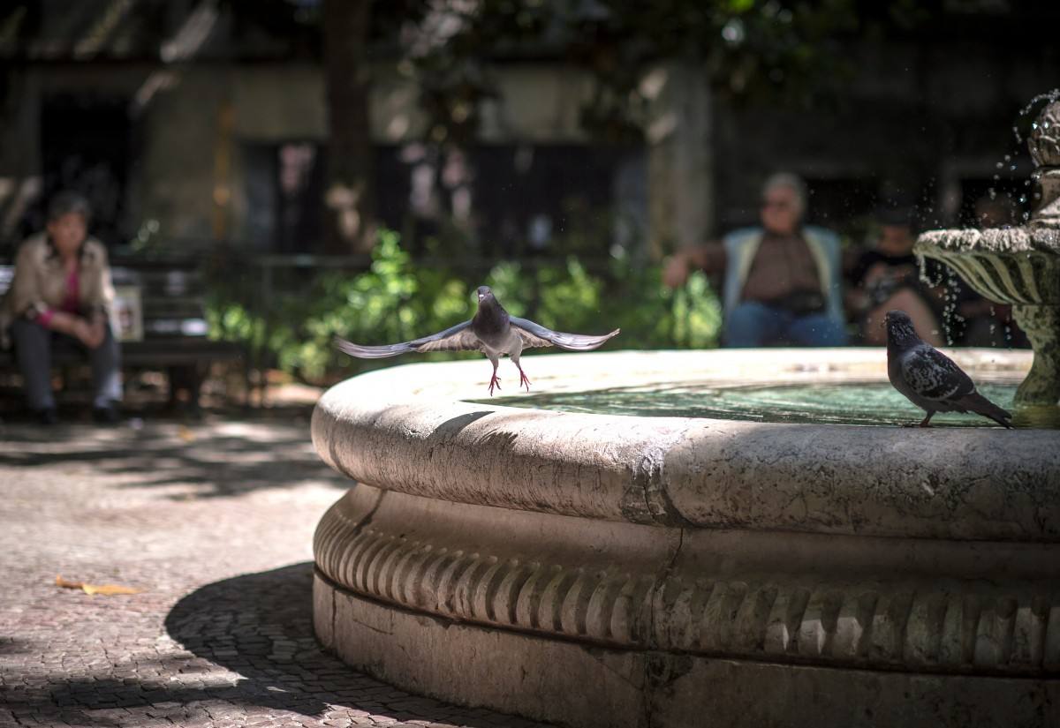

8.1: Questionless Story Problems
- 8 birds were splashing in the fountain.
- 3 of the birds flew away.
- Priya planted 6 flowers in the neighborhood garden at the park.
- Diego planted 3 more flowers in the garden.

8.2: From a Story to a Story Problem
Noah had 5 crayons.
Jada gave Noah 4 more crayons.
How many crayons does Noah have now?

8.3: Centers: Choice Time
Choose a center.
Math Stories
Subtraction Towers
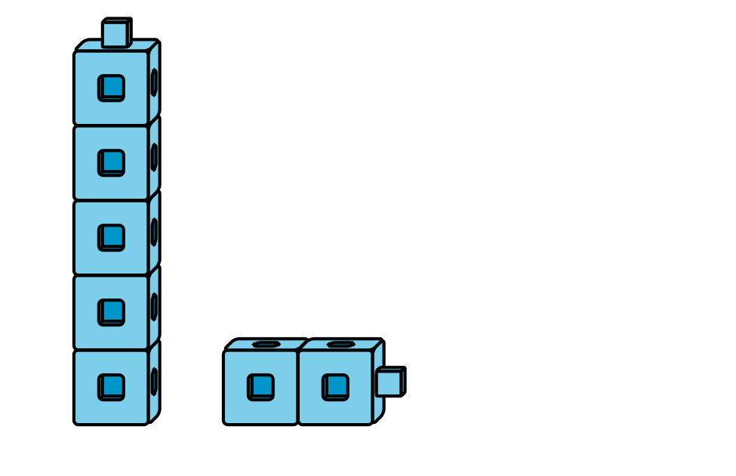
5-frames
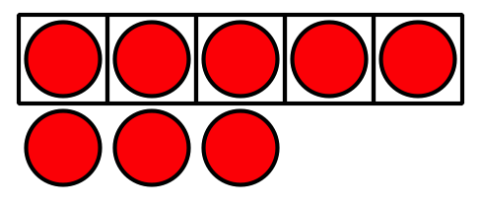
Build Shapes
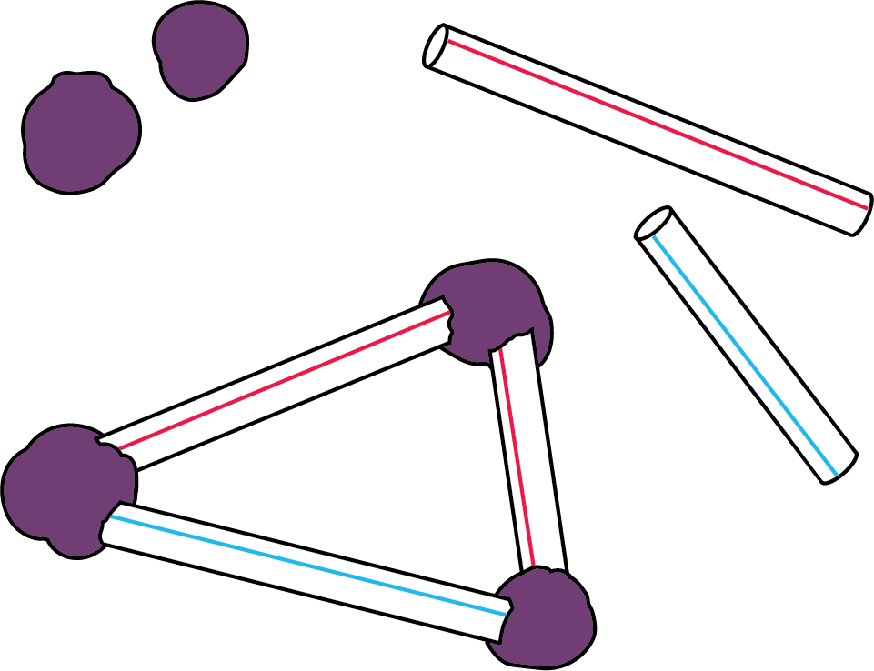
Counting Collections
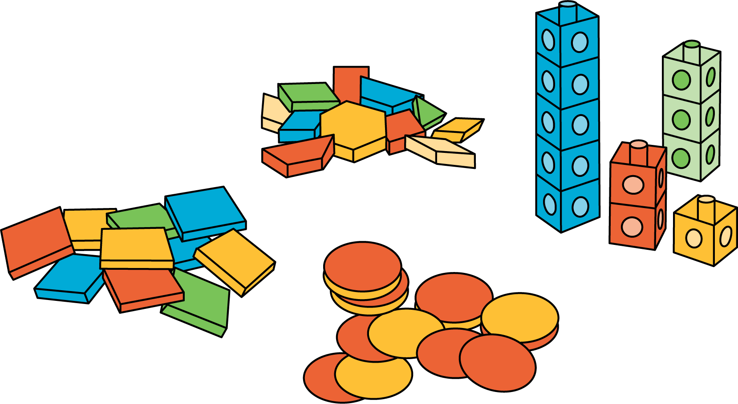
© CC BY 2021 Illustrative Mathematics®

