Unit 4 Lesson 8: Different Representations of Tens and Ones

WU Estimation Exploration: How Many? (Warm up)

Student Task Statement
- How many do you see?
- 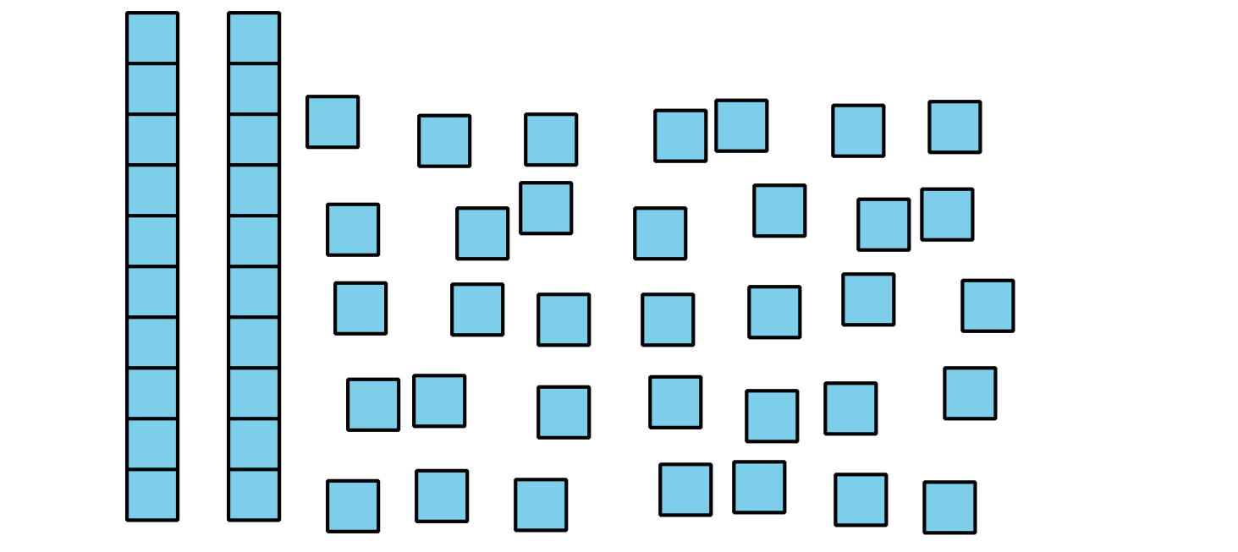
- Record an estimate that is:
- too low | - about right | - too high
- How many do you see?
- 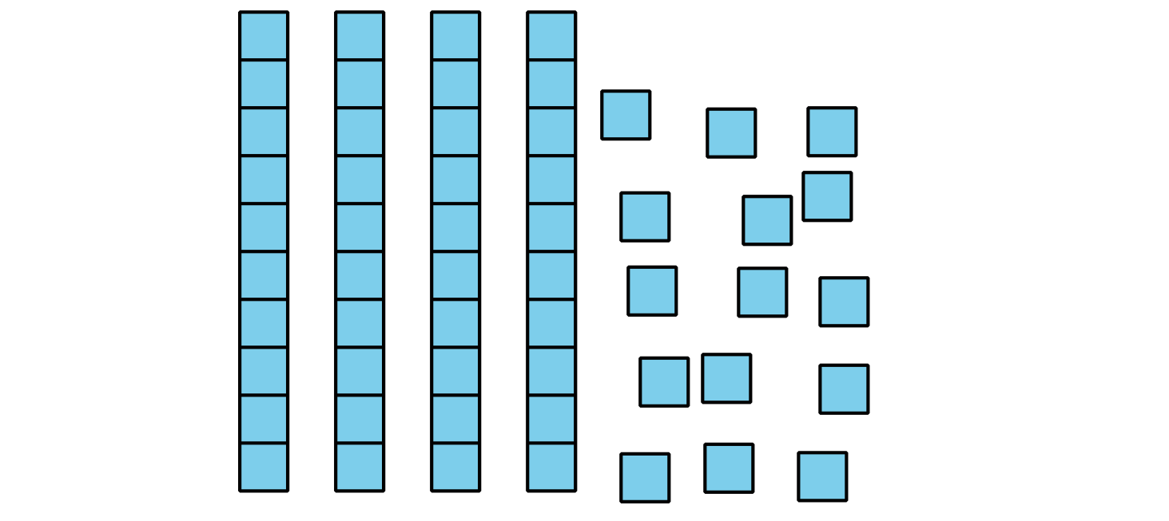
- Record an estimate that is:
- too low | - about right | - too high

1 Compare Representations of a Collection

Student Task Statement
Each student counted and showed a collection.
- Clare drew
- 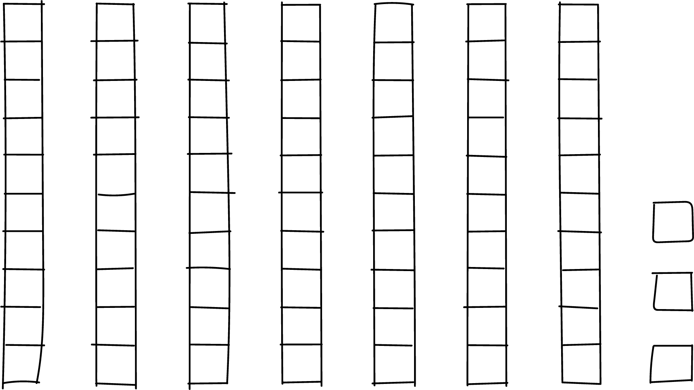
- Han drew
- 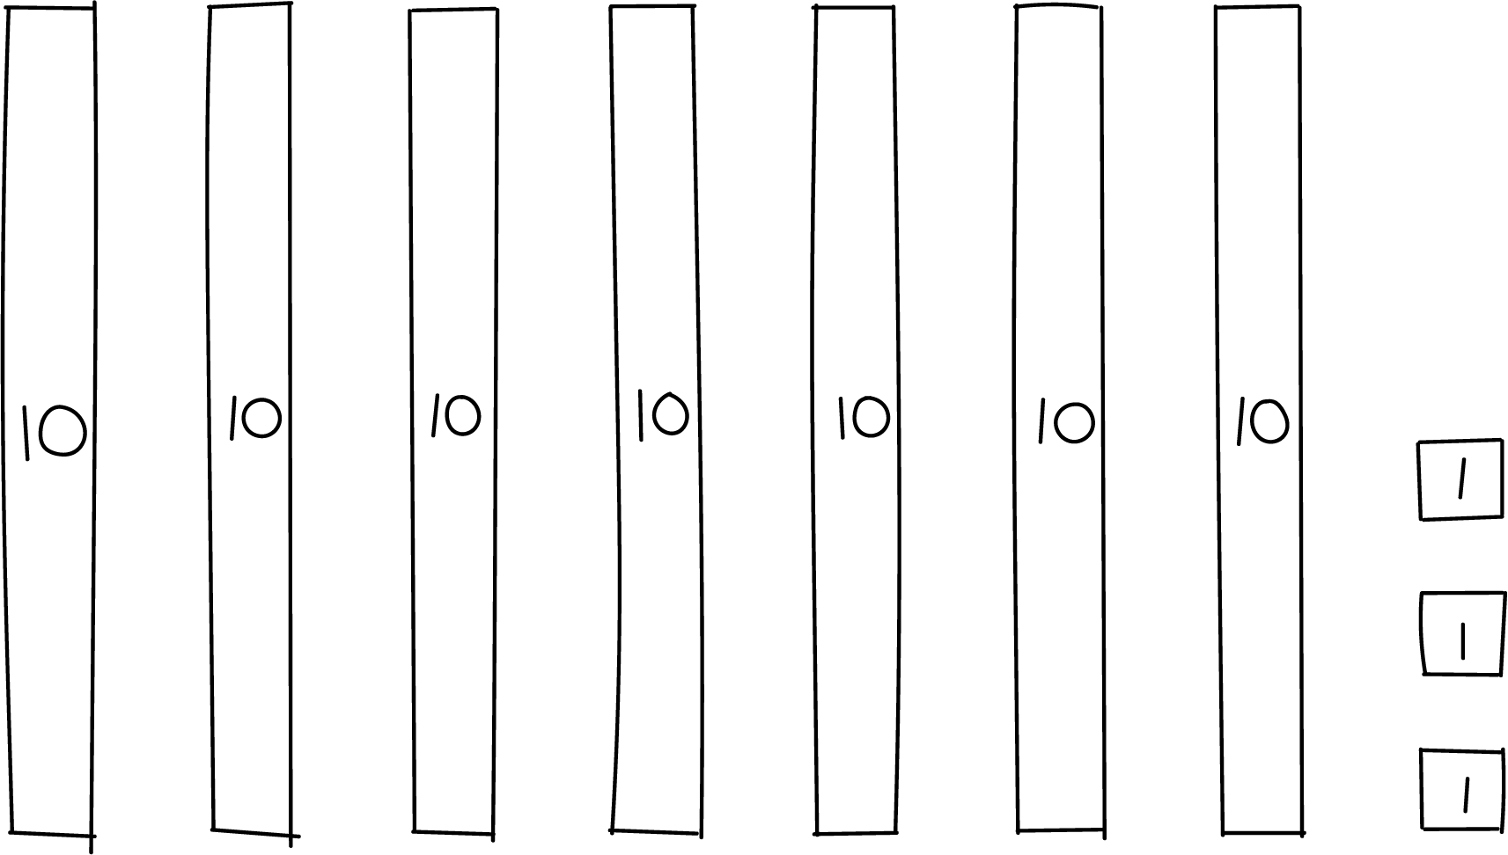
- Kiran wrote 3 ones and 7 tens.
- Priya wrote $70+3$.
Did the students count the same number of objects?
How do you know?
Show your thinking using drawings, numbers, or words.

2 Card Sort: Base-ten Representations

Student Task Statement
Your teacher will give you a set of cards that show different representations of a two-digit number. Find the cards that match. Be ready to explain your reasoning.
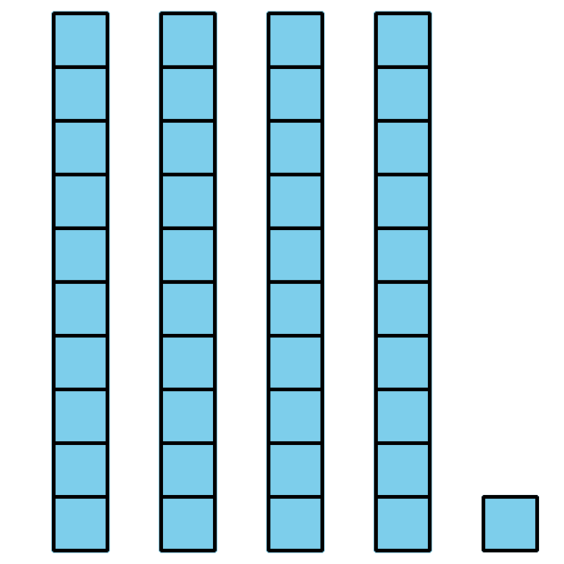
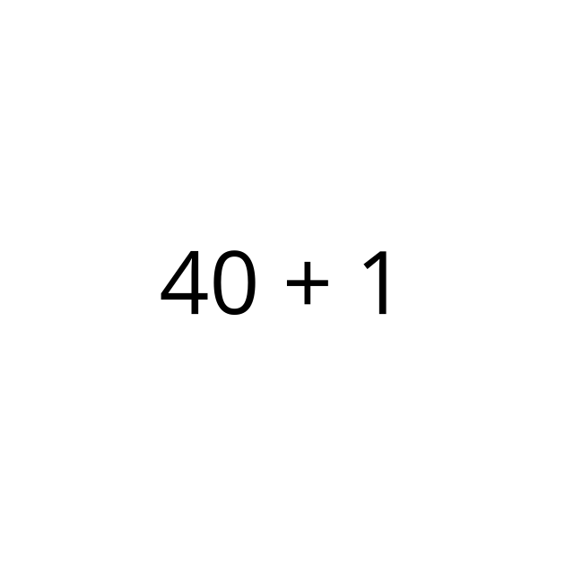
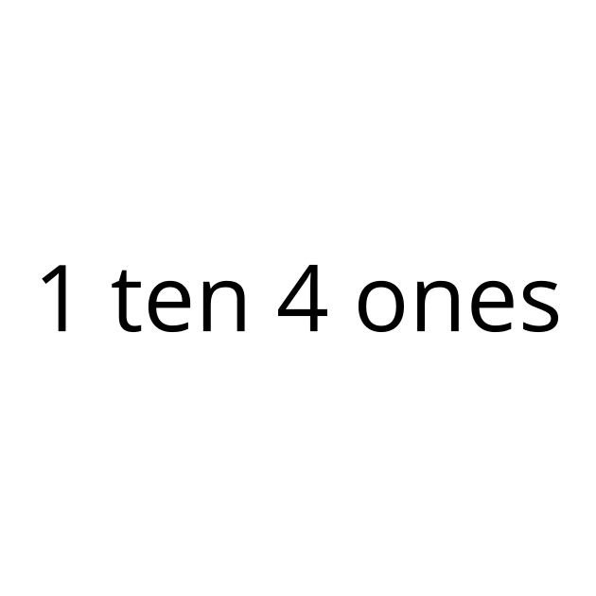

3 Introduce Grab and Count, Ones Cubes

Student Task Statement
© CC BY 2021 Illustrative Mathematics®

